BHS Lightning Policy & Procedures
- Purpose

Lightning is the most frequent weather hazard impacting athletic events. It is imperative for the safety of our student-athletes, coaches, staff and spectators that we develop and implement lightning safety guidelines. There must be mandatory compliance with these guidelines to ensure the safety of all involved.

- Statement

This policy describes the best practice procedures for monitoring lightning and taking appropriate precautions in the event lightning may interfere with athletics activity by the staff at Brighton High School.

This policy will be a living, working document, that is continually reviewed and updated yearly as the organization and community changes.

- Definitions

- Watch: issued when the risk of a hazardous weather event is significantly increased, but its presence, location, or timing is unclear; the purpose is to provide enough time to set plans in motion.
- Warning: issued when hazardous weather is occurring, is imminent, or has a very high probability of occurring.
- Direct Strike: occurs when a lightning bolt hits the victim without striking anything else before contact.
- Contact Injury: occurs when the lightning victim is touching an object that is in the pathway of the lightning current, such as a fence, indoor plumbing, hard-wired telephone, bleacher, or computer game.
- Side Flash: (or splash) occurs when lightning strikes an object near the victim.
- Step Voltage: (or ground surface) occurs when an individual near the strike intercepts a portion of the lightning current that flows radially outward from the ground strike.
- Upward Leader: a lightning channel developing from the earth toward the cloud.

- Scope

This policy applies to all staff members of Brighton High School who are associated with activities where lightning may impact athletic activities, specifically for outdoor activities.

- Procedures

Detection

The certified athletic trainer, coaches, and school administrators will have access to the mobile phone app WeatherBug in order to track local weather forecasts and receive notifications about severe weather alerts and lightning strikes in the area. WeatherBug is available for free from the App Store or Google Play store. You can save locations on the app or have the app track your current location by turning on your phone’s GPS. The app will send alert notifications about changing conditions and severe weather automatically. Also, in the app settings, you can select to have live weather conditions displayed in your phone’s status bar. WeatherBug Spark lightning detector comes with the app and will display colored alert notifications when lightning is detected in the area. Spark by WeatherBug detects lightning strikes within 30 miles of your location. The distances of the detected lightning strike are indicated in four ranges:

- 0-10 miles (red alert)
- 10-20 miles (orange alert)
- 20-30 miles (yellow alert)
- >30 miles (no alert, green)

Because the average stroke of lightning is 6 miles long, and because thunderstorms can move up to 25mph or more, you are in immediate danger any time lightning is detected within 10 miles of your location.

The National Weather Service (NWS) is also a reliable forecast suggested for use by the NATA. NWS should be monitored throughout an athletic event to actively look for signs of approaching or developing local thunderstorms.

“Flash-to-Bang” Method

The National Severe Storms Laboratory (NSSL) and National Collegiate Athletic Association (NCAA) describe the popular use of the flash-to-bang ratio as an easy way to determine the distance of the last lightning strike. This method requires no equipment. To use the flash-to-bang method, begin counting when a lightning flash is seen and stop counting when the associated thunder is heard. Divide the seconds counted by 5 to determine the distance (in miles) to the lightning flash.

For example: If the time in seconds between lightning seen and thunder heard is equal to 30, divide that number by 5, and you get 6 (30/5 = 6). Therefore, the lightning flash was approximately 6 miles away from the observer.

The WeatherBug app and NWS will be used in combination with the Flash-to-Bang method in the monitoring and tracking of potential hazardous weather and the decision to postpone or suspend play.

Personnel in Charge

The athletic director will be in communication with school administration as well as the sports medicine staff in the decision to suspend or postpone activity due to imminent hazardous weather. In the case the athletic director is not on site, the athletic trainer will be in charge of monitoring weather and notifying the athletic director or administration of any changes in dangerous weather.

Suspension of Activity

Lightning has been reported to strike up to 10 miles away from where it is raining, and the audible range of thunder is about 10 miles. Lightning safety procedures should begin when lightning is detected by the Flash-to-Bang method or the WeatherBug app within 6-10 miles of your location. Procedures summarized:

- Between 10 to 20 miles away: Coaches and officials should be notified of the impending inclement weather and warned that activity will need to be ceased should the storm move closer.
- 10 miles away: the athletic director, school administration, and sports medicine staff will discuss the situation and immediately notify the coach and/or official that activity must be suspended. All individuals should be informed of the danger and encouraged to take appropriate shelter
- 6 miles from the area: safety procedures should be complete, meaning activity is suspended and all persons are inside appropriate shelters.

Seeking Appropriate Shelter

Requirements needed for a building or location to serve as a shelter include:
- Fully enclosed
- Electrical& telephone wiring
- Plumbing

The Bengal Building is the primary shelter for the athletes, coaches, officials, and other on field personnel during a practice or game. The south gymnasium is the primary location for spectators during a practice or game. The Bengal Building May be accessed via the south gate of the football field. The gymnasium may be accessed through the south west doors of the school building. Visiting individuals should exit through the tunnel. Individuals on the home side my exit via the tunnel or through the (SW) gym doors. Other buildings safe for shelter include the main school building and the storage buildings located near the tennis courts & soccer practice fields and the soccer game field.
The secondary choice for a safe location is a fully enclosed vehicle with a metal roof and closed windows. Avoid touching the sides of the vehicle. School buses and all fully enclosed cars can act as shelter from lightning hazard.
Avoid high places (press boxes and watch towers), open fields, isolated trees, picnic shelters, baseball/softball dugouts, flagpoles, bleachers, metal fences, convertibles, golf carts, or any type of water.
Individuals, who feel their hair stand on end, feel their skin tingle, or hear crackling noises, should assume the lightning-safe position. The position is to crouch on the ground, legs/feet together, weight on the balls of the feet, head lowered, and ears covered. DO NOT LIE FLAT ON THE GROUND. You must minimize the amount of contact that you have with the ground.
Returning-to-Play

30-Minute Rule

When game, practice, or other activity is suspended or postponed due to lightning activity, the storm should be continuously monitored. Wait 30 minutes to resume activity after last sound of thunder or lightning flash. The 30-minute clock should be reset each time lightning is seen or thunder is heard. A blue sky or lack of rainfall is not an adequate reason to resume play and should not be used as criteria to return to activity.

Management of Victims of a Lightning Strike

In the event that a person is struck by lightning, proper care should be given. Lightning-strike victims do not carry an electrical charge and may be safely handled. However, personal safety must be considered before venturing into a dangerous situation to render care. If decision is made to give care, the first priority should be to move the victim to a safe location. It is imperative to treat lightning-victims promptly, as rescue breathing and cardiopulmonary resuscitation (CPR), along with early defibrillation through use of an automatic external defibrillator (AED), has been proven successful in restarting breathing and circulation. In the case of a lightning strike incident in which there are multiple victims, triage is necessary, but the basic principle of “treat the living first” should be reserved in a lightning-strike situation. Care should be administered to the apparently “dead” first. The following steps should be taken:

- Activate the Brighton High School EAP
- Survey the scene for safety
- Carefully move the victim to a safe area, if needed
- Evaluate and treat for any breathing and/or circulation problems
- Evaluate and treat for hypothermia and shock
- Evaluate and treat for fractures
- Evaluate and treat for burns

Documentation of Severe Weather and Lightning Events

The Certified Athletic Trainer should quickly and thoroughly document all lightning and severe weather events that require implementation of the above listed procedures. In a case where the Certified Athletic Trainer was not present, the party responsible for tracking the weather and suspending activity should write the report.

If medical services were needed or EMS was called due to lightning or severe weather injuries, the head athletic trainer should also fill out a complete injury SOAP (subjective, objective, assessment, plan) narrative. The documentation will remain with the athletic trainer for medical records. A description of the management of a lightning strike victim, activation of the EAP, and the call to EMS should be written up and turned into the assistant principal in charge of athletics along with the Lightning Safety & Severe Weather Episode sheet.

- Map of Shelter Locations

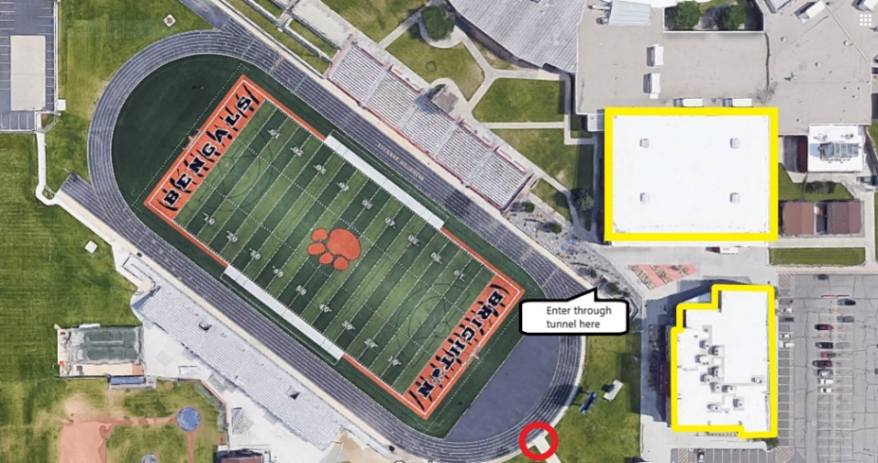
Freestone Field

Tennis Courts & Butler Park Field
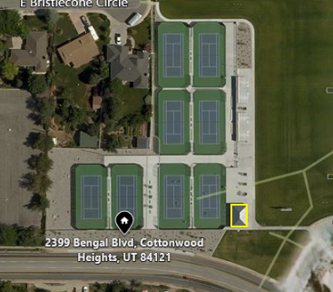
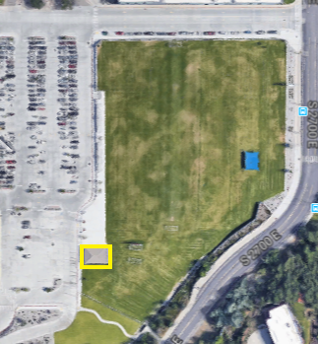
Soccer Game Field

- Contacts

POSITION | NAME | CONTACT | EMAIL
Athletic Trainer | Katelyn Graczyk | 231-239-3192 | Katelyn.graczyk@utah.edu
Sports Medicine Fellow | Ryan Dunn, MD | 920-539-8838 | Ryan.Dunn@utah.edu
Attending Physician | Julia Rawlings, MD | 845-264-5260 | Julia.Rawlings@utah.edu

POSITIION | NAME | CONTACT | EMAIL
Athletic Director | Lynn Moncur | 801-808-8179 | Paul.moncur@canyonsdistrict.org
Principal | Tom Sherwood | 801-244-5710 | Tom.Sherwood@canyonsdistrict.org

- References

National Athletic Trainers’ Association Position Statement: Lightning Safety for Athletics & Recreation

