ridgeline boys basketball youth camp  When  June 4-6  10am – 11:30am  Where  Ridgeline High School  180 North 300 West  Millville  Instruction to be given by Ridgeline players and coaching staff  web address |  |  | For all boys entering 1st – 8th grade in the fall  cost  $40  (Includes T-shirt)  Checks made out to Ridgeline Boys Basketball  registration  Form and payment can be given to Ridgeline HS Fee Window prior to camp  (Walk ups will also be accepted first day of camp)  what  Participants will receive instruction on improving their basketball skills, fun drills for practice, competitions, and T-shirt!  CONTACT  Any questions, contact Coach Buchmiller  435-512-1816  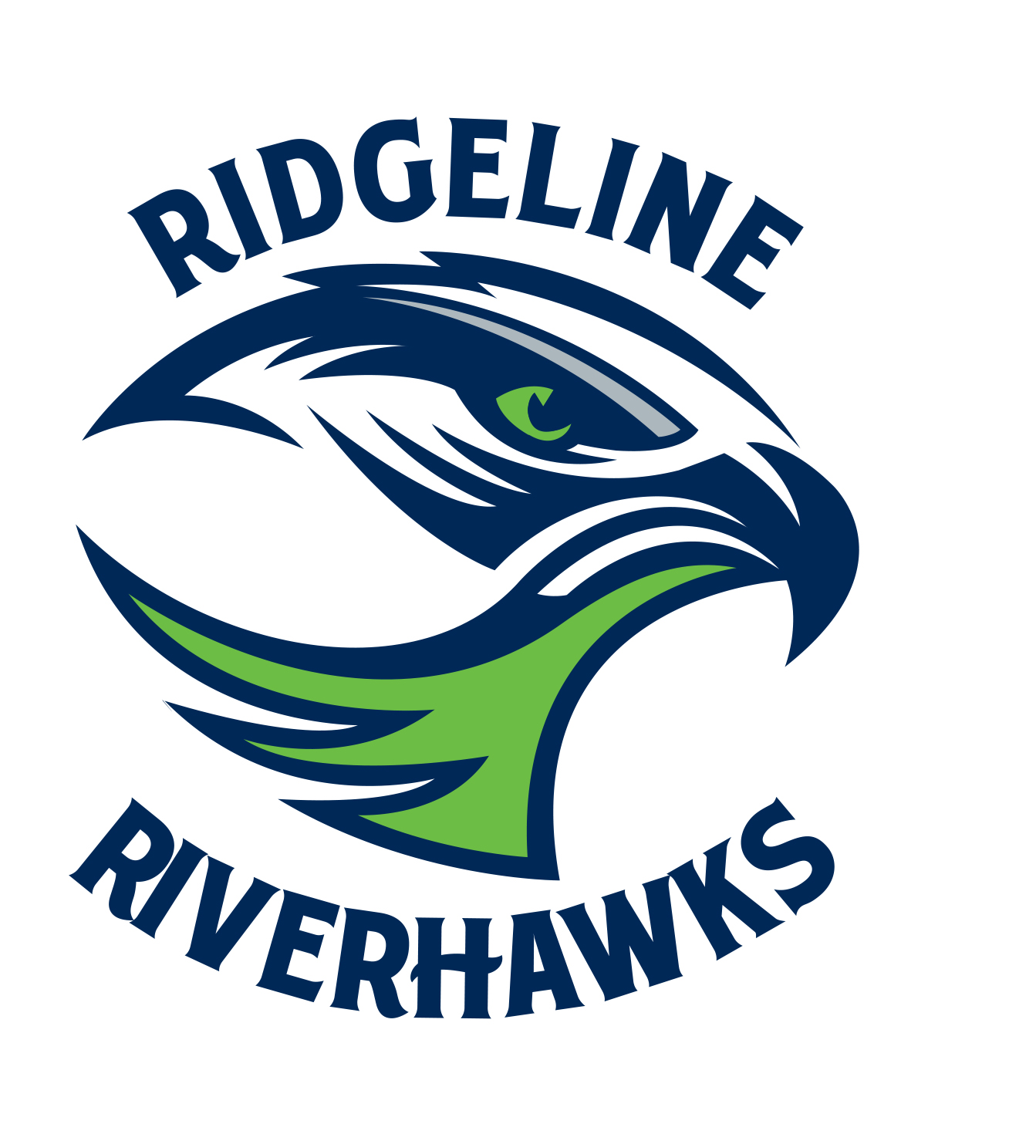

REGISTRATION FORM

Name________________________________ Grade___

Mailing Address____________________________________

Phone #______________ Email____________________

T-shirt size: S_____ M_____ L_____ XL_____

Youth M_____ Youth L_____ Youth XL____

In consideration of the acceptance of my son or guardian in the Ridgeline Boys’ Basketball Camp, I intending to be legally bound, and do hereby for myself, my heirs, executors and administrators, waive and release any and all rights and claims for damages I may have against Graydon Buchmiller, Ridgeline High School, Cache County School District, or their representative for any and all damages which may be sustained and suffered by me in connection with my association with or entry in this camp, and which may arise out of my travel to, participation in, or returning from the camp.

Parent of Guardian’s Signature_____________________________ Date_______

