About  Lecanto High School  CheerLEADING  Since the opening of Lecanto High School in 1984, LHS has consistently had a reputation for academic and athletic success. Our Cheerleading Squads have continued to showcase that you can be both a scholar and an athlete, while enjoying the excitement high school has to bring. Beginning this summer, we want to share this excitement with our community and welcome young athletes into the cheer world. Many of our cheerleaders and even our coaches began their journey as young athletes going to various camps put on in their communities. Now it is our turn to share and do the same for you! |  | CONTACT INFORMATION  Coach Allison Westmoreland  (352) 634-3805 alliegator5413@gmail.com  Coach Brittany Peterson  (407) 791-7759  (352) 746-2334, ext. 6294  petersonb@citrusschools.org |  | Lecanto high school Cheerleading’s  1st Annual  Summer Spirit camp  - June 14th-18th, 2021

Lecanto High School
3810 West Educational Path
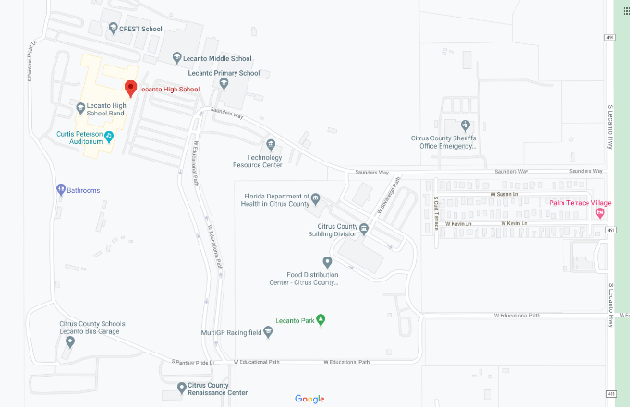
Lecanto, FL 34461

CAMP INFORMATION  When: June 14th – 18th, 2021  Time: M-TH 8/9 AM – 12 PM (Noon)  Friday 8/9 AM – 1 PM  Cost: $60 Cash or Check Accepted  - An option to pay and register will be available on Monday June 14th, but pre-registration is highly encouraged.  - Check – Please write checks out to Lecanto High School with Cheer in the Memo.  - Check & Cash – Submit payment with Registration Paperwork included, and mail to:  LHS CHEER  C/O Lecanto High School  3810 West Educational Path  Lecanto, FL 34461  Athlete Requirements:  *Hair in a Ponytail *Cheer/Gym Shorts *T-Shirt/Top that covers midriff *Sneakers *Water Bottle *A Smile |  | CAMP SCHEDULE  Monday  8-9AM Registration & Check-In  9-9:30AM Welcome & Split into Groups  9:30-9:45AM Introductions  9:45-10AM Stretch with Group  10-11AM Learn Cheer Basics  11AM-12PM Learn Sideline Cheers  Tuesday  8-9AM Check-In  9-9:15AM Stretch with Group  9:15-10AM Learn Cheer Jumps  10-11AM 4/5-10 Year Olds = Basic Tumbling  Experienced 10-13 Year Olds = Tumbling  11AM-12PM Review Sideline Cheers  Wednesday  8-9AM Check-In  9-9:15AM Stretch with Group  9:15-10AM Review Cheer Jumps  10-11AM 4/5-10 Year Olds = Basic Tumbling  Experienced 10-13 Year Olds = Tumbling  11AM-12PM Review Sideline Cheers  Thursday  8-9AM Check-In  9-9:15AM Stretch with Group  9:15-10AM Review Cheer Cheers & Jumps  10-11AM 4/5-10 Year Olds = Stunting (Only Half’s = Level 1 Stunts)  Experienced 10-13 Year Olds = Stunting (Level 2 Stunts)  11AM-12PM Learn Dance for Friday’s Showcase  Friday  8-9AM Check-In  9-9:15AM Stretch with Group  9:15-10:15AM Review Cheers, Jumps, & Dance  10:15-10:45AM Warm Up Tumblers for Showcase  10:45-11AM Relax with Groups while Parents Enter for Showcase 11AM-1PM Camp Showcase

MEET COACH ALLIE
Coach Allie has been around cheerleading since she was 8, participating in Inverness Youth Football & Cheer – Pop Warner. As she grew, she cheered and competed in several Conference and Regional completions, placing at Regionals five year in a row. Coach Allie started her coaching career at the age of 16. During her first year of coaching for the Inverness Youth Football & Cheer – Pop Warner program, her squad placed at Regionals. At 18, she switched over to All Star Competitive Cheerleading, coaching for Galaxy Tumble & Cheer. During her time there, she coached several squads, ranging from Tiny’s (Level 1) to all girls Level 3. Many of these squads placed 1st in competitions and received bids to both JAM Fest and National Competitions. In 2018, Coach Allie was offered a coaching position with LHS Cheerleading and has called this home since then. With Coach Allie’s extensive list of qualifications and certifications, she is excited to share cheerleading with young athletes, including her own daughter. Her vision as a LHS Cheerleading Coach is to lead and perfect a program that her own daughter dreams to, one day, be a part of. She is very excited for this coming season and can’t wait for what the future will bring to LHS Cheerleading.

MEET COACH PETERSON
Coach Peterson has been around cheerleading since the age of 5, participating in St. Cloud Youth Football & Cheer – Pop Warner. As she grew, she participated in middle school cheerleading at St. Cloud Middle School and high school cheerleading at Harmony High School, in Osceola County, FL. When her oldest daughter wanted to cheer at 6 in 2016, she volunteered to coach the Tiny Mite squad for Belleview South Marion Youth Football & Cheer – Pop Warner (Conference & Regional Competition Exhibitioners). The following year she coached the BSM JV Squad (Conference & Regional Competition Placers) and Co-Commissioned for BSM Cheerleading, until accepting a request to coach the Mighty Mite Squad for Marion County Youth Football & Cheer – Pop Warner. Coach Peterson took a break from coaching cheer in 2019 and accepted a coaching opportunity with LHS Softball, when her daughter moved to the competitive cheer gym, Ocala Athletix. In April 2020, missing cheerleading and coaching (due to COVID-19), a new additional opportunity to coach was presented and Coach Peterson accepted without hesitation. She is very excited for this season and can’t wait to do all the amazing things they have planned.

