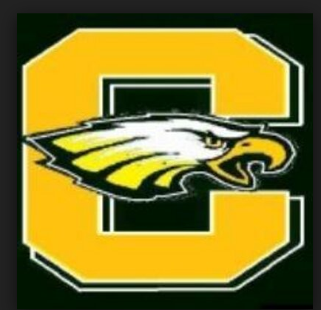

Clay High School Athletic Boosters
2018/2019 Officers

President – Jaci Bleau
Vice President – Preston Quinlan
Treasurer – Tami Gifford Neate
Secretary – JoAnn Quinlan

Trustees:
Dave Durczynski, Chuck Miller, Trina Myers, Jeff Pappas, Missy Szegeti, Brandy Schenkel,

