Clay Eagles Yard Signs
***NEW DESIGN***
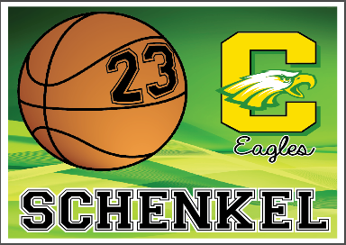
Are you proud of your Eagle Athlete?
Display it for the entire community to see!

*Purchase your personalized DOUBLE SIDED yard sign today*
Each sign is $30
- Display your student athlete’s sport and jersey#
- Two sports and two numbers ONE SPORT PER SIDE is $35
- Please complete and return this form by 8/15

YOUR NAME: _________________/PHONE: ___________/EMAIL: _________________

ATHLETE’S NAME: _______________________________________
JERSEY#: __________ SPORT: _________________ (0ne Side)
JERSEY#: __________ SPORT: _________________(Other Side)
ADDRESS: ____________________________________

Check made payable to: Clay Athletic Boosters
Mail form and check to:
Brandy Schenkel
Clay Athletic Boosters
1413 S Wynn Rd.
Oregon, Oh 43616

- Please email Oregonclayathleticboosters@gmail.com with any questions.

Thank you for supporting your Clay Athletic Boosters

