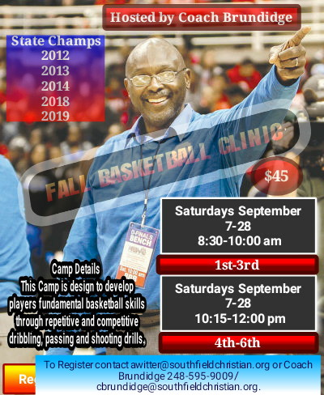
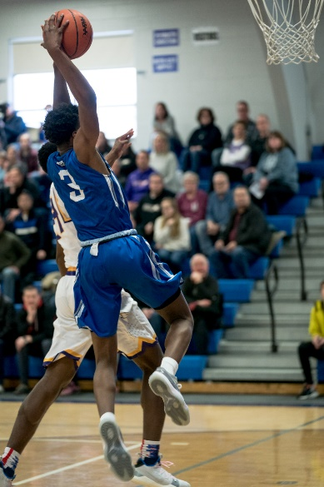
REGISTRATION
Mail or drop off your form at the Athletic Training Room!
-GUARANTEE YOUR SPOT-

To Register for Fall Basketball Clinic:
Complete the form below and include cash or a check payable to Southfield Christian. Cost is $45. Camp is held at Southfield Christian School and is run by our varsity coaches, assistants and players. For more information, please call SCS Athletics at 248.357.3660 ext 322. Non Southfield Christian Students are welcome.

Please complete the Information below:

Name:

Current Grade:

Address:

City and ZIP:

Home Phone: Cell Phone:

Email Address:

Has the participant ever had a concussion? If yes, list when:

I consider the above named summer camp participant to be in good health and grant permission to participate in all summer activities. I understand that payment for any medical expenses incurred during camp activities will be the responsibility of the parent/guardian and his/her insurance company. Southfield Christian is a member of the MHSAA and will adhere to their guidelines in treating concussions (Please attach any preexisting medical conditions or allergies for the camp director’s information).
I agree to hold Southfield Christian School, its employees and volunteers harmless for any claim or action that might rise on behalf of myself of my son/daughter other than for the willful, wanton or reckless misconduct of SCS, its employees or volunteers.

Signature: Date:

Registration is open to both Southfield Christians students and non Southfield Christian students. Payment is due at the time of registration. There will be a $15 late registration fee for those registering on the first day of the camp. Due to space restrictions and camper/coach ratios, space may not be available for “day of” registration. Please contact Coach Brundidge at 248-595-9009 for additional information or for any questions. You may also e-mail Amelia Witter, Assistant Athletic Director, at awitter@southfieldchristian.org.

