Good Morning Waverly High School Students and Families,

I wanted to reach out today and thank everyone for their quick responses in reference to our weight room protocols and procedures. I also want to thank you again for your patience as we ironed out a couple of glitches with the google survey. Below are a couple of updates and reminders for everyone.

- Don’t forget, if you haven’t done so already, if you plan on coming in and utilizing the weight room starting June 8th, please go to the Google Survey and respond. It only takes about 5 seconds. The cut-off time to sign up is TODAY, May 29th at 4:00pm. This will allow us to work on our groupings the week of June 1st.

- Please be sure to print off and sign this signed consent form. Your child will need to bring this to their first session on June 8th.

- Please understand that if you are not comfortable sending your kids to the weight room we as coaches completely understand! Your absence WILL NOT have any effect on team placements for the 2020-2021 school year. We do however expect you to be working out at home so that you are ready to hit the ground running when we are able to return.

- Payment
  - If you haven’t already paid for any summer weights, please send $35.00 and the signed consent form with your child on Monday June 8th.
  - If you already have registered and paid for summer weights, along with other summer camps, our plan at this time is to deposit the check that you have already written. Therefore, you will not need to send an additional $35.00. We will have this documented at the first weight session. IF we are not able to have any of the camps, or you are unable to attend because the rescheduled date doesn’t allow, then we will refund you at that time for those camps.

- Originally we were informed that anyone traveling out of state would have to isolate from the facilities for 14 days. We were told yesterday, and confirmed with officials, that we no longer have to keep this measure in practice. Therefore, at this time, out of state travel will not affect coming in and working out at the school.

We will communicate groups for each of the sessions next week along with any other updates from the health department or the NSAA. Please contact me at brad.mcmillan@district145.org should you have any questions or comments.

Sincerely,
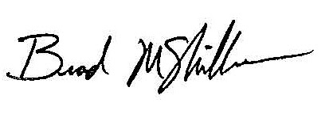
Brad McMillan
Assistant Principal & Activities Director

