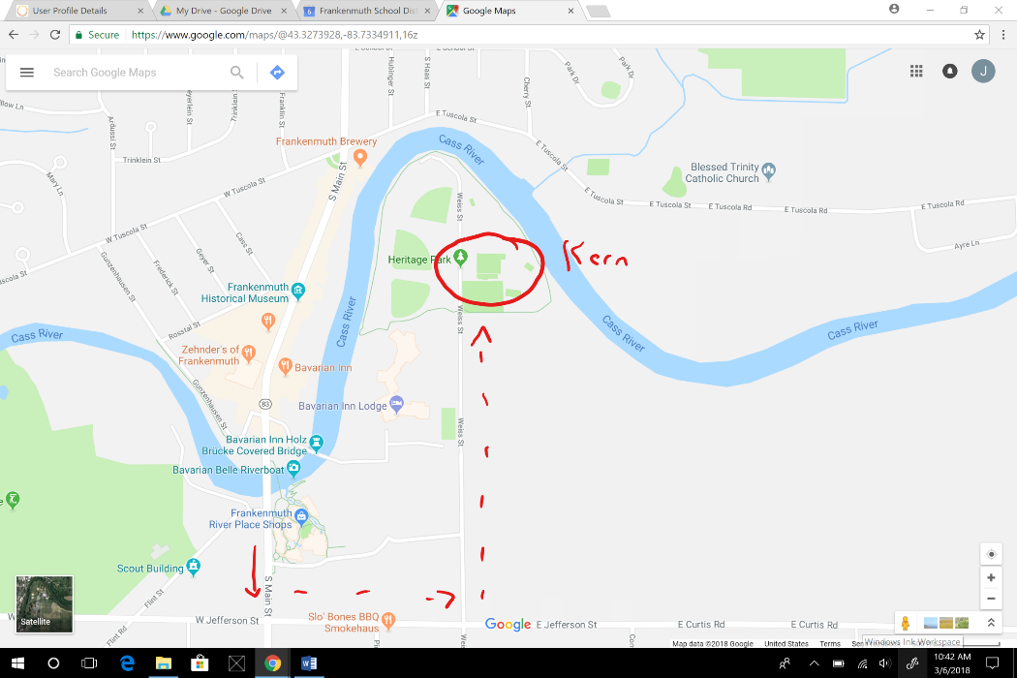
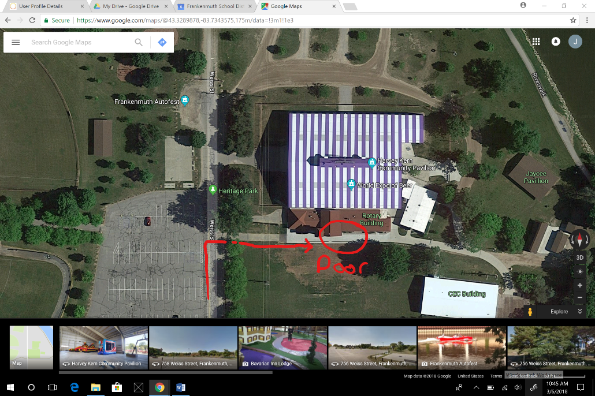

Venue Specific Emergency Action Plan –Frankenmuth School District Athletics, Frankenmuth, Michigan, 48734
Kevin Schwedler, Athletic Director (cell 989-513-1762);
Julie Felten, Certified Athletic Trainer (cell 989-652-4561)
Janelle Compton, Parks and Recreation (office 989-652-9901)
Harvey Kern Community Pavilion (GPS: 43° 19.76160, -83° 43.95840.)
Sports: Baseball, Softball, Soccer, Tennis
Address: 599 Weiss Street, Frankenmuth, MI 48734
Directions: From the corner of Main Street and Jefferson St: head East on Jefferson, Turn North on Weiss Street into Heritage Park at the bottom of the hill. Pavilion is on the right before the road ends. See pictures on previous page.

AED Locations: CALL 911 – Police will respond with AED
Descriptive location | GPS location | Adult pads | Child/ infant pads | Directions | Outside door #
In office during spring indoor practices | Same as above | Yes | No | Located with first aid kit | n/a

First Aid Kit Location: located in office during spring indoor practices.
Lightning Safety Procedure: Refrain from opening doors, stay away from windows, avoid wiring/ electronics/ plumbing. Assure people under your supervision remain indoors.

Tornado Procedure: Coach will announce if tornado watch or warning occurs as indicated by weather advisories. Warning will initiate the procedure of taking all teams/ people into office or North/South internal brick wall without windows, instructing to cover heads with hands until warning is expired. Coaches should account for all teammates during this time. Await further instructions from weather station/ earth networks.
Earthquake: Stay away from objects that will fall, find a location under something solid/ doorframe away from outer walls, hold your position, do not get up, do not run, cover your head with hands and stay that way until shaking stops. If trapped, do not yell, tap for noise to give location.

Fire Procedure: Evacuate through South doors and gather in the field/ CEC building. Coaches should account for all members of their team. Call 911.
Power Outage: Do not evacuate the building unless instructed to.

Evacuation Procedure: Evacuate through any unlocked door.
Evacuation Ordered
May I have your attention please!!
Due to a potential threat to your safety, we are now requesting that all persons walk in an orderly fashion to the nearest exit. Follow the direction of the staff and responders. Upon exiting move to ________. As soon as the area is verified safe, the event will resume.
Secure Mode: Lock doors, continue activities, monitor halls and exit/ entry areas, await further instructions.
Indoor Secure Mode Announcement
May I have your attention please!!
Due to risks outside our building, we are securing all doors and keeping everyone in this event center. Remain calm and we will continue the event. The police are securing the outer area and there is no threat to anyone inside.

Lock down/Threat of Violence: Lock, barricade the doors and turn off lights. GATHER PHONES TO NOT CAUSE UNNECCESARY PANIC! Gather people in a safe area of the building, such as the office. Prepare for an alternate emergency exit. Account for people under your supervision. AWAIT LAW INFORCEMENT DIRECTIONS ONLY. If your area becomes unsafe exit by any means possible.
Indoor Violence Announcement
May I have your attention please!!
Due to threat to our facility we are locking down all entrances. Remain calm, stay in your seat for your own safety. When the police secure the area and we can safely escort you out, we will move you to your vehicles. Follow coaches’ instructions!

Bomb Threat: Coach will call 911, lock and secure all doors, take a head count of all people under your supervision, instruct all to not use cell phones or turn off/ on lights, check for suspicious packages, do NOT touch packages if found. Await evacuation instruction if necessary.
Bomb Threat Announcement
May I have your attention please!!
We have an anonymous notice threatening damage to this facility. We are investigating at this time and the event will continue. Those wishing to leave, do so in an orderly manner following the direction of the staff and responders. We will keep you informed of further developments.

Shelter-In-Place/ hazardous materials: Close doors, turn off ventilation, move to center of pavilion, use wet towels and tape to seal off any outside air openings, breathe through wet cloths or towels if you smell chemicals. Maintain secure mode until fire department determines air is safe.
Shelter-in-Place Announcement
May I have your attention please!!
There is a potential hazardous material that if inhaled could cause great illness. You are safe with the air within this building and we are locking the building down to insure no air enters. Please remain in your seat and await for the all clear from the responders.
Injury Emergency Medical Plan- Athletics
Frankenmuth School District

When an injury occurs that requires emergency services please utilize this information for prompt assistance.

CALL 911
- When an emergency situation arises beyond the prevention of the staff, determine that the situation is safe to enter, recognize the issue and provide immediate care.
  - Check if unconscious and not breathing (and pulse if able) and begin chest COMPRESSIONS if suspicious of any absence.
  - If deemed appropriate, FIND AED IF NEEDED FIRST!!! AED should be applied AS SOON AS POSSIBLE if any question of heart issue exists.
  - If neck /bone injury is suspected the director of the emergency event will MAINTAIN THE POSITION FOUND with the athlete’s head and neck/ bone.

- Contact Certified Athletic Trainer and athletic director. Do NOT leave injured person alone. First responder becomes the director of the emergency event and will direct people to do specific tasks as listed below unless the ATC or athletic director arrives to take over.

- Team FIRST AID KITS are equipped with immediate response items or locate ATC’s first aid kits/ splints. Provide appropriate treatment.

- At director of emergency’s request, CALL 911 from cell phone, or 9-911 from a school telephone or a landline if possible. Give 911 operator all necessary information including:
  - Nature of injury
  - Address of your location – see beginning of this document.
  - Directions to gym/ field/ location where injury has occurred – see beginning of this document.
  - (give a contact number to the 911 operator)–
      - Cell phone #: yours, event coordinator’s or ATC’s: (989) 652-4561
      - Kevin Schwedler – Athletic Director cell: (989) 513-1782
      - JoLynn Clark - FHS Principal cell: (989) 525-3356
- Return to the site of the injury to inform the Certified Athletic Trainer or athletic director that emergency assistance is on the way. If parents are not present please gather the student athlete’s green medical information sheet from the head coach and contact parents. A parent/ adult chosen by the parent or director of the emergency will accompany the athlete when transported to the appropriate medical facility. Remind the family to contact the coach and/ or athletic trainer with updates upon arrival to the medical facility.

- Please find others to flag down and direct the emergency personnel when they arrive.

- If deemed appropriate by the emergency situation, nature of the injury or safety of any individual involved the injured party may be moved to a “safe” location. That location will be passed to those directing the EMS.

- Please have someone control and supervise any spectators/ athletes.

- Media may be dealt with post-event by the administration and authorities ONLY.

- Staff debriefing/ critical incident stress debriefing will take place post incident as deemed appropriate by the involved personnel.

- Injury Documentation will be directed by the Certified Athletic Trainer/ Athletic Director.

- Return to Play will be coordinated by the Certified Athletic Trainer, parents, coaches and athlete’s doctors when necessary and appropriate.

Thank you for your assistance.

