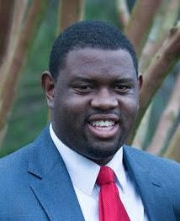
Alex Probst
Alex grew up in Heber City. He graduated in the class of 2011 and played multiple sports from Wasatch high school. He studied business management at UVU. Alex is now working for his family businesses: Probst Farms, Nature’s Hollow, and coaching Wasatch High School girls’ basketball. He enjoys evening walks with his wife, Matondo “Mattie” Probst.

