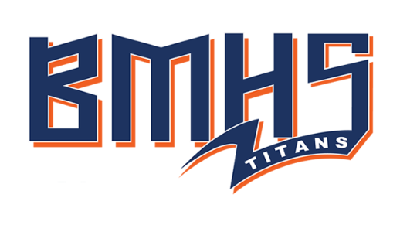
ORDER DEADLINE
AUGUST 24, 2018

PERSONALIZED TITANS YARD SIGN – ORDER FORM

If you want to order a Titans Yard Sign with your name and sport, fill out the information below.

COST: $25 for 1-sided, 1-sport sign (See Below for additions)

MAIL THIS FORM AND CHECK TO: PAYMENT MUST BE INCLUDED WITH THE ORDER
Berea-Midpark Athletic Boosters
c/o Denise Dacek-Engle
7411 Craigmere Dr.
Middleburg Hts, OH 44130

ORDER DEADLINE IS AUGUST 24th. NO LATE ORDERS ACCEPTED. You will be notified when the signed is available for pickup and where it is to be picked up.

CONTACT INFO: (PRINT CLEARLY)
Name: ______________________________
Address: ______________________________
______________________________
Phone #: ______________________________
E-mail: ______________________________

ATHLETE INFORMATION (PRINT CLEARLY)

Name (one name): _____________________________________
(Print athlete’s name as you wish it to appear on the sign. EITHER FIRST OR LAST NAME (CHOOSE ONE)

Sport (one sport): ______________________________________
(Add $5 for each additional sport that you list on the same side)

Second Sport (optional): __________________________________
(Add $15 for a double sided sign)

Grade Level - Circle one: 12th 11th 10th 9th 8th 7th

If you have any questions, please call Denise at 440-343-1743 or Ddacek@machor.com

