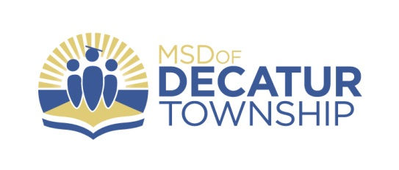
FOR IMMEDIATE RELEASE
March 5, 2018

CONTACT: Nate Davis
Assistant Superintendent
nsdavis@msddecatur.k12.in.us
Marion Adams Flooring Athletes of the Month- March 2018

The Decatur Central High School Athletic Department in partnership with corporate sponsor Marion Adams Flooring is happy to recognize the dedication, perseverance, and success of Decatur Central student-athletes. Each month during the 2017-18 and 2018-19 school years, Decatur Central Athletics awards the “Marion Adams Flooring Athlete of the Month Award.” This award is given to one female and one male student-athlete who have displayed athletic excellence in all areas of competition during the previous month. Marion Adams Flooring is proud to recognize student-athletes for their athletic achievements each month while supporting the Decatur Central Athletic Department.

The March female Student-Athlete of the month is Freshman Jasmine Hermosillo. Jasmine is a three-sport athlete competing in soccer, wrestling and is running the 100m, 200m, and 4x100m dash this spring for DCHS Track and Field. “She is one of the hardest workers I have in the sports performance program. She has a total index of 3.66. That means on the three major lifts of bench, squat and power clean, she lifts 366% of her body weight and has achieved all the girl club boards. More importantly she is a super young lady. Always asks for tips in her training. She is very coachable and always says thank you. She is a great role model for the younger Hawks,” says Strength and Conditioning Coach Kevin Kavanaugh. According to DC Wrestling Coach Aaron Schuleter, “Jasmine Hermosillo embodies what it means to be a total student athlete. She is a hardworking, dedicated and motivated individual that is respectful and disciplined in all aspects of her life. She is a three-sport athlete, soccer, wrestling, and track and field. In her first year of wrestling, she placed 6th at Indiana High School Girls Wrestling State Championship. We are excited to watch “Jazzy” continue to excel on the mat/field/track over the next four years.”

Senior Blayne Harrington is the March male Student-Athlete of the Month. Blayne is a Varsity Football letterman and a Track and Field standout for the Hawks. The Senior Hawk placed 5th in 60m Dash at the Hoosier Indoor State Relays with a personal best 6.94s finish. In addition, Blayne also took home1st place in three consecutive indoor meets in the 60m Dash. “Blayne has positioned himself as the leader of the boys team as we compete for a Mid-State title. His college recruitment continues to gain momentum as he continues to improve times at each meet,” says Head Coach Tony Tate. Blayne is ranked 109/371 in his senior class with a 3.29 G.P.A.

Congratulations to Jasmine and Blayne! Go Hawks!

(See attached photo)

