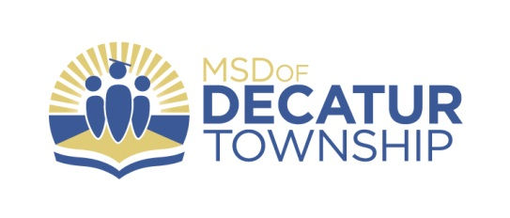
FOR IMMEDIATE RELEASE
November 30, 2020

CONTACT: Tony Burchett
Assistant Superintendent
tburchett@msddecatur.k12.in.us

Marion Adams Flooring Athletes of the Month- November 2020

The Decatur Central High School Athletic Department in partnership with corporate sponsor Marion Adams Flooring is happy to recognize the dedication, perseverance, and success of Decatur Central student-athletes. Each month during the 2017-18, 2018-19, 2019-20, and 2020-21 school years, Decatur Central Athletics awards the “Marion Adams Flooring Athlete of the Month Award.” This award is given to one female and one male student-athlete who have displayed athletic excellence in all areas of competition during the previous month. Marion Adams Flooring is proud to recognize student-athletes for their athletic achievements each month while supporting the Decatur Central Athletic Department.

The November Male Student-Athlete of the month is D.C.H.S. Senior Mark Everman. Mark is a member of the Hawks Wrestling team. He has had a fast start to the season going 5-0 in the month of November. His hard work this offseason has shown with him recording 2 pins, 1 tech-fall and 1 major in his 5-0 stretch. Coach Aaron Schlueter said, “Mark started his season off in the right way. He’s looking good in the early season. His effort and hard work in practice and in competition is looking great for this time of the year. We are excited to see what this season brings for him with his continuous hard work and effort.”

Junior Ayva Schmalz been nominated as the November Female Student-Athlete of the Month. The DCHS Junior is a member of the Lady Hawks Cross Country team. Ayva was named Captain at the beginning of the season and strong performances throughout led her to be voted team MVP for the 3rd time. This season, Ayva set a new personal best time at 20:01 ranking her 3rd in school history. She finished the season strong being named to the All Mid-State, All Sectional and All Regional teams as she finished the year as a Semi-State Qualifier. Coach Rogge said, “Ayva has always been a gifted runner, and it has shown over the past couple of years. However, her growth and drive this year was something more than we could have even asked for. She not only worked hard in practice, leading the other girls, she also put in work in the weight room and was even putting in extra work on her own. She had the most successful season she’s ever had, and is only the 4th ever Semi-State qualifier from Decatur Central. We are so excited to see where she goes form here.”

Congratulations to Mark and Ayva! Go Hawks! (See attached photo)

