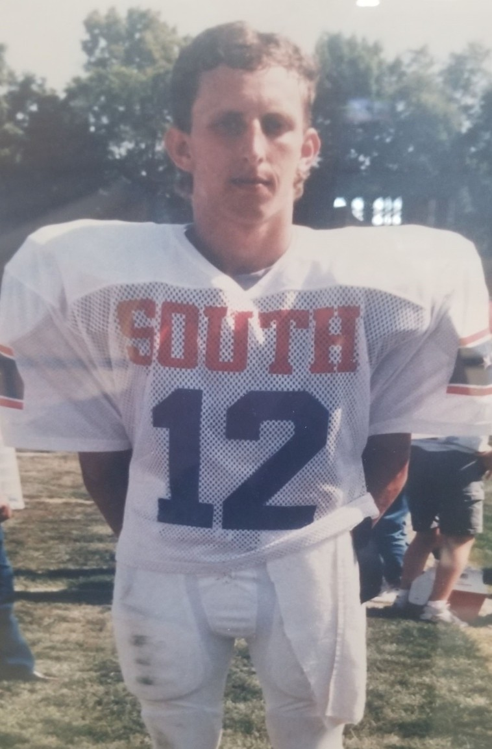

**HALL OF FAME**

**Induction Class of 2019**

**First Athlete in FCHS History named to All-Star Teams in Two Sports**

**High School Football 1991 Football South All-Star 1990 EIAC Conference MVP**

**1990 Palladium-Item First Team All-Area 3 Time Letter Winner**

**High School Baseball 1991 Baseball South All-Star**

**1991 Palladium-Item First Team All-Area 1991 Team MVP**

**3 Time Letter Winner**

**High School Basketball 3 Time Letter Winner**

**College Football University of Evansville Starting Safety**

**as a Freshman and Sophomore**

**College Basketball**

**Starting Forward at Indiana University East as a Junior and Senior**

**Brian Bischoff**