Frederick High School Athletics
2018-2019 Season/Family Passes
Ticket Prices starting 2018: $6.00 for adults
Parents or students may purchase season/family passes in the following manner:
- Passes can be purchased through the athletics office of Frederick High School.
- Passes can be purchased by completing the following form and:
  - Sending it in with your student-athlete to the athletics office (C/O Keivette Hammond)
  - Mailing it to: Frederick High School
c/o Keivette Hammond
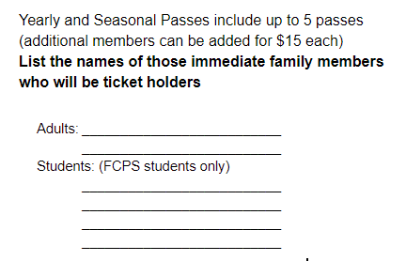
650 Carroll Parkway
Frederick, Md 21701

Please check which pass you will be purchasing:
____ Family Yearly Pass $200
____ Family Season Pass $125
____ Student Pass $25
(all year pass for FHS students only)

These passes allow parents and their children
(FCPS students only)
admission into all FHS home games with the exception
of the intra-city doubleheader vs Thomas Johnson.
This does not include local, county,
regional, or state tournaments.

Please contact the Athletic Department if you have any questions:

Keivette Hammond, Athletic Director
240-236-7083 or Keivettehammond@fcps.org

