MOD Supports: 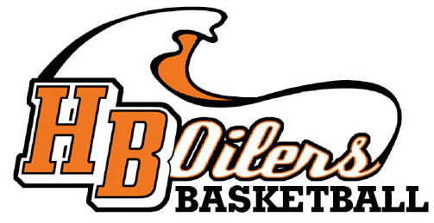

Please support the HBHS Boys Basketball by having lunch and/or dinner at MOD in Seacliff Village Center (7051 Yorktown Ave Suite 103, Huntington Beach, CA 92648) Wednesday, August 28 and be sure to mention our program at checkout. Mod will donate 20% of your bill to our program.

Thank you!

