
Join us for our
Spirit Night!

Wednesday, August 29th
3pm – 9pm
at Rita’s of Odenton
1111 Odenton Rd
Odenton, MD
410.672.0900

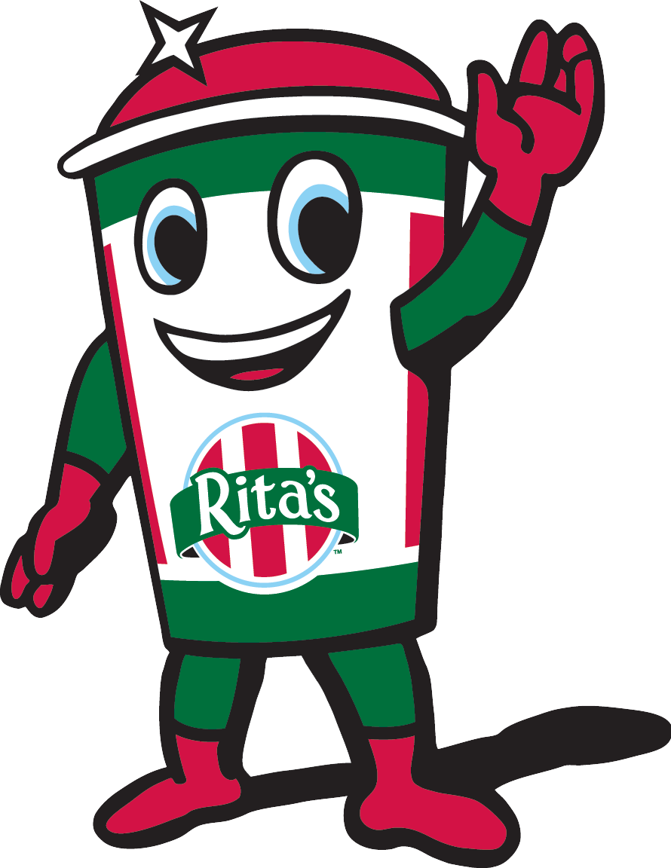
10% of Sales Benefits
OMHS Boys Soccer!
This Flier REQUIRED for Participation

