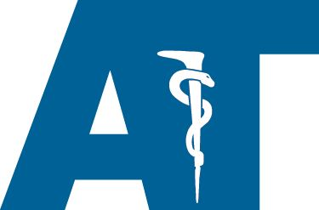
38th Annual Athletic Training Student Aide Workshop

July 12th – 15th, 2021

The Athletic Training Student Aide Workshop is designed to introduce students to the field of Athletic Training, while exposing them to other components under the sports medicine umbrella.
This is a four-day workshop that will include lectures as well as hands on practical sessions taught by staff members from Kettering Sports Medicine Center, athletic trainers, physical therapist, and other local sports medicine professionals.

Registration is available online at https://www.eventinterface.com/kettering-sports-medicine-athletic-training-workshop-3/
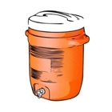
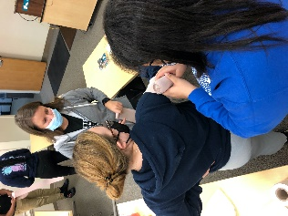
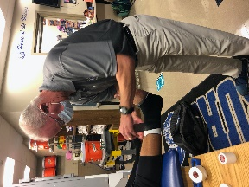
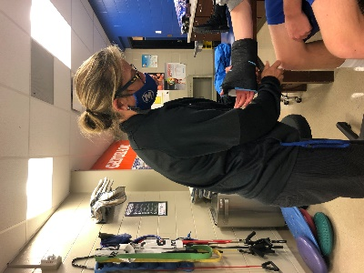
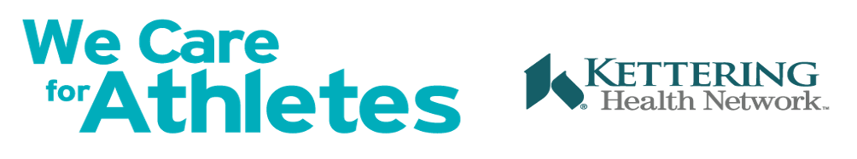
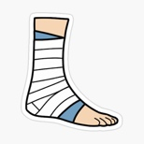
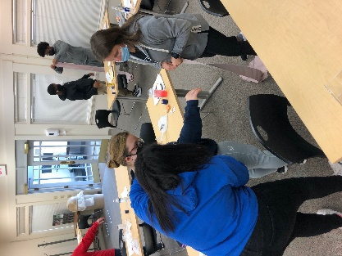
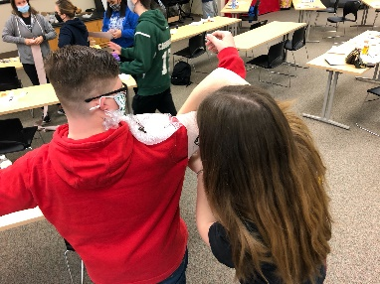
Questions? Please Contact:  Laura Stafford at LauraA.Stafford@ketteringhealth.org  Michelle Heckman at Michelle.Heckman@ketteringhealth.org | Kettering Sports Medicine Center  4403 Far Hills Ave.  Kettering, Ohio 45429  KetteringSportsMedicine.org

