2019 Viking Booster Association
“Bowling Bash”
9 Pins same as a STRIKE

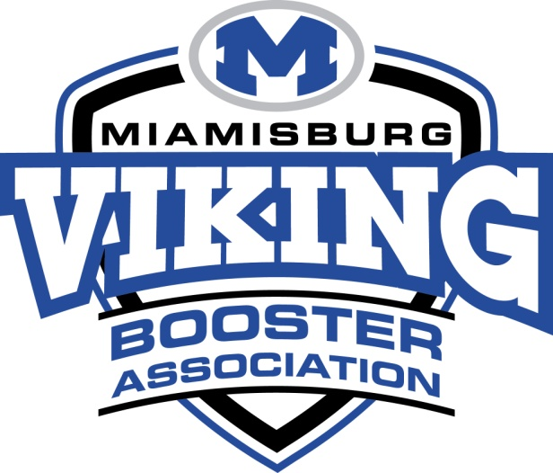
Where: Poelking Lanes South on Kingsridge Drive

When: Saturday, January 26th 2019

Check-in: 5:45 p.m. at Poelking Lanes South
6:30 p.m. start (4 games – “Dutch Doubles” alternate male/female each frame)

Door Prizes
50/50 Raffle * Lottery Board Raffle

Entry Fee: $40.00 per Team/Couple (Cash or Cashier Check payable to Viking Boosters Association)
(team must consist of 1-Male & 1-Female bowler to be eligible for prizes)

Prizes for Top 3 Total Scores
1st Place = $100, 2nd Place = $75, 3rd Place = $50

Registration Deadline: Saturday, January 26th (limited to the first 120 entries)

For Questions Contact VBA Secretary:
Mary Ann Smith masmith106@yahoo.com

-------------------------------------------------------------------------------------------------------------

Bowler 1: ______________________ Bowler 2:____________________________

Email:_____________________________________________________________________________

Would like to request to be grouped with (if applicable):___________________________________

Mail or Deliver Entries to the Athletic Office:
Miamisburg High School
Athletic Office
1860 Belvo Road
Miamisburg, Ohio 45342 Paid:_______________

