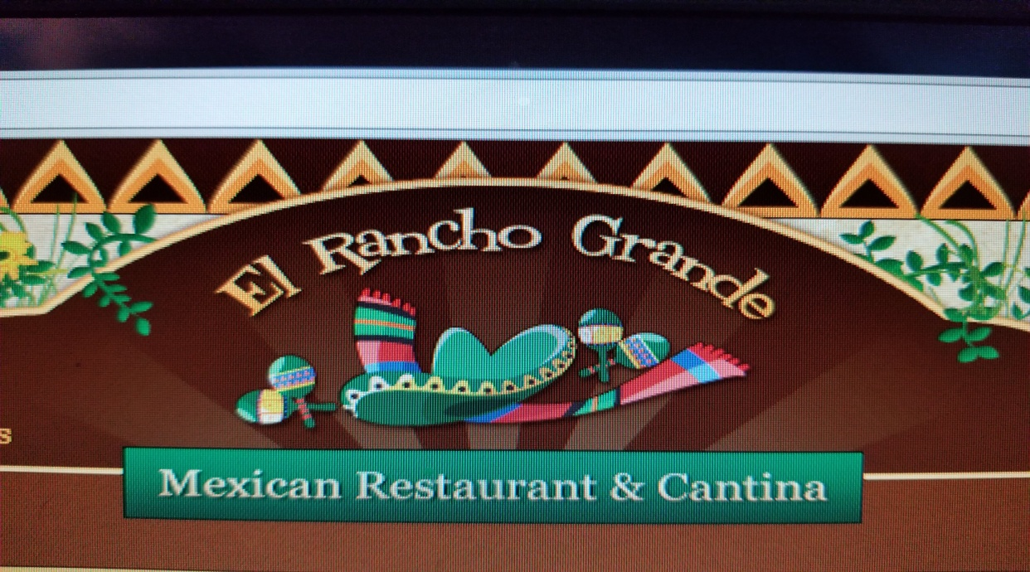

Takeover Night At El Rancho Grande!
Support Miamisburg High School Boys Soccer by joining us Monday, May 13th for some awesome food! The soccer teams will receive 20% of the proceeds, simply show a PAPER copy of this flyer. Please print the flyer out, do NOT plan to show electronic copy.
Valid at 2008 South Alex Road, West Carrollton, Oh 45449

