CCPS
Office of School
Safety & Security
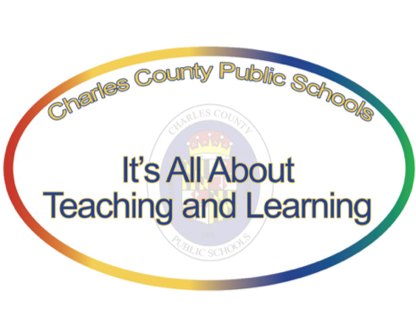
Charles County Public Schools
Office of School Safety & Security
5980 Radio Station Road
La Plata, MD 20646
301-392-5550

COVID-19 Standard Operating Procedures

Notification of a Positive COVID-19 Staff or Student

8-12-2020

The below guide was established to guide CCPS in cases where a student or staff member notifies the system that they have a positive test result and have been in a CCPS facility.

- Staff members who test positive for COVID-19 must self-report test result to Human Resources as soon as possible.

- Parents/Guardians of students are expected to notify their child’s principal of positive COVID-19 test results as soon as possible.

When CCPS is notified of a positive COVID-19 test result from a student, inquire about the following:
- When was their test completed?
- When was the last time the student was in the building?
  - Pull and archive potential contact tracing information:
    - Synergy
    - ScholarChip

Internal Notifications/Mitigation Team:
- Principal
- School Administration
- Supporting Services
- Student Services
- Office of School Safety and Security
- Supervising School Nurse
- Office of Communications

  - Notification of contacts who must quarantine:
- Charles County Health Department will lead the contact tracing process;
- CCPS will work with the health department to identify persons who may have had close prolonged contact with the person testing positive for COVID-19;
- When authorized by the Health Department the Office of Communications should provide written notification to all identified contacts.
The notification should include the following:
- When to seek medical care
- How to monitor for symptoms
- Who to contact and how to contact them if they develop symptoms of COVID-19 while under quarantine
- The projected length of quarantine if remain asymptomatic
- Plan for maintaining remote learning for those who remain well enough to engage in learning while under quarantine
- Information about local COVID-19 testing sites

Mitigation strategies that CCPS is prepared to implement when appropriate:
- Cleaning, disinfection, and sanitizing
- Fogging
- Closing the facility if necessary

When student return to school after a positive COVID-19 diagnosis:
- Students should not return to school until all the following have been satisfied:
  - 10 days since onset of symptoms, AND
  - 24 hours since last fever, AND
  - Symptoms have improved.

Parents who wish to have their children return to school after their child has tested positive for COVID-19 must maintain continuous communication with their school’s nurse via the telephone between the test results and the child’s return to school. Telephonic check-in should be no less than every two school days.

The parent’s failure to remain in contact with the school will result in a delay of the student returning to in-person instruction.

Staff members who test positive for COVID-19 must follow the latest guidance from the Office of Human Resources.

