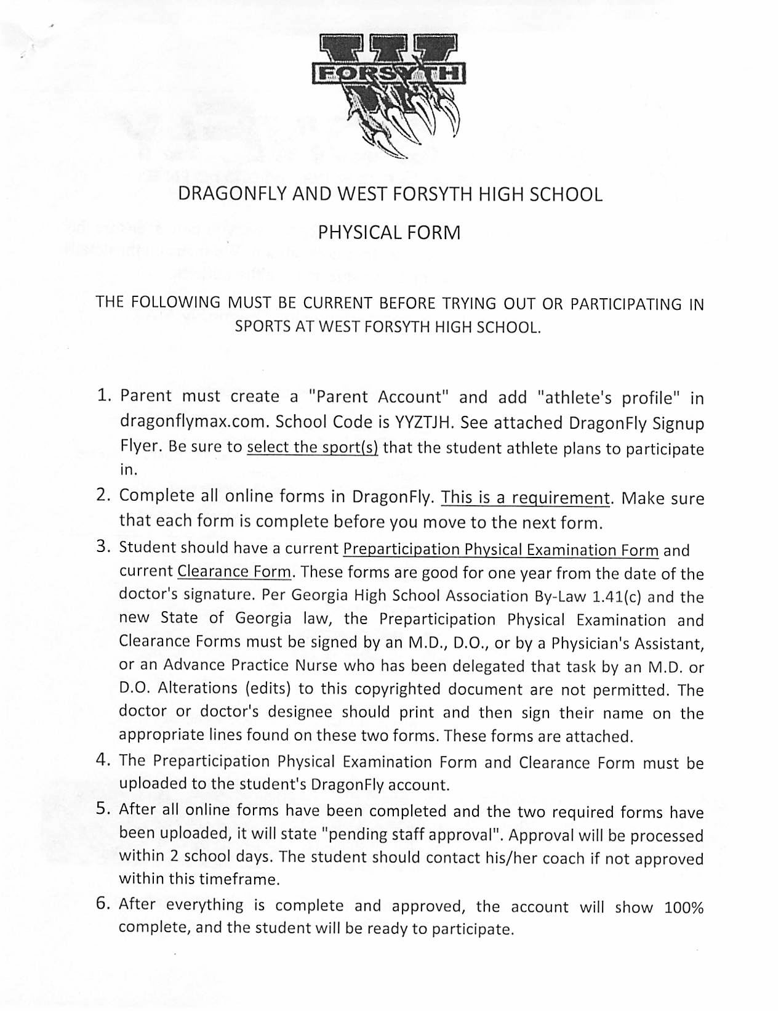

Medical Eligibility Form.

Medical Eligibility Form.

Medical Eligibility Form.

