Mask Up Cougars!
Support BHSN Girls Basketball with North Branded Gear

https://bloomingtonnorth.itemorder.com/sale

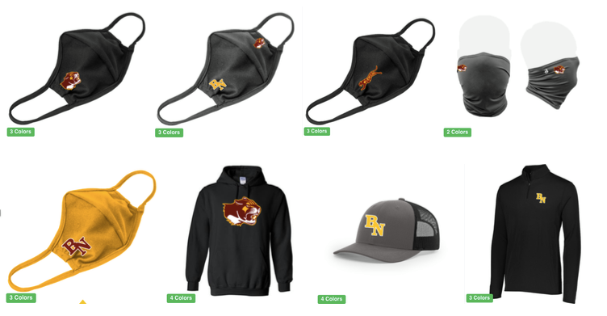

https://bloomingtonnorth.itemorder.com/sale

