A current pre participation physical is required for all in season athletic activities at Desert Edge High School. Use this opportunity to meet the Desert Edge team physicians, and get your physical for the 2019-2020 school year. All while supporting the Desert Edge Sports Medicine Program.
When: Saturday, May 11, 2019 from 8:30-11:30 AM
Cost: $20 per student athlete
All proceeds will go directly to DE Sports Medicine
Where: PCH Southwest Valley Center
1665 N. Avondale Blvd, Avondale, AZ 85392

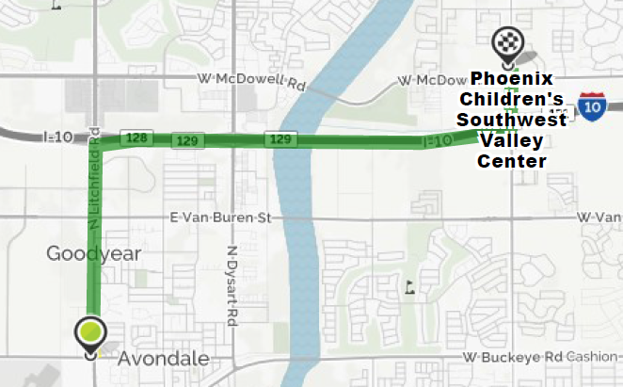

If you have further questions, contact Mr. Johnson cjohnson2@aguafria.org

