Marysville Exempted Village School District
Cheerleading Tryout Information
2021-2022

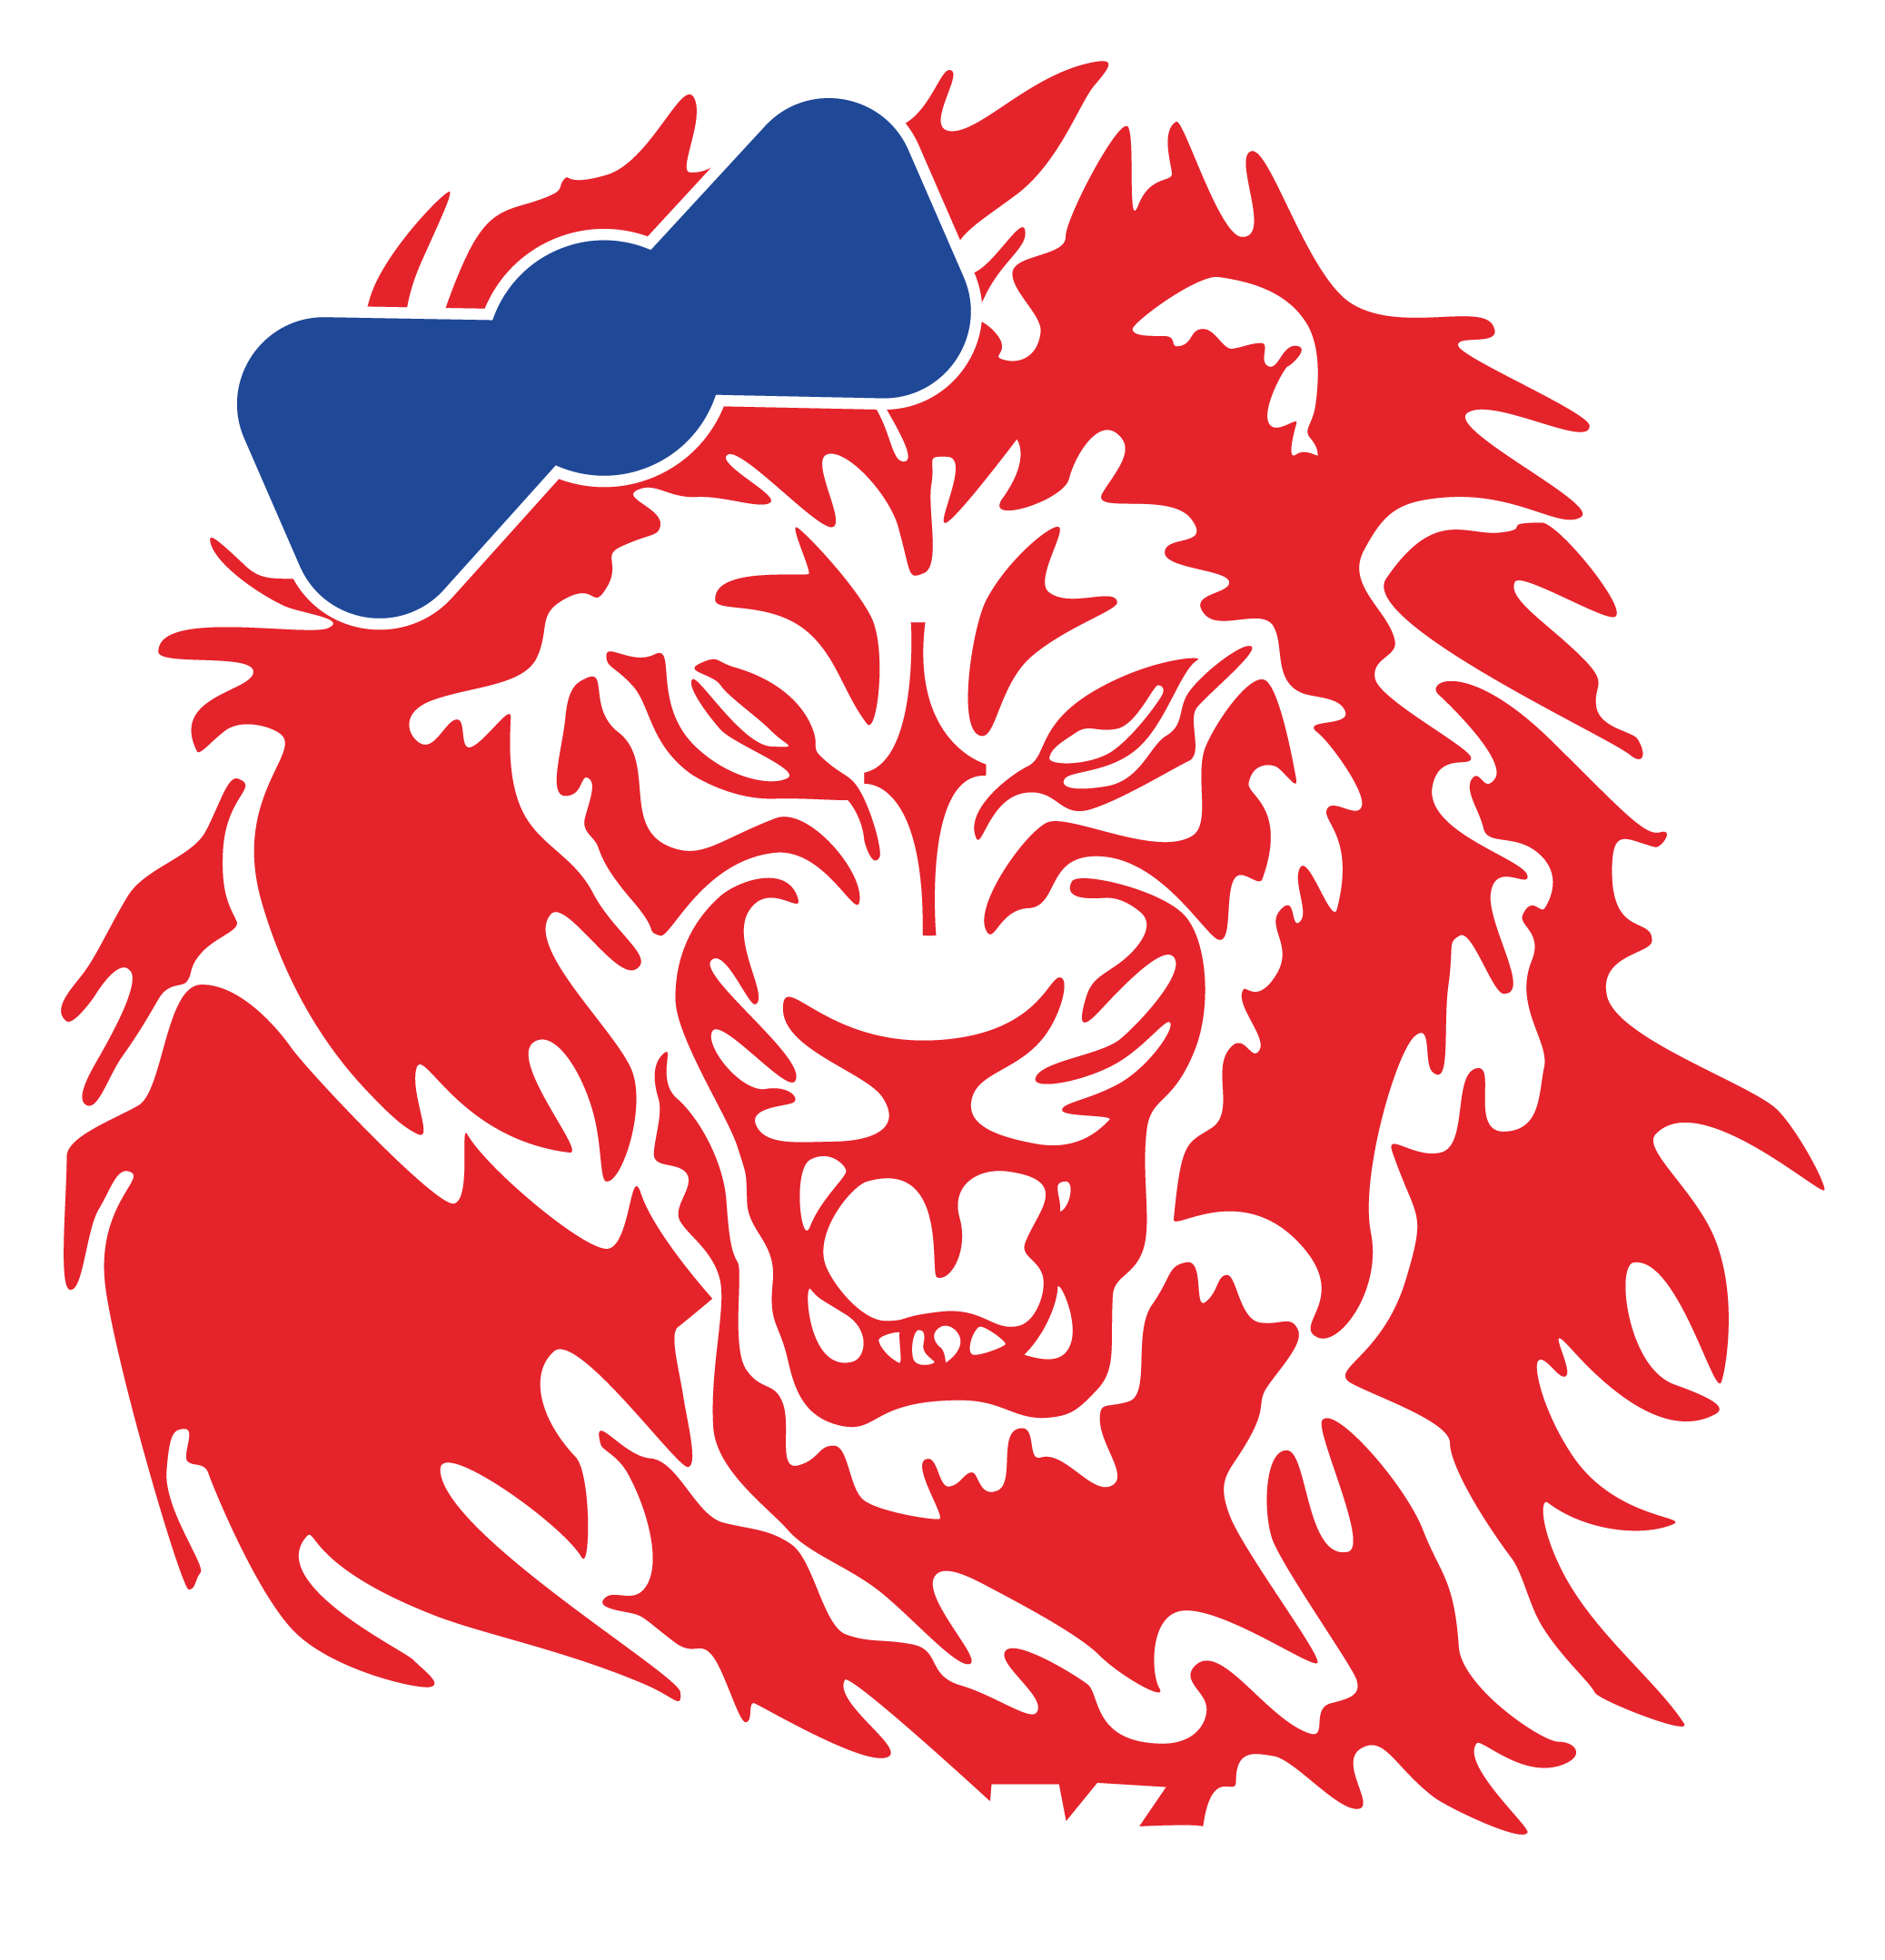

Important Dates

Online Sign-Ups - April 13 to April 23

Mandatory Virtual Parent Meeting - April 20, 7pm
Zoom Meeting ID: 840 6176 8935 Password: cheer

BMS Cheer Clinics - April 28 and 29, 6-8pm
@ Bunsold Middle School
*Open clinics for any MHS candidate if they would like to attend*

BMS/MHS Tryout Clinic #1 - April 30, 6-8pm
@ Bunsold Middle School

BMS/MHS Tryout Clinic #2 - May 1, 10am - 12pm
@ Bunsold Middle School

Tryouts for All Candidates - May 2, 10am
@ Bunsold Middle School

2021-2022 Cheerleading Tryouts Process

Online Cheerleading Application must be completed no later than 11:59pm Friday, April 23rd, 2021.

Each applicant will be added to the 2021-2022 BAND Cheer Tryout Page via email.
- If you have not used the BAND app previously, instructions will be provided when filling out the Online Application

Clinics:
- All material will be learned at the tryout clinics on Friday, April 30th and Saturday, May 1st.
- If you are unable to attend one or both days, please contact a coach immediately.

Clinic Days:
- All candidates will learn a chant, a cheer, and a dance routine
- All candidates will have the opportunity to review correct placement of motions, jumps, tumbling, etc.

*DO NOT attempt ANY tumbling skills that you have not done previously*

Tryout Number:
- All Candidates will receive their tryout number on Friday, April 30th at the tryout clinic.
- Tryout groups will be assigned at this time.

Tryouts:
- All tryouts will take place on Sunday, May 2nd beginning at 10am.
- Candidates will try out with their group, after arriving promptly at a designated time to warm-up before their try out.
- Following their group’s tryout, applicants will need to leave immediately.

A current physical must be on file with the athletic department prior to being allowed to practice
- Forms can be found on marysvillemonarchs.com (Athletic Website).

Tryout Appearance:
- Apparel - blue or red cheer/nike shorts, a plain white t-shirt, no show socks, & white tennis shoes.
- All hair must be pulled up and completely away from the face in a ponytail with a plain ribbon.
- No beads, headbands, or hair clips other than bobby pins may be worn.
- No jewelry (including nose and belly button rings!) and no nail polish or fake nails. These will be checked!

Tryouts Procedure:
- Candidates will be judged on the tryout material by a panel on the following:
  - Motions - Jumps - Tumbling - Dance - Technique - Crowd Appeal - Interview Question
- Candidates Final Tryout Score will be compiled as:
  - Score from each tryout judge (panel provided by outside source) (sample score sheet attached)
  - 1 Coaches evaluation based on the prior season (20 possible points)

Results / Following Tryouts:
- Results will be posted on both the BAND app and the Marysville Monarch Cheer Website as soon as tryouts conclude and scores are tallied on Sunday, May 2nd.
- You can access the website at www.marysvillemonarchcheer.weebly.com
- The results will be listed by squad and name.
- Candidates will not be permitted to see their score sheets.
- Candidates will receive a form with tips for improving and notes from the tryout on the band app upon request.
- If selected to a squad, coaches will invite you to that squad's specific BAND group on Monday, May 3rd, 2021 and more information will be shared at that time.

Please direct any questions to coaches at marysvillemonarchcheer@gmail.com

Sample Judges Score Sheet - Per Judge

