Elkhart High School Athletics
COVID Protocol: Elkhart Aquatic Center

General Event Policies:
- Only essential personnel are allowed on pool deck
- Everyone entering the building must have a face covering to be worn at all times.
- No face covering = No admittance/asked to leave
- Face covering must be worn at all times.
- Hand sanitizer will be available.
- Names logged and symptom/exposure checked before entering the building.

Opposing Team:
- We will be alternating use of locker rooms for changing.
- You may use the showers in the locker room.
- Team personnel are expected to enter the building wearing masks continue wearing them at all times.
- Athletes are expected to wear masks when not in the pool (removing them only just before entering).
- We suggest having ziplock bags with names for athlete masks.

Guidelines for Athletes:
- Athletes are expected to wear masks when not in the pool (removing them only just before entering).
- Athletes are expected to provide their own water/bottle. Water will not be provided for teams.
- Athletes should spread out on the bleachers provided. No more than 5 swimmers per bleacher section.
- At the end of the meet, we ask that you exit the building and do not stay to talk to spectators.

Spectators:
- All spectators must wear a face covering.
- Spectators should social distance in the stands.
- Spectators should not linger after games. We ask that they leave immediately after the meet is concluded. If they are waiting on their own child, they should exit and wait for them in their vehicles.
- Social distancing at the concession stand and restroom facilities is expected.

Ticket Policies:
- Tickets will be sold online at www.gofan.co. Tickets are $5.00 per person.
- All remaining available tickets will be sold at the door beginning one hour before the meet starts.

Warm-up Procedures:
- Athletes should wear their masks behind the block until they are ready to get into the water.
- There should be no more than 6 athletes per lane.
- While stopped at the wall, athletes should maintain social distancing.
- Starts should be done following social distancing guidelines. We suggest starting in even lanes and swimming back in odd lanes to maintain social distancing guidelines.
- There should never be more than one swimmer on a block and one behind each block at anytime.

Meet Procedures:
- Swimmers will put on their masks when they are done with an event before exiting the bulkhead.
- Swimmers will exit the bulkhead from the locker room side of the pool.
- All swimmers will enter the bulkhead from the scoreboard side of the pool after the bulkhead is cleared.
- While athletes are on the side of the pool they should maintain social distancing.

Bus Information:
- Buses need to follow a specific path to ensure they can enter and exit parking safely.
- Buses should take E. Elkhart Ave to Hannah Ct. The bus should then drop off the athletes and proceed to N. Clark St. to exit back onto E. Elkhart Ave.
- Buses will have parking available parallel to the street on Hannah Ave.
- Please see attached maps

Construction Information
- There will be three construction projects very close to the pool.
- The front of the parking lot is currently under construction for a new building
- The overfull parking lot is getting redone and will be closed.
- The bridge on East Jackson Blvd will go down for at least three weeks during the high school season.

Onsite parking will be very limited due to construction. Please see maps for additional city parking within walking distance.

Map
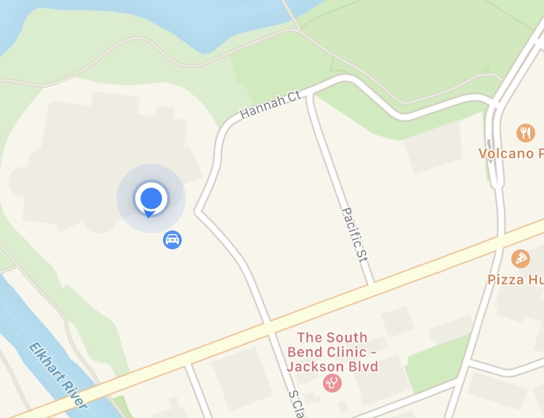
Construction
Construction
Bus Parking
Elkhart
Aquatic
Center

