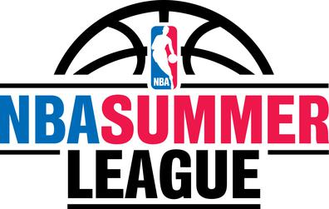  EAST RIVER BB | June 2019  East River BB
Monday | Tuesday | Wednesday | Thursday | Friday | Saturday | Sunday
May 27 | May 28 | May 29 | May 30 | May 31 | June 1 | 2
 | Practice 6-8 | Last Day of School  Practice 5:30-7:30  Freshmen 7:30-9 | Practice 5:30-7:30  Freshmen 7:30-9 | JV & Vars-  Lk Howell/Oviedo Camp – 2 Games each | JV & Vars-  Lk Howell/Oviedo Camp – 2 Games each | OFF
3 | 4 | 5 | 6 | 7 | 8 | 9
Summer League Game TBA | Practice – 6-9 | Summer League Game TBA | Practice – 6-9 |  | Practice TBA | OFF
10 | 11 | 12 | 13 | 14 | 15 | 16
Summer League Game TBA | Practice – 6-9 | Summer League Game TBA | Practice – 6-9 | JV- Rollins Camp  V- Orangewood Christian | JV & Vars-  Rollins Camp | OFF
17 | 18 | 19 | 20 | 21 | 22 | 23
Summer League Game TBA | Practice – 6-9 | Summer League Game TBA | Practice – 6-9 |  | Vars only-  Stetson Camp (3 games)
24 | 25 | 26 | 27 | 28 | 29 | 30
No Gym rest of summer- Floor getting resurfaced…  Summer League Game TBA | FCA TEAM CAMP (RDV Maitland) | FCA TEAM CAMP (RDV Maitland) | FCA TEAM CAMP (RDV Maitland) | Maybe- V only FABC Camp- College Recruiting Tourney – in Bradenton | Maybe- V only FABC Camp- College Recruiting Tourney – in Bradenton | Maybe- V only FABC Camp- College Recruiting Tourney – in Bradenton
May 31-June 1st- Both JV and Varsity will play 2 games each day at either Hagerty HS, Oviedo HS, or Lake Howell HS.
June 14th-June 15th- JV will play both days at Rollins College Team Camp. Varsity will play Friday at Orangewood Christian, and Saturday at Rollins College Team Camp.
June 25th -27th - JV and Varsity will play 2 games each day at the Fellowship of Christian Athletes camp – Games will start in late afternoon at RDV Sportsplex in Maitland. We will help car pool over. Should be all 3 nights.

