Interested in Girls Volleyball??

Join us over at Atlee High School this summer for a volleyball clinic!!!
July 23th thru July 25th (Monday – Wednesday)
Open to girls ages 9–18
6:00PM – 9:00PM
Atlee High School (Main gym)

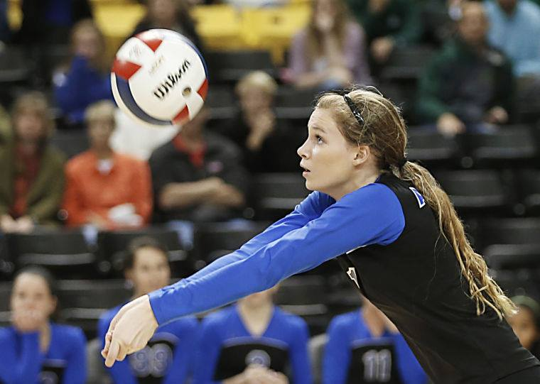

Registration fee- $90 (each additional sibling is $45)
Checks made payable to Atlee High School Girls Volleyball

For more information, please contact Curtis Carpenter at Curtis.f.carpenter@gmail.com

Like our Facebook page “Atlee Girls Volleyball” for other information!

