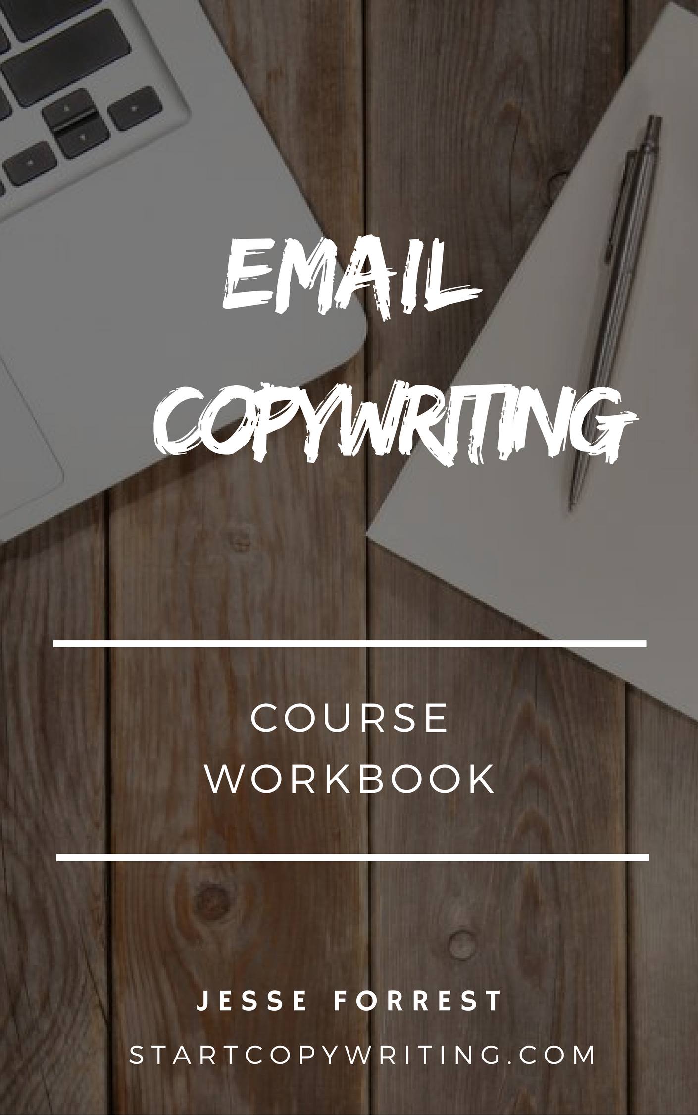

Copyright © 2017 by Jesse Forrest

All Rights Reserved. No part of this publication may be reproduced, distributed,
or transmitted in any form or by any means, including photocopying, recording, or
other electronic or mechanical methods, without the prior written permission of the publisher, except in the case of brief quotations embodied in critical reviews
and certain other noncommercial uses permitted by copyright law.
For permission requests, write to the publisher, addressed
“Attention: Permissions Coordinator,” at the address below.

Start Copywriting
1 Soi Plub Plueng
Huay Kaew Road
Chiang Mai, Thailand
50300
www.StartCopywriting.com

Welcome to the Email Copywriting Workbook and 6-Part Email Campaign Template!
The campaign is most useful for people who are offering a free lead magnet and want to follow up and convert email subscribers into purchasing a product. But with some tweaking, you could use the email campaign for other purposes too.
Simply follow the 3 steps below to quickly and easily create your very own 6-part email follow up campaign.
- Type in your answers to the questions below
- Copy-paste your answers into the Email Copywriting Template document
- Review the emails and fine tune them if needed
1. Fill out the Workbook below
The Workbook document lists a set of parameters that also appear in the email templates. Some examples of parameters are [MAIN GOAL] and [TARGET AUDIENCE].
All you have to do is provide information about your product that will replace these parameters in the Email Copywriting Template document. This is how the emails become personalized and refer specifically to your product.
2. Copy and paste your answers into the Email Copywriting Template
Once you’ve typed your answers in the workbook, the next step is to replace your answers with the relevant parameters in the Email Copywriting Template. There is a video which explains how to do that in the introduction video of this course.
3. Review the emails and fine tune them if needed

Once you have finished replacing the parameters with your answers in the Email Copywriting Template, it’s a good idea to review, fine tune and edit the emails where necessary. Once you’re happy with them, it’s time to upload them into your email marketing software.

[LEAD MAGNET TYPE]

What type of lead magnet are you delivering? For example: Checklist, report, video, etc.

‘[LEAD MAGNET TITLE]’
What is the name of your lead magnet? For example: ’13 Step Copywriting Blueprint’ or ‘7 Steps To Generating More Leads With LinkedIn’

[Bullet Points]
What are the 3 main things people will learn or experience after going through your lead magnet? Write a benefit oriented bullet point for each. For example: ‘3 steps to attracting more customers’ or ‘the psychology behind binge eating’
- [bullet point 1] ______________________________________
- [bullet point 2] ______________________________________
- [bullet point 3] ______________________________________

[CLAIM TO FAME]
What is your biggest claim to fame? What makes you an authority or expert in your field? For example: ‘Australia’s leading copywriter’ or ‘worlds #1 poker player’.

[TARGET AUDIENCE]
Who is your main target audience? For example: ‘business owners’ ‘financial planners’ or ‘students’.

[MAIN GOAL]
What is the main goal that your customers want to achieve? Phrase this starting with the word "to". For example: “to attract your ideal partner” or “to build a million dollar property portfolio”.

[PROBLEM]
What is the main problem your prospects are experiencing that you can help them to solve? For example: “experience crippling anxiety” or “lack of money”.

.
[BENEFIT 1] and [BENEFIT 2]
What are the 2 biggest benefits that your product or service provides? These should be related to the [MAIN GOAL] parameter. For example, if the main goal is to “attract ideal partner” then benefits 1 and 2 could be: “confidently approach women anywhere” and “get more dates”.

[PRODUCT]
What is the name of the product or service that your sales page is promoting?

"[TESTIMONIAL]" – [TESTIMONIAL NAME]

This is a 2-3 sentence long testimonial from one of your customers. It should be written in first person and should mention the value your product delivered and what makes it different or special. It would be ideal if you can sign the testimonial off with your customer’s full name (to be added in the TESTIMONIAL NAME parameter).
Example: “For a long time I struggled to find a decent copywriter. I tried many only to find that they just couldn’t deliver the goods. Then a close friend suggested that I call Jesse Forrest, so I did. Jesse’s copy has been responsible for over $100,000 worth of sales.”
Dale Beaumont, Business Blueprint

[QUESTION] and [ANSWER]
What are the frequently asked questions that your prospects ask in relation to your product or service? The second parameter should contain a brief yet helpful answer to the question. Make sure you write each question in first person (“How do I…?”).
An example from an eczema cream solution.
Question: “Are there any harmful side-effects?”
Answer: Flatly, no. Our product contains 100% safe and natural ingredients that work to treat your skin rash and not make it worse.

EMAIL #1: Lead Magnet Delivery and Establish Authority
Subject Line: Here's your [LEAD MAGNET TYPE] as requested [FirstName]
Hi [FirstName],
Thanks for requesting our [LEAD MAGNET TYPE] ‘[LEAD MAGNET TITLE]’
Here's the link to access the ‘[LEAD MAGNET TYPE]’ if you haven't accessed it already: [LINK]
Inside the ‘[LEAD MAGNET TYPE]’ you’ll learn:
- [bullet point 1]
- [bullet point 2]
- [bullet point 3]
- Plus much more

I’d also like to take this opportunity to introduce myself and share with you why I decided to create and share ‘[Lead Magnet Title]’ with the world.
I’m [YOUR NAME], founder of [BUSINESS NAME]. I’m regarded as [CLAIM TO FAME] with over [NUMBER] year’s experience in helping [TARGET AUDIENCE] [MAIN GOAL].
For years, I listened to [TARGET AUDIENCE] complain about how difficult it is to [MAIN GOAL]. It seemed like everyone I talked to were struggling with [PROBLEM] and just couldn’t find a solution.
Things had to change! And that why I decided to create ‘[LEAD MAGNET TITLE]’ as my way of helping [TARGET AUDIENCE] [MAIN GOAL] without [PROBLEM].
I hope you enjoy the [LEAD MAGNET TYPE] as much I did creating it.
If you have any questions about anything, feel free to hit reply and let me know.

Warm Regards,
[YOUR NAME]
P.S. Are you interested in [BENEFIT 1] and [BENEFIT 2]? If so, then you may be interested in this too [LINK TO SALES PAGE].
EMAIL #2: Follow Up and Introduce Offer
Subject Line: [FirstName], Did you see this?
Hi [FirstName],
Yesterday you requested our [Lead Magnet Type] ‘[Lead Magnet Title]’ and I wanted to see if you had a chance to go through it yet?
More importantly, we wanted to make sure you saw this:

[LINK TO SALES PAGE]
[PRODUCT] is designed specifically to help [TARGET AUDIENCE] [MAIN GOAL] faster and easier than ever before.
If you’re someone who’d like [BENEFIT 1] and [BENEFIT 2] even if you [PROBLEM] then [PRODUCT] can help you.

Go here to check it out now [LINK TO SALES PAGE].

And of course, if you have any questions or feedback you'd like to share, feel free to get in touch.

Warm Regards,
[YOUR NAME]

EMAIL #3: Testimonials / Case Studies

Subject Line: [FirstName], DON’T believe what I say …
Hi [FirstName],
We've been saying a lot of great things about [PRODUCT].

But instead of just taking our word for it, we invite you to read what some of our existing customers have to say about [PRODUCT]:

"[TESTIMONIAL 1]" – [TESTIMONIAL NAME 1]

"[TESTIMONIAL 2]" – [TESTIMONIAL NAME 2]

"[TESTIMONIAL 3]" – [TESTIMONIAL NAME 3]

What about you? Are you ready to finally achieve [MAIN GOAL]? If you are, then don’t wait another minute to get started on the journey to enjoying [BENEFIT 1] and [BENEFIT 2].

Our [PRODUCT] can help you get there faster and easier than you ever thought possible. And the first step is simple. Click on the link below to visit our website to find out all the details.

Go here to get started [LINK]

Warm Regards,
[YOUR NAME]

EMAIL #4: FAQ and Answers

Subject Line: Does THIS answer your question [FirstName]?
Hi [FirstName],

Every day I receive emails from [TARGET AUDIENCE] like you who ask the same questions about [MAIN GOAL]

You too, may be asking yourself one or more of these questions. You may even feel stuck because you don’t yet have the answers.
And that’s why I decided to write you this email and list the top [NUMBER] Frequently Asked Questions I receive from [TARGET AUDIENCE] and my answers.

[QUESTION 1] and [ANSWER 1]
[QUESTION 2] and [ANSWER 2]
[QUESTION 3] and [ANSWER 3]

We hope you found these answers helpful. But if you’re anything like the [NUMBER] of people we’ve helped, you need more than just answers.

What you’re really looking for is a total solution to help you achieve [MAIN GOAL] faster, easier and without experiencing [PROBLEM]. Am I right?

The good news is this: You don’t have to struggle alone any more. You can get the help you need right now by taking action.

Go here to get started today [SALES PAGE LINK]

Warm Regards,
[YOUR NAME]

IMPORTANT NOTE: The following 2 email reminders are used to create a sense of urgency and fear of loss to motivate the recipients to take action.
The way you create urgency may be different, depending on what you’re selling and how you intend on selling it. For these emails, we are using the limited number of products to create urgency. But you could do it differently.

EMAIL #5: Final Reminder
Subject Line: FINAL Reminder [this ends soon]
Hi [FirstName],
Just wanted to give you a heads up and let you know that there are only [NUMBER] copies of our [PRODUCT] remaining.
Go here to claim one of the last few copies.
So if you really want to achieve [BENEFIT 1] and [BENEFIT 2] then I highly recommend you claim your copy of [PRODUCT] while you still can.
This email is going out to my database of [NUMBER] subscribers, the majority of whom are interested in [TOPIC] and will likely be interested in snapping up one of the remaining copies of [PRODUCT].
Grab your copy of [PRODUCT] here.
Warm Regards,
[YOUR NAME]

EMAIL #6: Last Chance
Subject Line: LAST CHANCE

Hi [FirstName],
Today is your LAST chance…
To claim your copy of [PRODUCT] before the remaining [NUMBER] of copies are taken (probably within the next few hours).

Go here to claim your copy while you still can.
I really believe that [PRODUCT] is one of the fastest and easiest ways for [TARGET MARKET] to achieve [MAIN GOAL].
When you claim your copy, you’ll be joining [NUMBER] of people who are already [MAIN GOAL]. But don’t take my word for it. Just read what [TESTIMONIAL NAME 1] had to say …

"[TESTIMONIAL 1]"
Go here to get started now.
Warm Regards,
[YOUR NAME]
P.S. If you’re even slightly interested, please take action now, while it’s still fresh on your mind. Because if you come back later, and there’s nothing left, I won’t be able to help you … [LINK TO SALES PAGE]

