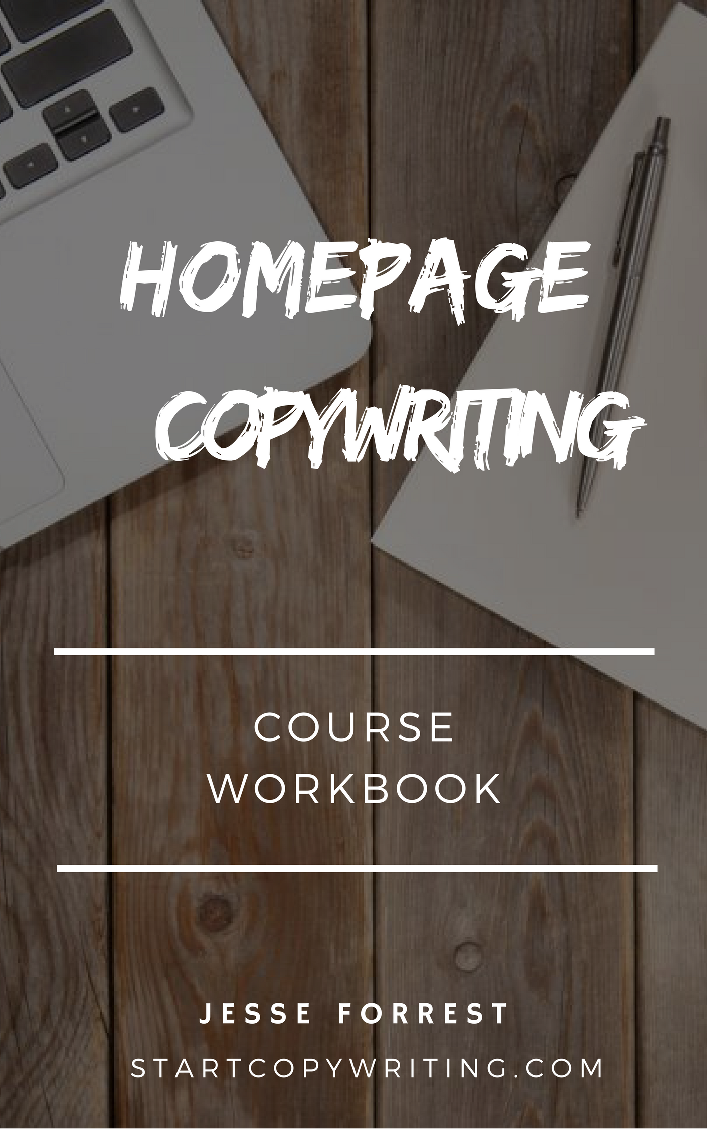

Copyright © 2017 by Jesse Forrest

All Rights Reserved. No part of this publication may be reproduced, distributed,
or transmitted in any form or by any means, including photocopying, recording, or
other electronic or mechanical methods, without the prior written permission of the publisher, except in the case of brief quotations embodied in critical reviews
and certain other noncommercial uses permitted by copyright law.
For permission requests, write to the publisher, addressed
“Attention: Permissions Coordinator,” at the address below.

Start Copywriting
1 Soi Plub Plueng
Huay Kaew Road
Chiang Mai, Thailand
50300
www.StartCopywriting.com

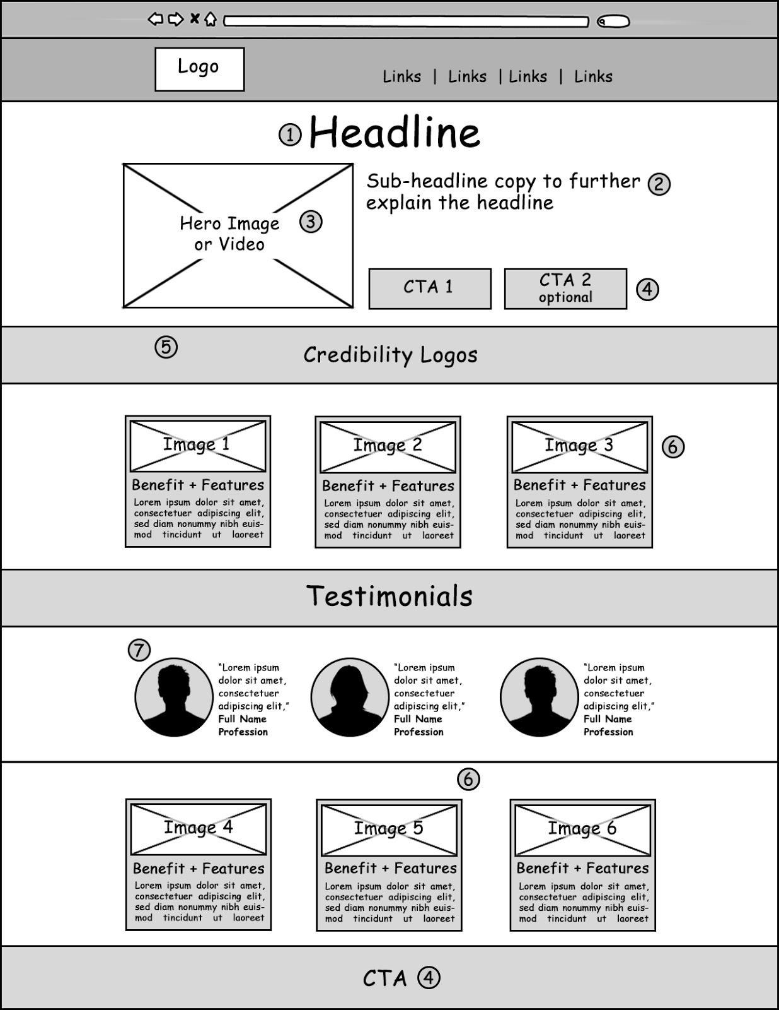

Copy Elements

1. Headline
2. Sub-Headline
3. Hero Image / Video
4. CTA
5. Credibility Logos
6. Benefits + Features
7. Testimonials

1. Headline

Purpose
Your headline is the very first thing that people will see and read. It’s critical that it clearly describes what a visitor will get from the page (its goal) and the message match is strong enough to show the visitor that they are in the right place.

Homepage headlines are different to blog post headlines because the goals are different. A blog post headline attempts to attract as many ‘clicks’ and shares as possible on social media. The goal of a homepage headline is to entice people to stay on the site.

Here are 3 formulas for writing effective homepage headlines:

1. Say what it is
2. Say what you get
3. Say what you’re able to do with it

Real World Examples
1. Video Marketing For Small Business Owners
2. Managing Your Finances Is Hard. FreshBooks Makes It Easy
3. Accounting That Makes Billing Painless

Fill in the blanks
- [What it is, i.e. Video Marketing, Accounting, etc] For [target market, i.e. Small Business Owners]
- [Problem, i.e. Managing Your Finances] Is Hard. [Business Name, i.e. FreshBooks] Makes It Easy
- [What it is, i.e. Accounting] That [benefits, i.e. Makes Billing Painless]

2. Sub-Headline

Purpose

The purpose of the sub-headline is to further expand on and clarify the headline. The second purpose is to intrigue your visitors to continue reading the page.

Real World Examples

1. The fastest way to take control of your financial life … Without declaring bankruptcy … Without borrowing extra money … and without waiting around for some real estate agent to sell your house.
2. We provide personalised strategies and structures to help you minimise tax, build wealth and protect your assets. So you can achieve your life goals.

Fill in the blanks
1. The fastest way to [Main Benefit] … Without [Problem 1] … Without [Problem 2] … and without [Problem 3]
2. We provide [Feature 1] and [Feature 2] to help you [Benefit 1], [Benefit 2] and
[Benefit 3]. So you can achieve your [Big Goal].

3. Hero Image / Video

Purpose

People are visual creatures. Images capture people’s attention quickly. The hero image is a visual representation of what your website and offer is about. Your image should visually demonstrate the benefits or results your customers receive from doing business with you. It can also show your product or service in the context of use.

If a picture is worth a thousand words then a video is worth ten thousand words. Videos are even more effective method for capturing attention and engaging your visitors. Shorter ‘explainer’ type videos work well on website homepages.

- Your image should scale down responsively.
- Use a unique image — no stock photography.
- Make sure your image doesn’t cause eye tracking confusion.

Fill in the blanks

Decide on a ‘hero image’ or ‘hero video’ that visually represents what your website and offer is about or demonstrates your main product or service being used.
4. CTA

Purpose

A call-to-action (aka CTA) is an image or line of text that prompts your visitors to take action. You need to decide what the primary and secondary action you want visitors to take is. There are a few rules you need to following when designing your homepage CTA image.

- Attention Getting Design (bright & contrasting colours)
- Action words (not ‘submit now’)
- Prominent placement (above the fold and near the footer of your website)

Real World Examples
"Free Trial"
"Get A Quote,"
"Buy Now,"
"Learn More"
“Book My Session”

Fill in the blanks

Write the copy for your homepages primary (and secondary) CTA button(s).

5. Credibility Logos

Credibility indicators can help visitors trust your website, products and services more. Social proof, awards, trust seals and recognisable brands or companies will make people more willing to trust your website.

Real World Examples
- Recognisable companies or brands
- Trust or security seals
- Award Symbols
- As Seen On TV

Fill in the blanks

Decide what ‘credibility logos’ you’ll use to demonstrate trust on your homepage.

6. Benefits and Features

Purpose

What are the products or services that should be featured on your homepage? Don’t overwhelm your visitors with too many options. When presented with too many choices most people find it difficult to make a decision.

When writing about each of your offerings, its important that you communicate the benefits the user will experience from each one, before writing about the features. The benefits describe the problem you are solving, and the features describe what it does.

Real World Examples

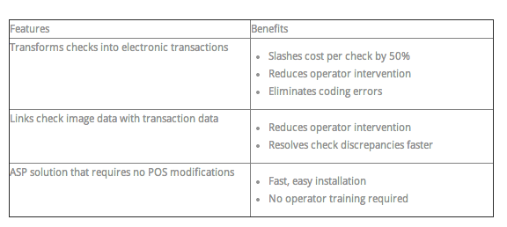

Fill in the blanks

Features (“So What?) | Benefits

7. Testimonials

Purpose

Testimonials are a powerful way to increase your credibility and trust. Adding the person’s photo, name and contact details make them appear real. The best testimonials come from authority figures or celebrities. Or are specific about the results the person achieved.

Real World Examples

Bad testimonial example

“Jesse’s workshop was really good. I thoroughly enjoyed it”
J.K

Great testimonial example

“Jesse's copy has been responsible for over $100,000 worth of sales. Needless to say I recently engaged him for yet another project and within a few short weeks I've already seen noticeable increase in sales. I know for a fact Jesse's copy works, so I'd happy recommend him to anyone."
Dale Beaumont, Australia’s most prolific author of 16 best selling books

Fill in the blanks

Decide which customers or clients you’ll contact to request a testimonial. You may even draft a testimonial on their behalf, email it to them, and ask for permission to use it.

