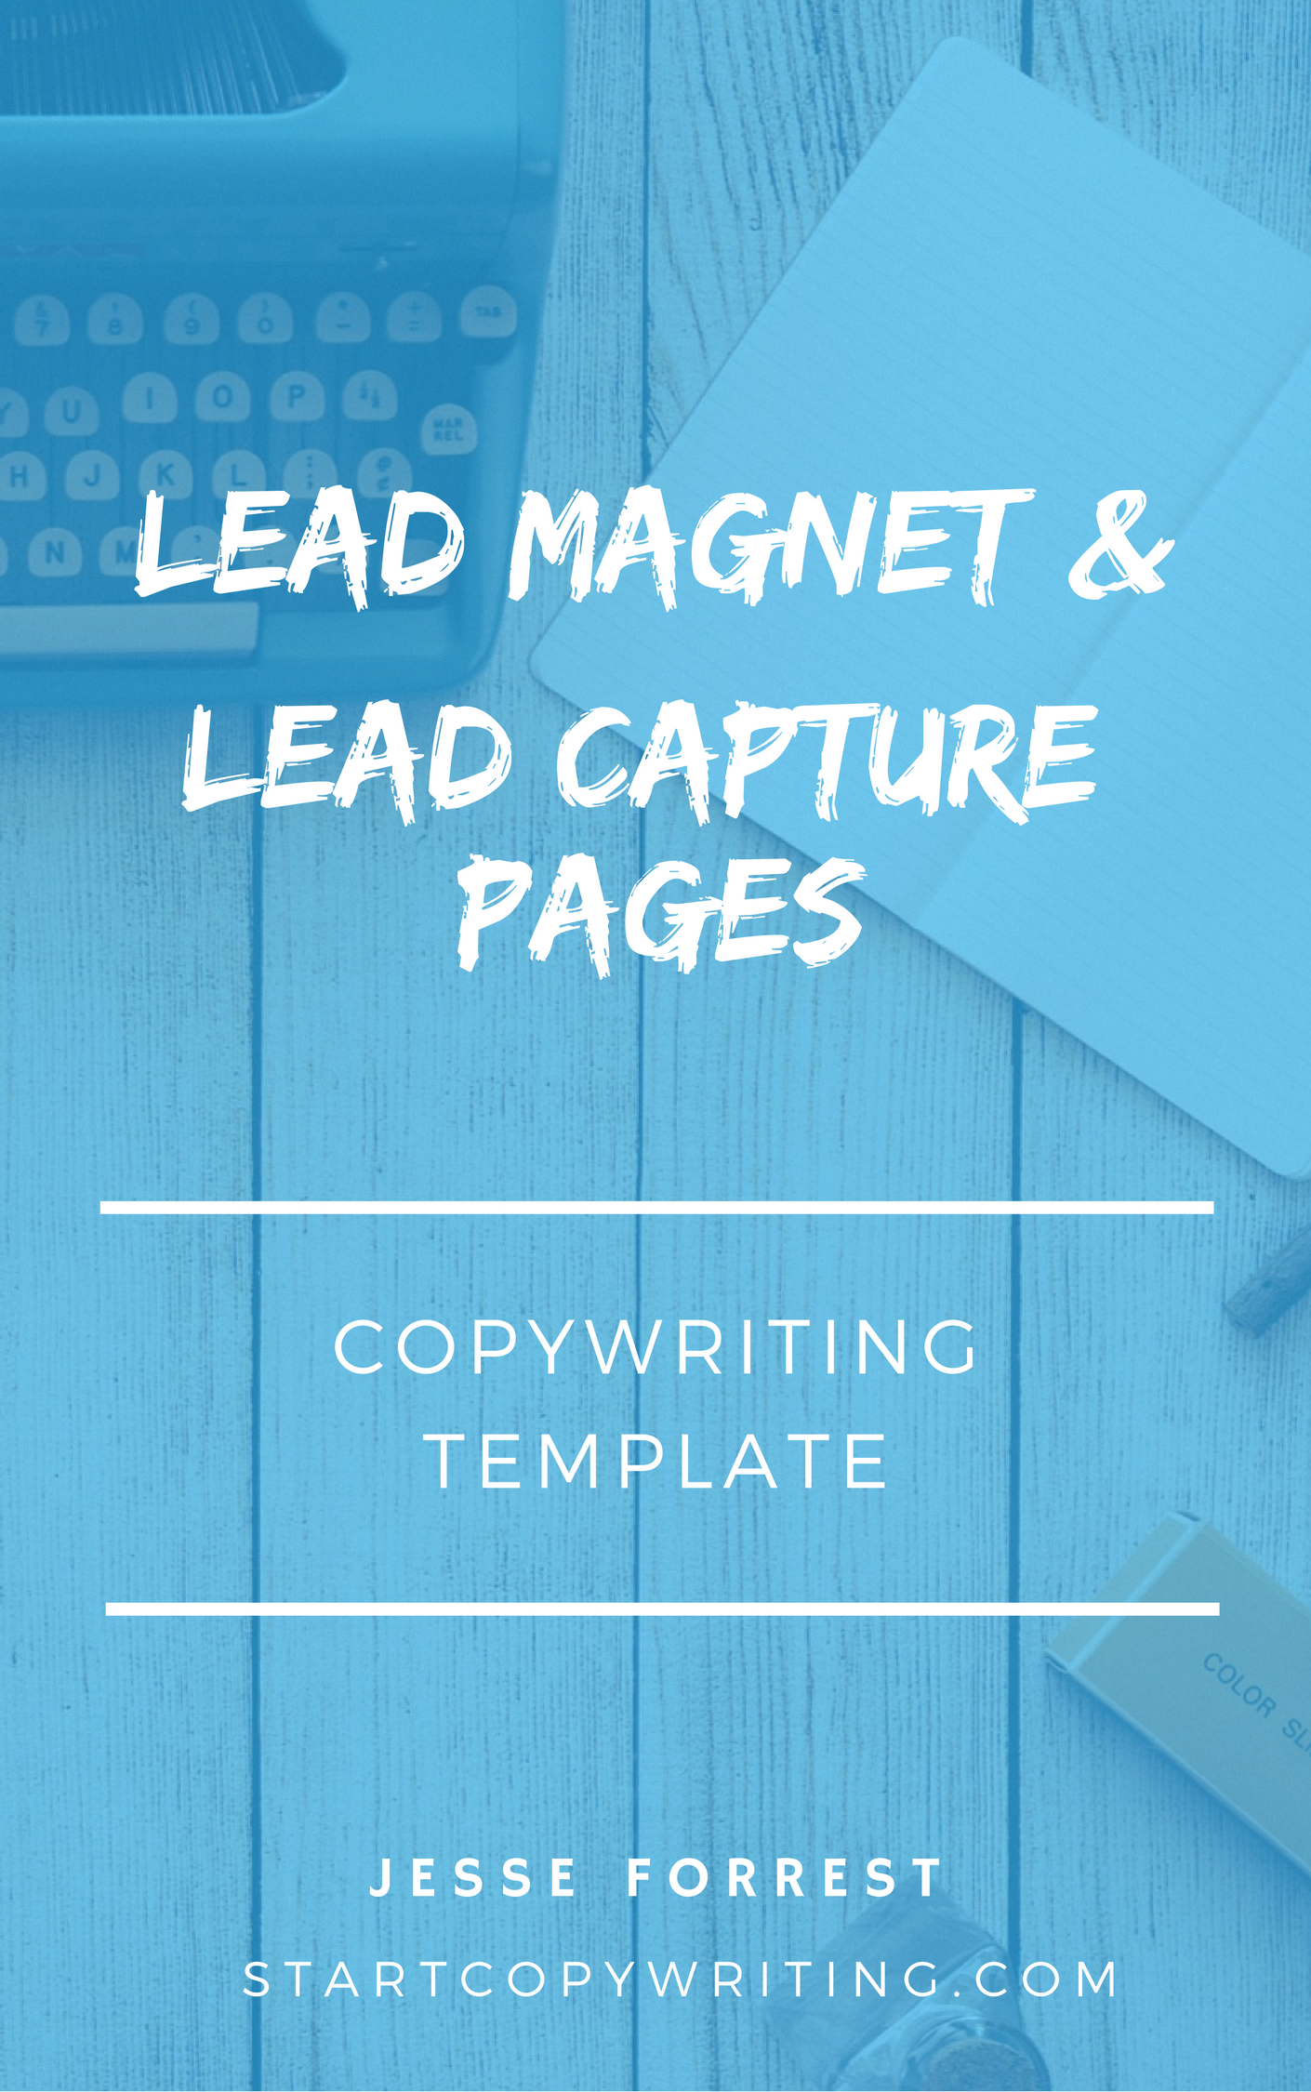

Copyright © 2017 by Jesse Forrest

All Rights Reserved. No part of this publication may be reproduced, distributed,
or transmitted in any form or by any means, including photocopying, recording, or
other electronic or mechanical methods, without the prior written permission of the publisher, except in the case of brief quotations embodied in critical reviews
and certain other noncommercial uses permitted by copyright law.
For permission requests, write to the publisher, addressed
“Attention: Permissions Coordinator,” at the address below.

Start Copywriting
1 Soi Plub Plueng
Huay Kaew Road
Chiang Mai, Thailand
50300
www.StartCopywriting.com

Welcome to the Lead Capture Page Template!
This fill-in-the-blanks template follows the Lead Capture Page course videos which have examples and best practices on how to wire a lead capture page. We recommend you watch the videos while filling in the sections of the template below.
When finished, remove all the instructions (in blue). And when you are ready to get feedback on your sales page, feel free to upload and share it within our members only Start Copywriting Academy Community.

Headline

Choose from one of the headline templates below and fill in the blanks. Then delete the other remaining headlines.

Headline option #1:

FREE [Lead Magnet Type, i.e. Report]: [Your Location and Gender, i.e. Melbourne Woman] Reveals How [He/She] [Achieved Result, i.e. Purchased 10 Properties] In Less Than [Time Frame, i.e. 10 Years]

Headline option #2:

FREE VIDEO: [Number, i.e. 10] Tips Every [Target Market, i.e. Parent] Needs To Know

Headline option #3:

Download This Free: [Number, i.e. 27] [Lead Magnet Topic, i.e. Webinar Marketing] Checklist

Headline option #4:

Learn Secrets Most [Target Market, i.e. Men] Will Never Know About [Topic Of Interest, i.e. Women And Dating]

Visual

Choose from 2 types of images you could use…

1. A digital image of the actual Lead Magnet you’re offering

2. An image of the benefits or results the Lead Magnet promises to deliver

[insert lead magnet visual here]

Web Form

Your web form should include these 4 elements:

1. Headline
2. Lead Magnet Visual
3. CTA Button
4. Privacy statement

Write your web form headline, call to action button and privacy statement using the template below...

1. Form Headline Templates
Download Your Free [Lead Magnet Type, i.e. Report, Checklist, Video, etc]
Send Me The [Lead Magnet Type, i.e. Report, Checklist, Video, etc]

3. CTA Button Templates

Send Me The [Lead Magnet Type, i.e. Report, Checklist, Video, etc]
Download Now
Get Your Free [Lead Magnet Type, i.e. Report, Checklist, Video, etc]
Now

4. Privacy statement

Your information is always secure with us and will never be shared with anyone else.

Bullet Point Examples

[Optional] Use the following examples as inspiration to write bullet points describing what people will learn from reading / consuming your lead magnet

The (number) things you must know / have
The 9 point “Checklist” you MUST go through before having your book printed.

3 things you must do if you want publishers to take your book seriously

The biggest mistake (prospects) make when trying to (benefit) and how you can avoid it.

The 7 biggest mistakes most guys make when trying to start a conversation with women that ruin their chances with her.

The biggest mistakes investors make when approaching a bank for finance.

How to (benefit) without (problem)

How to sell a truckload of your books virtually overnight without using a bookstore or a publisher (just these FREE resources).

How to turn your book into an E-book in 5 minutes! Even if you’re a computer novice

