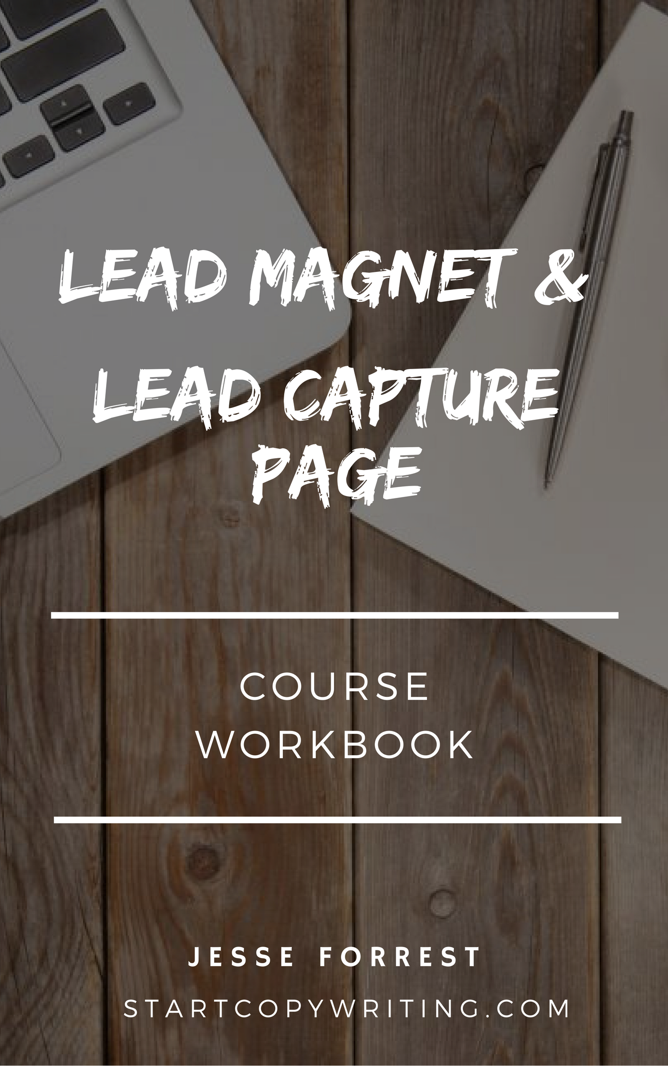

Copyright © 2017 by Jesse Forrest

All Rights Reserved. No part of this publication may be reproduced, distributed,
or transmitted in any form or by any means, including photocopying, recording, or
other electronic or mechanical methods, without the prior written permission of the publisher, except in the case of brief quotations embodied in critical reviews
and certain other noncommercial uses permitted by copyright law.
For permission requests, write to the publisher, addressed
“Attention: Permissions Coordinator,” at the address below.

Start Copywriting
1 Soi Plub Plueng
Huay Kaew Road
Chiang Mai, Thailand
50300
www.StartCopywriting.com

Lead Magnet Questionnaire

LEAD MAGNET: What type of lead magnet will you offer?
__________________________________________

BENEFITS / RESULTS: What benefits / results can people expect after going through your lead magnet?

__________________________________________

TIME: What time frame can they expect to achieve these results in?

__________________________________________

5 Important Lead Capture Page Elements

- Headline
- Visual
- Web Form
- CTA Button
- Bullet Points

Lead Capture Page Examples

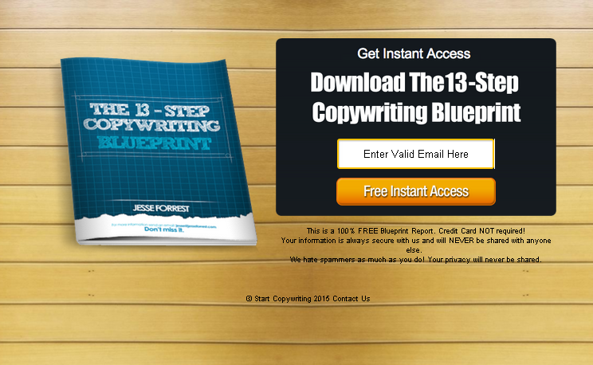

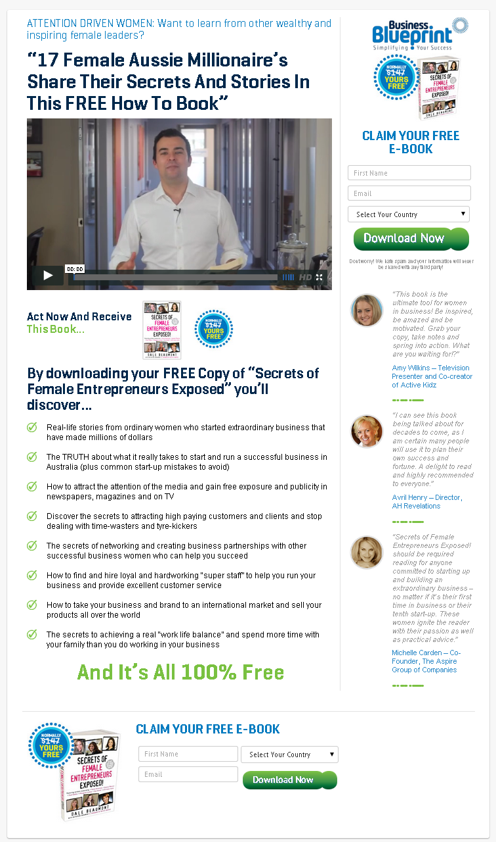Lead Capture Headlines

FREE REPORT: Melbourne Woman Reveals How She Purchased 10 Properties In Less Than 10 Years
FREE [Lead Magnet Type]: [Your Location and Gender] Reveals How [He/She] [Achieved Result] In Less Than [Time Frame]

FREE VIDEO: 10 Parenting Tips Every Parent Needs To Know
FREE VIDEO: [Number] Tips Every [Target Market] Needs To Know

Download This Free: 27-Point Webinar Marketing Checklist
Download This Free: [Number] [Lead Magnet Topic] Checklist

Learn Secrets Most Men Will Never Know About Women And Dating
Learn Secrets Most [Target Market] Will Never Know About [Topic Of Interest]

Lead Magnet Visual
Choose from 2 types of images you could use…
1. An image of the actual Lead Magnet you’re offering
2. An image of the benefits or results the Lead Magnet promises to deliver



Web Form
Your web form should include these 4 elements:
- Headline
- Lead Magnet Visual
- CTA Button
- Privacy statement

EXAMPLE #1

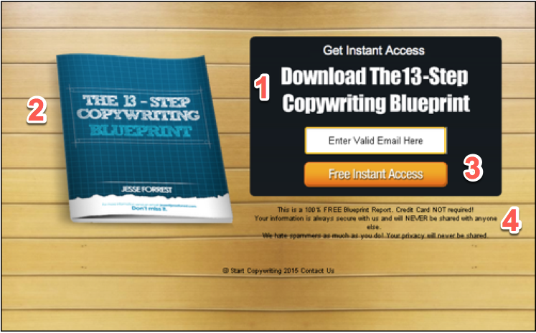

EXAMPLE #2

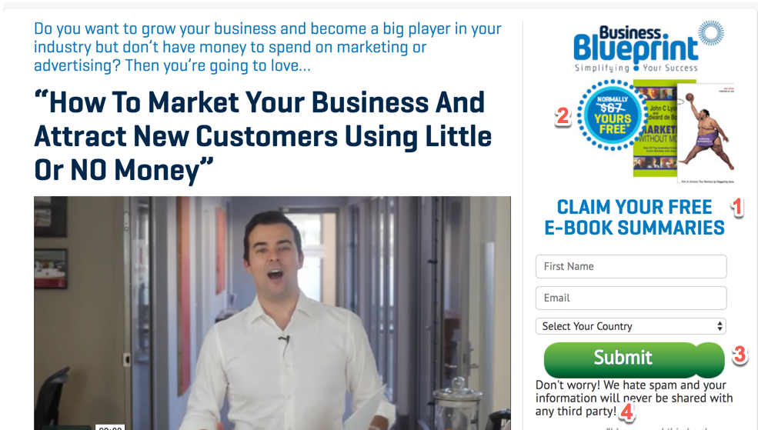

1. Form Headline Templates:
- Download Your Free __________
- Send Me The __________

2. CTA Button Templates:
- Send Me The ______
- Download Now
- Get Your Free _____ Now

Bullet Points

Exercise: Turn the example information from a lead magnet into a bullet point using any of the bullet point examples below.
EXAMPLE
“Often, when newspapers don’t have enough advertisers, they will call past advertisers and offer them space at huge discounts. You can get on the list of businesses they call by simply asking the newspaper to put you on their “distressed advertising list”. I know one person who was offered a full page of space worth $15,000 for just $400”.

The (number) things you must know / have
- The 9 point “Checklist” you MUST go through before having your book printed.
- 3 things you must do, if you want publishers to take your book seriously

The biggest mistake (prospects) make when trying to (benefit) and how you can avoid it.
• The 7 biggest mistakes most guys make when trying to start a conversation with women that ruin their chances with her.
• The biggest mistakes investors make when approaching a bank for finance.

How to (benefit) without (problem)
• How to sell a truckload of your books virtually overnight without using a bookstore or a publisher (just these FREE resources).
• How to turn your book into an E-book in 5 minutes! Even if you’re a computer novice

