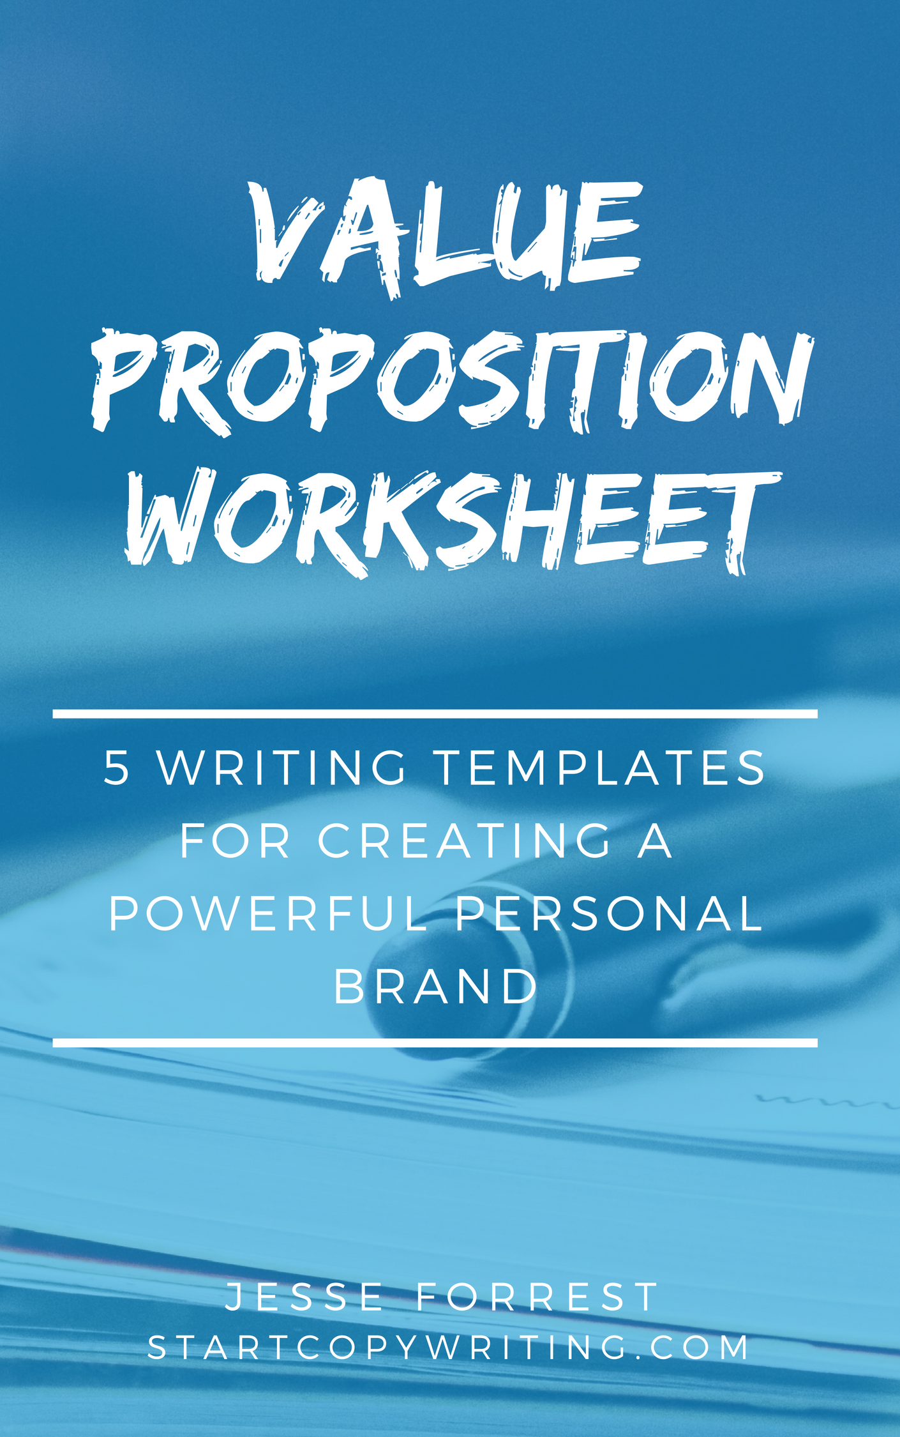

© 2018 by Start Copywriting and Jesse Forrest. All rights reserved.

This worksheet document is licensed for your personal enjoyment and use only. This worksheet may not be re-sold, duplicated or given away to other people without written permission from the publisher. For requests, please contact the publisher jesse@startcopywriting.com

Research Questions

Your value proposition should attempt to answer the following questions:
Who is your ideal target market(s)?
Target Market 1:
Target Market 2:
What problems do you help them solve?
Problem 1:
Problem 2:
Problem 3:
What benefits can they expect from working with you?
Benefit 1:
Benefit 2:
Benefit 3:
Why should people buy from you and not the competition?

Reason 1:

Reason 2:

Reason 3:

Value Proposition Templates & Examples
for Creative Businesses

Template #1:

[Business name] offers [adjective] [products / services] for
[target market], who want to [desired outcome].
Unlike other [competitors], we don’t [common problems]
[points of difference].

Example for a presentation designer

Speaker Design offers beautiful presentation design services for thought
leaders who want to captivate their audience with impactful presentations.

Unlike other designers, we don’t use cheesy stock images or generic typography.
We hand-craft every presentation with images and content that are as unique as you are.

Template #2:

Forget the [problems]. At [Business name], we offer [points of difference] for
[target audiences]

Example for a graphic designer

Forget expensive, egotistical, and slow-moving graphic designers. At Design
Frog, we offer affordable, ego-free design services with a fast turnaround for
startup founders and small business owners.

Template #3:

[We/I] help [target market] [benefit] with [our/my] [adjective] [services].

Example for a freelance copywriter
We help hardworking business owners turn more of their website visitors
into customers with our professional and affordable copywriting services.

Template #4:
[multiple points of difference] are just some of the reasons why more
[target audience] choose to work with [business name].

Example for a web designer

Unlimited support, beautiful design and free hosting are just some of the reasons
why more business owners choose to work with Big Web Design.

Template #5:

Example for a video animator

We provide [service] that [verb, i.e. brings] [benefits].

We provide video animation that brings your ideas to life, engages your audience, and communicates your unique message in a powerful way.

Website Examples Mentioned In This Class

www.CopywritingCrew.com
www.DollarShaveClub.com
www.AutomationAgency.com
www.DesignPickle.com
www.ShutterRocket.com.au

