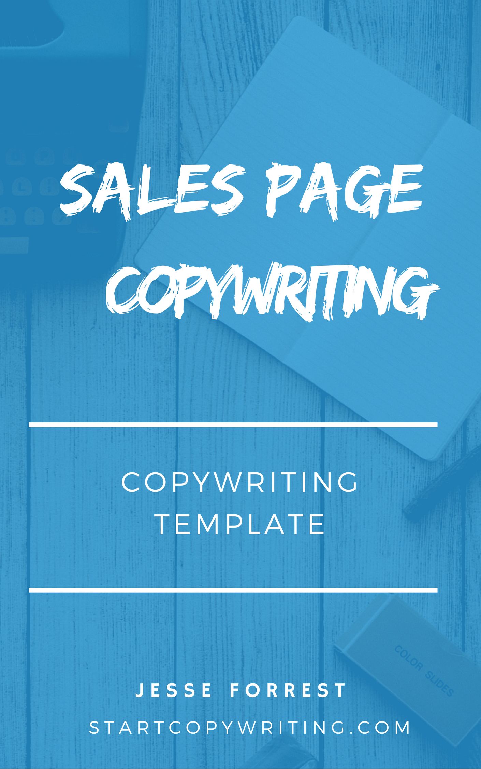

Copyright © 2017 by Jesse Forrest

All Rights Reserved. No part of this publication may be reproduced, distributed,
or transmitted in any form or by any means, including photocopying, recording, or
other electronic or mechanical methods, without the prior written permission of the publisher, except in the case of brief quotations embodied in critical reviews
and certain other noncommercial uses permitted by copyright law.
For permission requests, write to the publisher, addressed
“Attention: Permissions Coordinator,” at the address below.

Start Copywriting
1 Soi Plub Plueng
Huay Kaew Road
Chiang Mai, Thailand
50300
www.StartCopywriting.com

Welcome to the Sales Page Template!
This fill-in-the-blanks template follows the Sales Page Copywriting course videos which contain examples and tips on how to write a compelling sales page. We recommend you watch the videos while filling in the sections below.
When finished, remove all the instructions (in blue). And when you are ready to get feedback on your sales page, feel free to upload and share it within our members only Start Copywriting Academy Community.

Headline
How To [achieve benefit or result, i.e. Attract Your First Paying Client, etc] In Just [time frame, i.e. 14 Days, 30 Minutes, etc] Even If [common problem, i.e. You’re A Beginner, Have No Experience, etc]
Sub-headline
[describe what your product / service is, i.e. Business Seminar is a 2-day workshop, Eczema Cream is an all-natural skin care solution, etc] for [target audience, i.e. small business owners, eczema sufferers, etc] who want to [benefit 1 and 2, i.e. stand out in a crowded marketplace and double their sales, heal their eczema and enjoy clear and smooth skin, etc]

[Call To Action Button]

Identify The Problems

Step 1: Write 3 pain related questions that your target market are likely to answer ‘yes’ to.
Let me ask you a few important questions:
- Are you struggling to [get everything done, lose weight, etc]?
- Do you feel frustrated when [you work long hours but fail to get everything done, you eat healthy foods but fail to lose weight, etc]?
- Do you lay in bed at night worrying about [how you’re going to pay your bills, how you’re going to fit into your wedding dress, etc]?
- Have you always wanted to [start your own business, look great for summer, land your dream job, etc] but you just have no idea how to get started?

If you answered ‘yes’ to any of the above questions, then I want you to realise something. You are not alone.

Step 2: Agitate the big problem further.
Write a paragraph that describes what it’s like to have that problem
If you’re like most [target market, i.e. small business owners, aspiring photographers, eczema suffers, etc] then you’ve always dreamed of [achieving a goal, i.e. building a successful business, taking breathtaking photos, having smooth and clear skin, etc] but no matter how hard you try, it hasn’t happened, and you feel [negative emotion, i.e. depressed, like a failure, utterly disappointed, etc].
But what if you could [achieve your goals, i.e. attract a flood of new customers, become a skilled and confident photographer, heal your eczema once and for all] - without [common obstacle, i.e. spending a fortune on advertising, spending hours attending classes, using harmful drugs or injections, etc]
Here’s good news is: You can. And as you read every word of this webpage, you’re going to discover how [achieving goal] is not only possible, it’s actually easier than you may think.

Flex Your Authority

Who Is [Your Name] And
Why Should You Listen To Me?

You’re probably wondering why I am qualified to help you [main benefits i.e. improve your self image and change your life for the better, attract more sales and customers into your business, etc] so here’s my background.
I am the [position, i.e. founder, CEO, etc] of [business name] which is based in [location, i.e. Sydney, Australia] and is regarded as [claim to fame, i.e. one of Australia’s leading professional stylist companies, etc].
My qualifications are in [insert qualifications i.e. psychological science, communications and coaching, etc] and I have over [number] years of real-world experience working in the [industry, i.e. fashion, business coaching, etc] industry.
At [business name] [we / I] have helped over [number of people i.e. 500 clients, 10,000 customers, etc] to [how you helped them, i.e. improve their style and wardrobe, grow their sales and profits] which has [resulted in these benefits, i.e. boosted their self-confidence and self-esteem, given them peace of mind, helped them make better financial decisions].
[I’ve / We’ve] been fortunate enough to work with leading companies such as [insert recognisable company names here, i.e. Coca Cola, Mcdonald's, JP Morgan, etc]
[I’ve / We’ve] also been featured in the following media publications [insert online or offline media publications, i.e. Forbes, Huffington Post, PC Magazine, etc]

Introduce The Solution

[Your Product or Service Name]

- Your USP: Explain why your offer is different (and superior) to other alternatives / competitors.

[Product service name] is unlike any other [product type, i.e. skin care product, coaching program, etc] that you’ve seen or experienced before.
Unlike our competitors, we don’t [industry norm, i.e. charge you every time you call to speak with us, put harmful chemicals in our products, etc]. At [Business Name], we’re proud to be one of the few companies to [list 2 competitive advantages, i.e. guarantee results, offer free delivery and 24/7 support, use only 100% natural ingredients].

- Features and benefits: What are the biggest features and benefits that you offer? Choose from the fill-in-the-blanks templates below to turn your product or services features into benefits.

[Product or service name] is a [what it is, i.e. 2-hour interactive workshop, online coaching program, all nature skin care product, etc] designed to help [target market, i.e. small business owners] who are looking to [main benefits your target market wants, i.e. boost their self-confidence, attract more sales and customers, enjoy smooth and clear skin, etc].
With [Product or Service Name] you’ll get…
- Our [Feature, i.e. Gym is open 24/7] which means you can [Benefit, i.e. train anytime you want, even if it’s three in the morning!]
- With our [feature, i.e. Step-by-Step Training Videos] you can [Benefit, i.e. learn in your own time and at your own pace]. No more [optional secondary benefit i.e. wasting time traveling to and from classes].
- [Choose a verb, i.e. generate, get, attract, build, create] [benefit, i.e. more sales and customers] with [Feature name, i.e. our Live Chat Plugin]
- Say goodbye to [problem your feature solves, i.e. yellow teeth, etc] and hello to [benefit, i.e. sparkling white teeth] with our [feature name, i.e. Whitening Formula]

Make An Irresistible Offer
There are 3 parts to making an irresistible offer:
- Price Comparison
- Money Back Guarantee
- Bonuses

Price Comparison
How Much Does [Product or Service Name] Cost?

If you were to [more expensive alternative, i.e. sit down with me for private coaching, hire an expensive copywriter, etc] then it would cost you about [$ figure that’s higher than what your product / service costs].

Fortunately, I’m not going to charge [$ figure that’s higher than what your product / service costs] for [product / service name] even though many [target market, i.e. small business owners, parents, etc] have told me that they would happily pay much more to [enjoy clear and beautiful skin, attract more leads and customers into their stores].

As a [your profession, i.e. certified accountant, qualified personal trainer, experienced relationships counsellor, etc] it’s my mission to help as many i.e. small business owners, parents, etc] as possible. Which is why I’ve priced [product / service name] so that it’s affordable and accessible for everyone.

Your investment in [product / service name] is just [payment terms, i.e. a one-time payment, etc] of [your $ price]. Which is a fraction of what you’d pay [more expensive alternative, i.e. for private coaching, to hire an expensive copywriter, etc].

So what are you waiting for?

You can get started today by [Call To Action, i.e. clicking the add to cart button below, filling out the form below, calling us on 1800, etc].

Money Back Guarantee

100% Money Back Guarantee

You can “test drive” [product or service name] risk-free.

Here’s how: Sign up for [product or service name] today. [Describe how someone should go through your product or service, i.e. Watch all the videos in the course and take pages of notes, apply the skin care solution and feel the difference, test out the product for 30 days, etc.]

And if you’re not 100% satisfied for any reason, simply let us know within [guarantee period, i.e. 30 days, 60 days, 12 months, etc] by [contact method, i.e. sending me an email, calling us on 5551234, etc] and we will arrange a full and prompt refund, no questions asked. That's more than a guarantee, that’s my personal promise to you.

You’ve literally got nothing to lose and everything to gain. Sign up today.

Bonuses

Sign Up Today And You’ll Also Get These
[number] Special Bonuses Valued At [$ value]

Bonus #1: [Bonus name]
[A short paragraph that explain what the bonus is, what the customer receives, and why it’s valuable. I.e. Free membership to the Property Investor Club. You’ll get a full 12 months access to all of our private meetings where you can network with and learn from other successful property investors. A $xxx value - YOURS FREE]

Bonus #2: [Bonus name]
[A short paragraph that explain what the bonus is, what the customer receives, and why it’s valuable. I.e. Free membership to the Property Investor Club. You’ll get a full 12 months access to all of our private meetings where you can network with and learn from other successful property investors. A $xxx value - YOURS FREE]

Bonus #3: [Bonus name]
[A short paragraph that explain what the bonus is, what the customer receives, and why it’s valuable. I.e. Free membership to the Property Investor Club. You’ll get a full 12 months access to all of our private meetings where you can network with and learn from other successful property investors. A $xxx value - YOURS FREE].

Scarcity

Why Should You Act Now?
If you’re selling a service or your time
There are only so many hours in a day, and so many people I can physically work with! So, in order to give all of my [clients, students, customers] the [support, coaching, training, etc] they deserve, I have to limit the number of new [clients, students, customers] I take on.
So if you’re serious about [main benefit, i.e. having your bookkeeping taken care of, attracting more leads and sales, etc] then I urge you to take action and sign up today. Because if you procrastinate and come back later and my schedule is full, then I may have to put you on a waiting list.
If you’re selling a physical or digital product
Sign up today and get [Product or Service name] for the lowest price ever. Let me explain. Right now I’m conducting a marketing experiment to see how many people sign up for the low price of just [current price, i.e. $97].
Once the marketing test is over, which could be any day now, I’ll be raising the price to [increased price, i.e. $297] without warning. So if you’re reading this now, I urge you to take advantage of this experiment and claim [Product or Service name] for the lowest price ever.

Call To Action
What is the primary action you want your visitors to take on your sales page? Here are 10 proven CTA buttons to help you decide...

- [Sign Up Now]
- [Get Started]
- [Get In Touch]
- [Get Your Free Quote]
- [Request Free Quote]
- [Add To Cart]
- [Book My Seat]
- [Get Instant Access]
- [Send Me The Videos]
- [Enroll Now]

