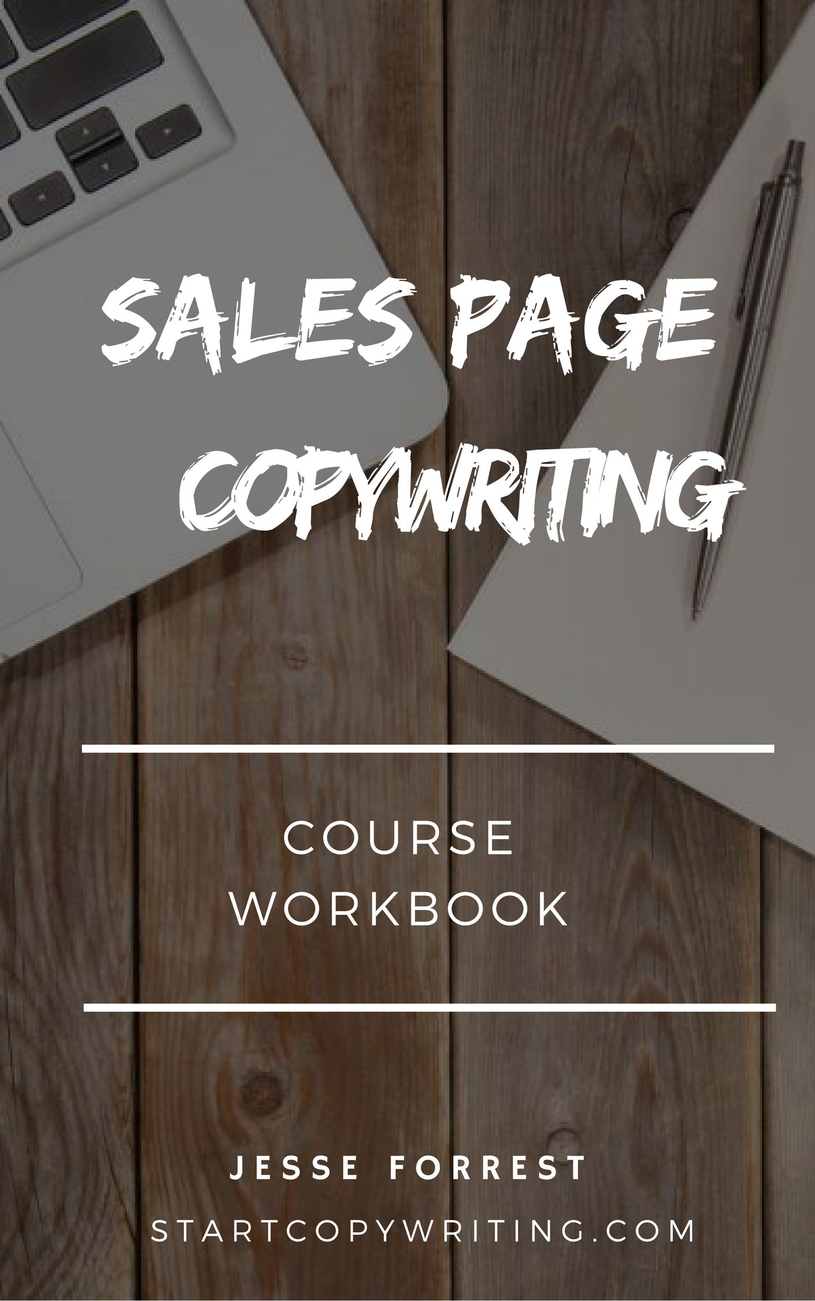

Copyright © 2017 by Jesse Forrest

All Rights Reserved. No part of this publication may be reproduced, distributed,
or transmitted in any form or by any means, including photocopying, recording, or
other electronic or mechanical methods, without the prior written permission of the publisher, except in the case of brief quotations embodied in critical reviews
and certain other noncommercial uses permitted by copyright law.
For permission requests, write to the publisher, addressed
“Attention: Permissions Coordinator,” at the address below.

Start Copywriting
1 Soi Plub Plueng
Huay Kaew Road
Chiang Mai, Thailand
50300
www.StartCopywriting.com

Copywriting Questionnaire
Answer these 8 research questions before writing copy:

- What are you selling?

- Who is your ideal prospect / customer?

- What are their biggest problems that you help them to solve?

- What do they ultimately want?

- What results / benefits do you provide?
- Why should people believe / trust you?
- What is your USP?
- What is your primary CTA?

9 Crucial Sales Page Elements

The elements you need whether your sales page is promoting a product, service, or a live event.

- Get attention with a headline
- Clarify with a sub-headline
- Identify the problems
- Flex your authority
- Introduce the solution
- Brag with testimonials
- Present your offer
- Inject some scarcity
- Repeat your call to action

Sales Page Headlines

How To Attract Your First Paying Copywriting Client In Just 14 Days … Even If You’re A Beginner
How To [achieve benefit / result] In Just [time frame] Even If [problem]

3 Wealth Strategies You Can Use To Create Multiple Streams Of Passive Income And Retire Wealthy In Just 5 Years
[number] [strategies] You Can Use To Create [benefit 1] and [benefit 2] In Just [time frame]

Managing Your Finances Is Hard. FreshBooks Makes It Easy.
[problem] Is Hard. [your product/service] Makes It Easy.

Sub-Headlines

The purpose of the sub-headline is to further expand on and clarify the headline.

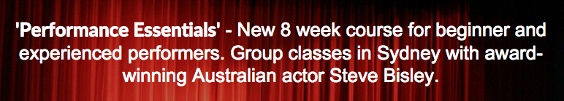
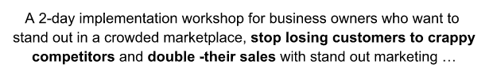

Sub-Headline Template
[say what it is] for [target audience] who want to [benefit 1] and
[benefit 2]

Identify The Problems

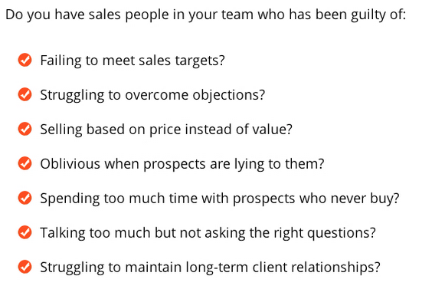

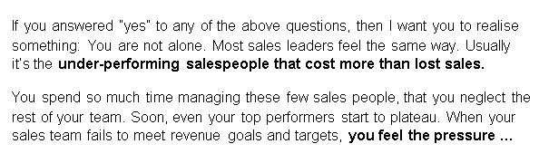

Step 1: Write 3 pain questions …
Let me ask you a few important questions:
- Are you struggling to __________?
- Do you feel frustrated when ______?
- Do you lay in bed at night worrying about ________?

Step 2: Agitate the big problem further
Choose the biggest problem and write a paragraph that describes what life is like to live with that problem.

Flex Your Authority
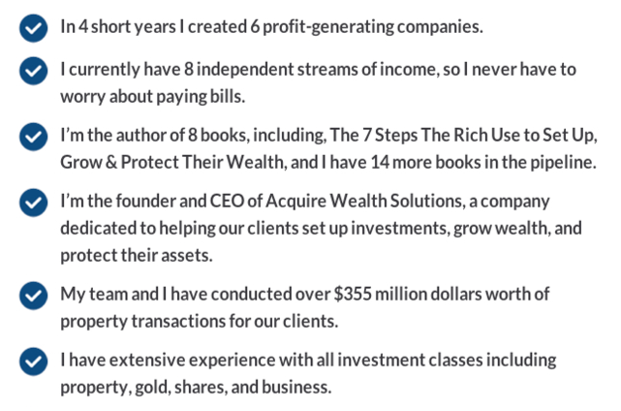

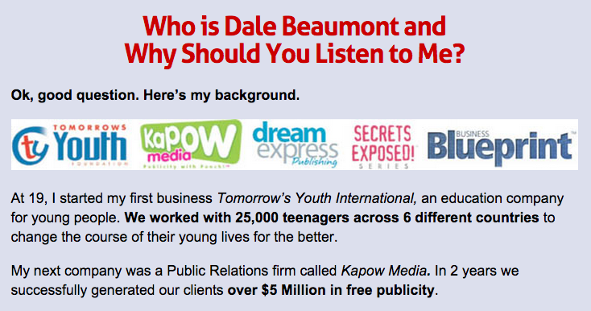

Flex Your Authority Template

Write a bullet point list of …
- Your achievements in business
- Media appearances (articles and TV)
- Your qualifications and credentials
- Years you’ve been in business
- Number of customers you’ve served

Introduce The Solution

- Your USP: Explain why your offer is different (and superior) to other alternatives / competitors.

- Features and benefits: What are the biggest features and benefits that you offer?

Make An Irresistible Offer
There are 3 parts to making an irresistible offer:
- Price Comparison
- Free Bonuses
- Money Back Guarantee

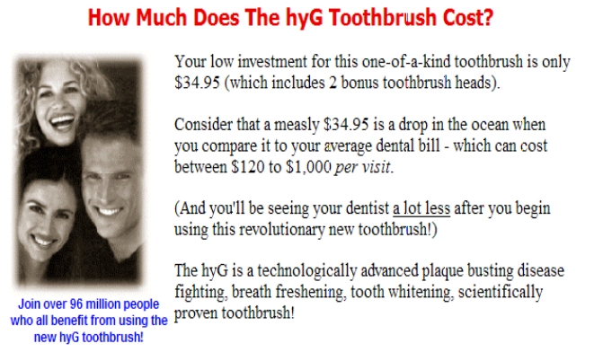

Scarcity Example

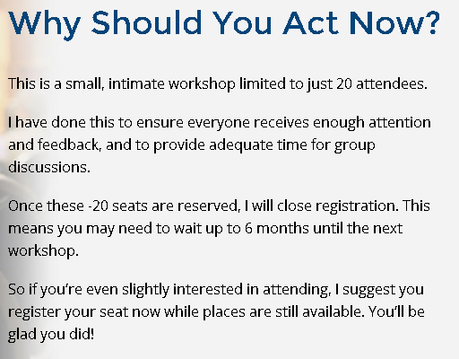

Call To Action

A call-to-action (aka CTA) is an image or line of text that prompts your visitors to take action.
- Attention Getting Design (bright & contrasting colours)
- Action words (not ‘submit now’)
- Prominent placement (above the fold and near the footer of your website)
What is the primary action you want your visitors to take?

