Magnets
Lesson Plans for Grades 2 and 3

If you have a Studies Weekly teacher account, please log in to access the videos and articles mentioned in the lesson plan. If you do not have a Studies Weekly teacher account, or you do not have access to the publication listed, please be our guest and use our demo account. To access your state materials you will need to use the two-letter U.S. Postal code for your state followed by ‘teacher.” To log in with a demo account:
- Go to http://www.studiesweekly.com/online
- Username example: TXteacher (for Texas teacher access), UTteacher (for Utah teacher access), etc.
- Password: demo

Materials List:
- Projector or Smart Board
- Video - Magnets
- Chart paper
- Markers
- Magnets
- String or yarn (14 inch segments, 1 segment for each pair)
- Tape
- Pencils
- Buckets or containers
- Objects attracted to magnets (i.e. paperclips, staples, binder clips, AA batteries, etc.)
- Objects not attracted to magnets (i.e. toothpicks, popsicle sticks, water bottle caps, soda tabs, etc.)
(Extension activity materials)
- Pencils
- Crayons
- Manila paper
- Magnets (with adhesive)
- Paperclips or other small magnetic items

Approximate time the lesson will take not including the video:
- 30 - 45 minutes
Balanced Literacy Format:
- Shared Reading
- Independent Writing

Lesson Presentation Format:
- Whole group and/or small cooperative groups

Specific strategies:
- Observing
- Listening
- Experimenting
- Writing
- Presenting
- Building Academic Vocabulary
- Using domain-specific vocabulary correctly and in context

Activity:
- Using your projector or Smart Board, do a Shared Read Aloud of the article, “Magnets” found in Second Grade Science, Week 23, “Physical Science - Forces.”
- As a class, discuss magnets and create a class web of different ways magnets are used. Clarify any unfamiliar vocabulary.
- Introduce the video, Magnets. As a whole class, watch the video and have the students listen for different uses of magnets. Add to the class web any new uses for magnets that students learned from the video.
- Introduce the activity, Fun with Fishing, to your class.
  - Divide the students into pairs or small cooperative groups.
  - Tell the students that they will make one fishing pole per group using a pencil, string, and magnet. (Tape can be used to make sure the string stays in place on the pencil, if necessary.)
  - Give a bucket to each group and have them go on a scavenger hunt around the classroom and add items they think might be attracted to a magnet. They can select items from their own desks first, and then go to containers of items that you have set out around the classroom. (You can have certain items readily available. i.e. erasers, paperclips, staples, binder clips, AA batteries, tabs from soft drink cans, water bottle caps, toothpicks, popsicle sticks, nuts, bolts, screws, etc.)
  - After students have collected items, they will return to their desks or work areas and take turns fishing for items. It is important that each student has the opportunity to participate.
  - Students will write down their observations in two columns: Magnetic and Non-magnetic.
- Students will present their findings to the class, including any results that might have surprised them.
Differentiated Instruction:
- Students who have difficulty presenting can be paired with students who enjoy presenting.
- Students can also present to a different pair or small cooperative group.

Extension Activity:
- Have students create a pop-up book to compare and contrast magnetic and non-magnetic items. Students should write their observations in complete sentences. They can also choose to place an adhesive magnet on the pop-up tab instead of a picture and place a small magnetic object on it.
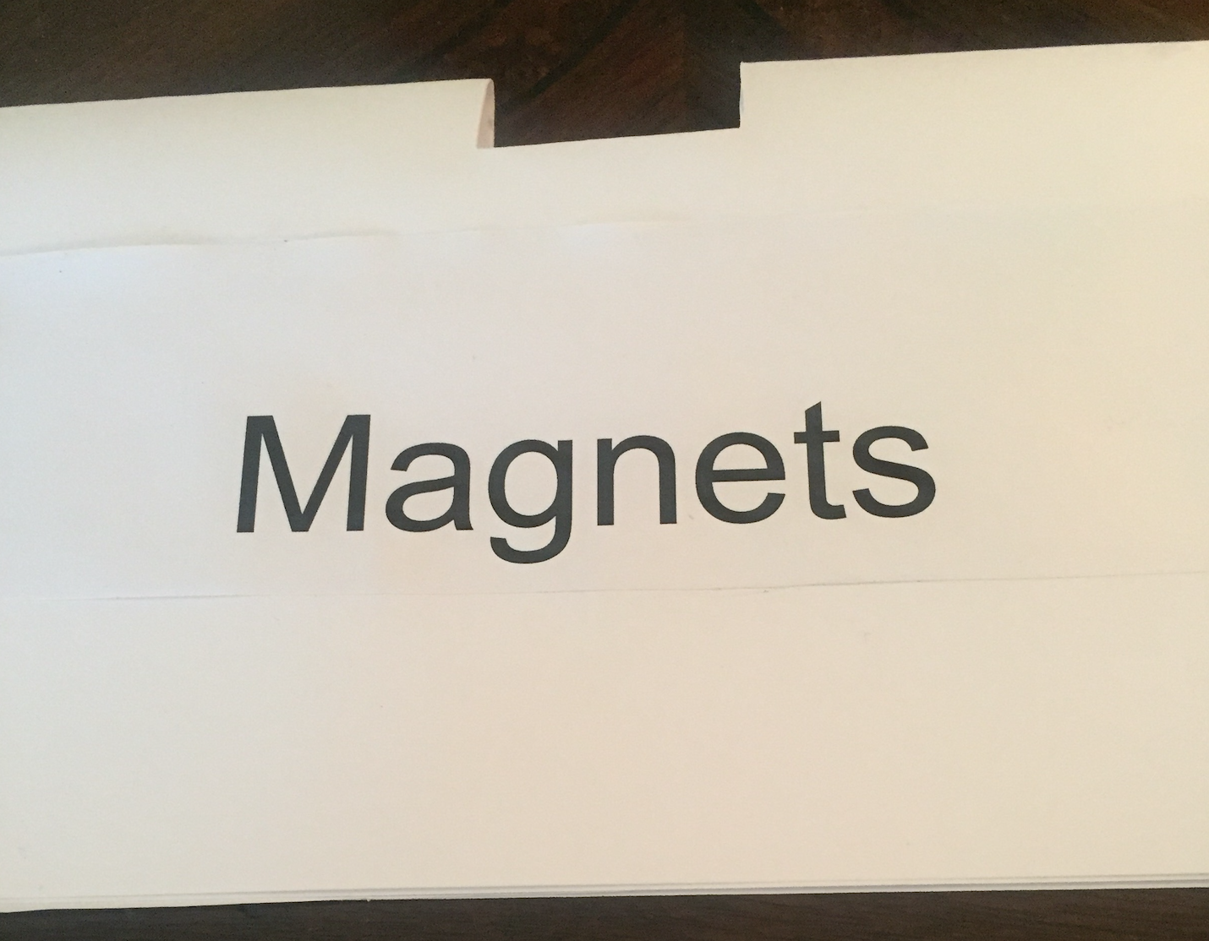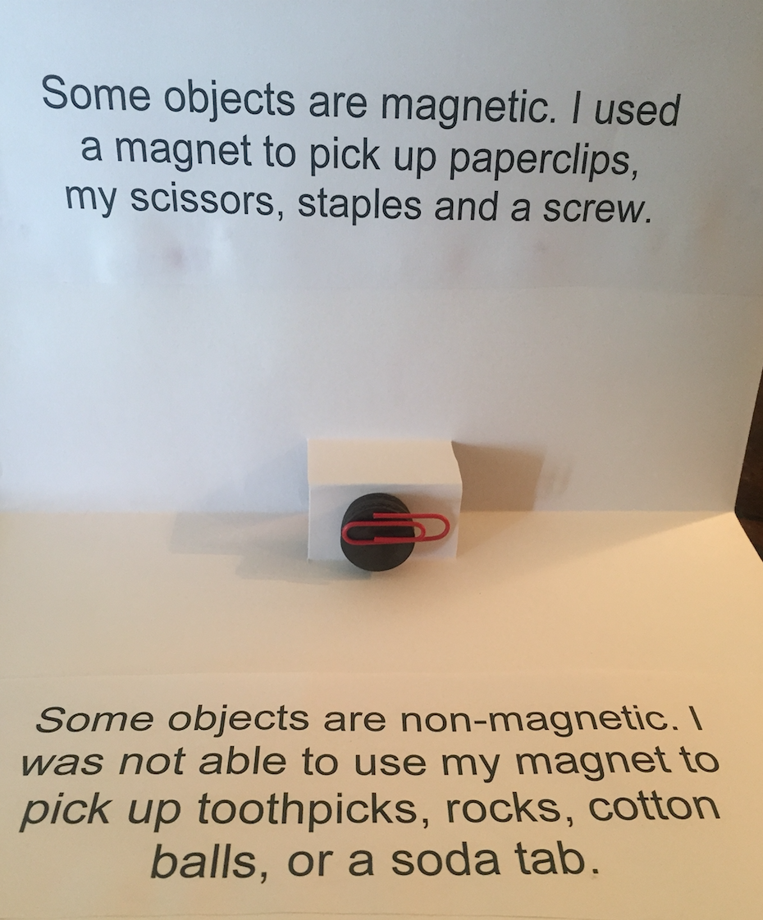

Quiz:
- Magnets can be used
  - to make electricity.
  - in medical equipment such as an MRI.
  - both a and b
- The earth has its own __________ force.
  - magnetic
  - non-magnetic
  - directional

Answer Key/Complexity Level:
- C Low/2
- A Low/2

