Prospect Attraction Tool to Nurture

Email #1
Subject: Members are canceling…

Hey John,
It's one of the issues we don't like when it comes to running a membership business...
Members canceling!
Sometimes cancellations can feel personal, as if you did something wrong.
Sometimes cancellations cause you to doubt the value of what you provide.
Sometimes cancellations cause you to wonder if your pricing is just right.
When you start that downward spiral, you begin to make decisions based off of bad information. And then you do even more damage to your membership business.
But I've got GOOD NEWS.
You can get your FREE copy of "Why People Quit Your Membership Program & What You Can Do About It."
Click here to download your FREE copy now!
You'll get many tips and tools that I've personally used to grow a membership business from 72 to over 3,000 members, personally handling cancellation requests and training staff members and other membership businesses to do the same.
There are no forms to fill out, just click the link and you'll be taken to the page to download it.
In this free strategy guide you will discover:
- Eleven reasons why people quit and what you can do about it
- The one reason why YOU SHOULD let a member quit
- Four ways to keep members from even thinking about quitting
- Six tools you can quickly implement to improve your membership program
- How to increase retention and offer opportunities for ascension and descension in your membership program.
Click here to download your FREE copy now!
My goal is to help you get new members, increase retention and keep people from quitting.
Enjoy!
Scott
If you're ready to multiply your membership and money, here are three more ways we can work together!
1. Get a FREE copy of Accelerate: How to Get Your Next 10, 100, 500 or Even 1,000 Members... Yes, you can get a free copy of my brand-new book! In it, you discover more on how to promote your membership, get more members and increase retention. Kim wrote the foreword - you'll discover more about her membership.
Click here to get your free book now!
2. The Membership Accelerators Club... This is the place for membership businesses looking for marketing tools that you can plug and play to get more members. Literally, these tools will help you promote your program and get more members. Click here to learn more now (and get the 4-Day Membership Generator!)
3. Have you subscribed to the More Members Now Podcast? Every episode includes practical tips and tools to use in your membership or association. Plus, you can get over $472.67 in free resources. Listen to the latest podcast here - www.MoreMembersNowPodcast.com
4. Are you interested in growing your membership by 300% in the next 12 months? If you're looking to get more members in a week than you did all month and you're tired of "sending and hoping" people will sign up...just REPLY to this message and put “Private” in the subject line... tell me a little about your membership and what you’d like to work on together, and I’ll get you all the details!

Scott Whitaker, Founder
Membership Multipliers

Prospect Attraction Tool to Nurture

Email #2
Subject: Is this your number #1 stressor too?

Hey John,
Every membership business I know juggles a lot of things… but the number 1 stressor?
Cancellations (i.e. membership churn)
Would you agree?
Because if you can't keep members from quitting, you're a rat on the wheel just trying to keep up, replacing cancellation after cancellation…
Then it's time to take the rose-colored glasses off. Time for the honest truth. If you don’t have the stomach for it or want to pretend for a while longer that you can survive if you continue as you have been, you may want to click away right now.
Here is the honest truth: Most membership businesses don't have a cancellation strategy.
But I've got GOOD NEWS.
You can get your FREE copy of "Why People Quit Your Membership Program & What You Can Do About It."
Click here to download your free resource now.
You'll get many tips and tools that I've personally used to grow a membership business from 72 to over 3,000 members, personally handling cancellation requests and training staff members and other membership businesses to do the same.
There are no forms to fill out, just click the link and you'll be taken to the page to download it.
In this free strategy guide you will discover:
- Eleven reasons why people quit and what you can do about it
- The one reason why YOU SHOULD let a member quit
- Four ways to keep members from even thinking about quitting
- Six tools you can quickly implement to improve your membership program
- How to increase retention and offer opportunities for ascension and descension in your membership program.
Click here to download your free resource now.
My goal is to help you get new members, increase retention and keep people from quitting.
Enjoy!
Scott
If you're ready to multiply your membership and money, here are three more ways we can work together!
1. Get a FREE copy of Accelerate: How to Get Your Next 10, 100, 500 or Even 1,000 Members... Yes, you can get a free copy of my brand-new book! In it, you discover more on how to promote your membership, get more members and increase retention. Kim wrote the foreword - you'll discover more about her membership.
Click here to get your free book now!
2. The Membership Accelerators Club... This is the place for membership businesses looking for marketing tools that you can plug and play to get more members. Literally, these tools will help you promote your program and get more members. Click here to learn more now (and get the 4-Day Membership Generator!)
3. Have you subscribed to the More Members Now Podcast? Every episode includes practical tips and tools to use in your membership or association. Plus, you can get over $472.67 in free resources. Listen to the latest podcast here - www.MoreMembersNowPodcast.com
4. Are you interested in growing your membership by 300% in the next 12 months? If you're looking to get more members in a week than you did all month and you're tired of "sending and hoping" people will sign up...just REPLY to this message and put “Private” in the subject line... tell me a little about your membership and what you’d like to work on together, and I’ll get you all the details!

Scott Whitaker,
Author & Founder of Membership Multipliers

Prospect Attraction Tool to Nurture

Email #3
Subject: The real reason(s) why your members quit..

Hey John,
This week, you’ve had the opportunity to get a FREE copy of "Why People Quit Your Membership Program & What You Can Do About It."
Today is your last chance!
Click here to download your free resource now.
There’s so much competing for your members and so much going on in the personal life and business of your members that even the slightest interference can cause your members to quit.
Do you have a plan? Do you know what to do? What to say?
People quit your membership when they’re:
- In trouble
- In transition
- Under tension
They need your help to get over the barriers they’re facing.
You just need to know what to say and do.
If you’re ready to keep people from quitting your membership and multiply your money, then pick up your FREE copy of "Why People Quit Your Membership Program & What You Can Do About It."
Click here to download your free resource now.
You'll get many tips and tools that I've personally used to grow a membership business from 72 to over 3,000 members, personally handling cancellation requests and training staff members and other membership businesses to do the same.
There are no forms to fill out, just click the link and you'll be taken to the page to download it.
But you must do so today!
My goal is to help you get new members, increase retention and keep people from quitting.
Scott
If you're ready to multiply your membership and money, here are three more ways we can work together!
1. Get a FREE copy of Accelerate: How to Get Your Next 10, 100, 500 or Even 1,000 Members... Yes, you can get a free copy of my brand-new book! In it, you discover more on how to promote your membership, get more members and increase retention. Kim wrote the foreword - you'll discover more about her membership.
Click here to get your free book now!
2. The Membership Accelerators Club... This is the place for membership businesses looking for marketing tools that you can plug and play to get more members. Literally, these tools will help you promote your program and get more members. Click here to learn more now (and get the 4-Day Membership Generator!)
3. Have you subscribed to the More Members Now Podcast? Every episode includes practical tips and tools to use in your membership or association. Plus, you can get over $472.67 in free resources. Listen to the latest podcast here - www.MoreMembersNowPodcast.com
4. Are you interested in growing your membership by 300% in the next 12 months? If you're looking to get more members in a week than you did all month and you're tired of "sending and hoping" people will sign up...just REPLY to this message and put “Private” in the subject line... tell me a little about your membership and what you’d like to work on together, and I’ll get you all the details!

Scott Whitaker,
Author & Founder of Membership Multipliers

Sales Sequence

Email #1
Subject: and then this happened

John, the other day I heard from Crystal Thies who really needed help.
She just lost her biggest paying member, hadn't picked up a new member in months and it was causing her to lose money, provide less for her members and keep her membership from growing.
She was afraid that she would continue to lose money, her membership would continue to decline and she would have to go back to her old job. She definitely didn't want to shut down her membership.
Luckily, after chatting with me briefly she realized that she could triple her membership and get more members paying her more money.
I realized that there may be a number of people that are either in a similar situation or know someone who is, which is why I created the “4-Day Membership Generator.”
The toolkit not only eliminates the decline of your membership but it will literally get you more members in 4 days than you do all month.
So, if you or anyone you know is interested in tripling your membership simply click here for all the details.
Let’s multiply your membership,
Scott
P.S. I’ve put together a special on this that’s only good for the next three days. You’ll get everything when you click here but this does end on Friday, September 27th.

Scott Whitaker,
Author & Founder of Membership Multipliers

Sales Sequence

Email #2
Subject: [Contact First Name], you ready?

John, are you ready to get more members in 4 days than you do all month?
Fill in the blank -> More members = __________________
What goes in the blank for you?
Is it:
- More IMPACT
- More MONEY
- More FREEDOM
- More EFFECTIVENESS
- More MEANING
Which is it for you?
Here are just some of the results that people have gotten from the “4-Day Membership Generator.”
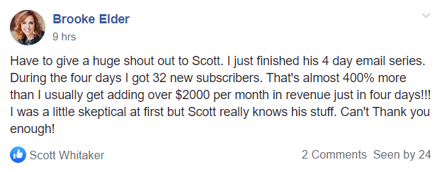
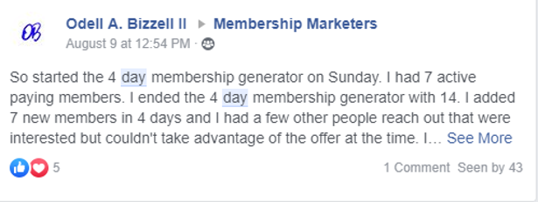
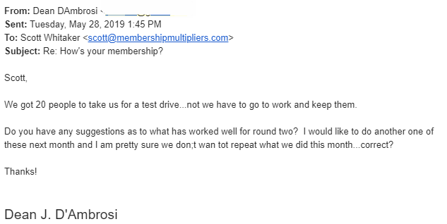

Here’s everything you get when you purchase the “4 Day Membership Generator”:
- A special hands-on training from me explaining exactly how to use this tool to skyrocket your membership growth without spending a dime on advertising. We’re using your most important asset - people who have already expressed interest in your membership! ($250 Value)
- The complete email campaign that you’ll simply fill in the blanks to create your very own unique email sequence that will having your leads flocking to your membership en masse. ($500 value)
- A very special bonus of my Million Dollar Membership Swipe File that gives you a behind the scenes look at how to grow a Million dollar membership. I put this together with internet marketing ninja Kim Walsh-Phillips - the value in this bonus alone is reason enough to buy! (Priceless - this is top secret, your eyes only information you won’t find anywhere else).
This opportunity ENDS MIDNIGHT, TOMORROW, Friday, September 27th.
And once the deadline hits, it’s over.
Click here to get your copy and get all the bonuses!
Let’s increase your membership,
Scott
P.S. You’ve got nothing to lose. You have my promise! Go through the 4-Day Membership Generator and if you don’t get any members, let me know and you will get an immediate refund.
Just click here and let's get you more members in 4 days than you do all month!

Scott Whitaker,
Author & Founder of Membership Multipliers

Sales Sequence

Email #3
Subject: Swipe File - Million Dollar Membership [Disappears at Midnight]

John, For the past couple of days, I’ve been telling you how you can get more members in 4 days than you do all month.
Today though you’re going to get the best news yet.
When you invest in the “4 Day Membership Generator” by midnight tonight, you’ll not only get everything you need to triple your membership, but you’ll get something I’ve NEVER offered before.
Through midnight tonight, when you click here and get started you’ll also get my Million Dollar Membership Swipe File that gives you a behind the scenes look at how to grow a Million dollar membership.
This swipe file contains the best of the best from some of my private clients - the value in this bonus alone is reason enough to get your 4 Day Membership Generator! You won’t find anywhere else.
Anyhow, if you’re interested in getting more members, helping more people and you want the Million Dollar Membership Swipe File then CLICK HERE before this offer disappears at midnight.
Let's multiply your membership!
Scott
P.S. Please don’t call me, write me or find me on social media after midnight begging to get this deal. I believe in 100% integrity and I can’t do anything that goes against that. So if you want “4 Day Membership Generator" and the Million Dollar Membership Swipe File be sure to click here now.

Scott Whitaker,
Author & Founder of Membership Multipliers

Sales Sequence

Email #4
Subject: bad news... :-(

Yes, I've got some bad news... :(
Tonight at MIDNIGHT the investment for the “4 Day Membership Generator” DOUBLES!
Plus, you'll miss out on the FREE bonus - The Million Dollar Membership Swipe File!
Last time I told people we were going to double prices, and I don't think they believed me. The next day we got hundreds of emails from angry people who missed out.
This is the deal... I've been talking about the 4 Day Membership Generator for the last couple of days.
NOW is the time to take the leap of faith...
This resource will be a turning point in your ability to get members to sign up for your membership and grow your membership.
But only if you pick it up.
If you try to sign up tomorrow, the price will have DOUBLED...
Do yourself a favor, and go get your copy NOW!
Together, let’s get you more members in 4 days than you do all month!
Scott
P.S. You’ve got nothing to lose. You have my PROMISE! Go through the 4 Day Membership Generator. If you don’t get any members, let me know and you will get an immediate refund.
Just click here to get your copy now.

Scott Whitaker,
Author & Founder of Membership Multipliers

Event Promotion

Email #1
Subject: bad news... :-(

Hey John,
Time is running out for you to save $300.00 and get the Super Early Bird rate for the Triple Your Membership Incubator in Atlanta, GA on October 8-9.

[Use www.Giphy.com]
We just added my good friend, Kim Walsh Phillips as a guest speaker.
Kim is an expert at building audiences, getting prospects and turning those prospects into raving members.
During the event, she's going to share with you some of her best kept secrets on building your list, including:
- Uncover audiences by identifying the 7 places your PERFECT prospects already gather.
- Rally your tribe with the 12-month media plan to attract thousands of raving fans and expertly position yourself as THE authority in your field.
- Unleash your power monetizing your message doing things that you love choosing the BEST way for you.
Click here to secure your spot!
By the way, her company was just recently named by Inc Magazine as one of the fastest growing membership businesses (ranked #475!)

Plus, I'm going to share with you:

It’s a set of three unique metrics that tell me which of my proven membership offers is needed to crank-up your membership sign-ups.
And it’s extremely simple...
So simple, it removes all the mystery and guesswork from the process of getting more members from every promotion.
The FAST AND EASY part for you...
Applying the The 3X Formula™ to your marketing does NOT require you to change the price of your membership, add a new membership level or change anything you're currently providing with your membership.
So, you're able to see the financial impact in just days, instead of weeks or months.
That's why I use the The 3X Formula™ every month to get more members in my own Membership Accelerators Club and Membership Multipliers.
The same ones you see me using everyday to get hundreds of new members.
And, I also use it on my private clients, some paying me upwards of $20K a year in my Membership Mastermind™ and with VIP Members who invest $10,000 for just one day with me.
Click here to secure your spot now and save $300.00 with the Super Early Bird Rate!
I look forward to seeing you in Atlanta!
Scott
P.S. One more thing, after the Super Early Bird Deadline passes, so does the convenient 3-pay option. So if need to break your registration into 3 investments, now is the time.
This will lock you in at the Super Early Bird rate with $1997.00 in bonuses!
Click here to learn more!

Scott Whitaker,
Author & Founder of Membership Multipliers

Event Promotion

Email #2
Subject: have any questions?

Hey John,
Tomorrow, Friday, Aug 30th is your last chance to save $300.00 and get the Super Early Bird rate for the Triple Your Membership Incubator in Atlanta, GA on October 8-9.


[Use www.Giphy.com]

>>Go here to secure your spot.
Some people have been asking questions about the event and I realize that you may be wondering the same questions.

What questions might you have?

Will I really be able to grow my membership if I attend the event?
Yes! For the past couple of years, I've been doing these events with private clients in a VIP Day. Lately, I've moved to doing them in a small group setting like this. You will get members as a result of our time together.
Will it be worth my time and money?
There's a saying, "money buys speed." This event is proven to get you members more quickly and that recurring revenue will more than pay for the event. For some, they'll make their investment back within a month and others, quite honestly can pay for the event BEFORE they even attend by using the BONUS: Triple Your Membership In 21 Days Toolkit ($997.00 value.)
Where is the event?
The event will be held in Atlanta, GA. There's a convenient flight to Atlanta from any major city. (That's what makes it the largest airport in the US.)
Can I bring a guest?
Not only can you bring a guest, but you can bring a guest for FREE! You're going to be blown away by what you discover at the event. I want to make sure you have someone else there who can help you when you get back home.
Why are you limiting the number of attendees?
This isn't some marketing trick. I've done these types of events and I know how many people I can effectively help. You will have me working on your membership with you. We're not going to "increase the room size," "open up more space," or "add more spots." There are just 12 seats left. When they're gone they're gone!
Are there discounted hotel rates?
Yes, we've been able to secure a discounted rate at the host Marriott Hotel. You're more than welcome to stay there or choose a nearby hotel.
Here's my question for you:
When is the last time you were around other membership businesses working toward the goal of doubling or even tripling your membership?
I get it. There's no other event like this. So, in many respects, you're walking into the unknown. But many times that step of faith is just what is needed so that you can break the barriers that are keeping you and your business from growing.
So, let's do this... for you and for your members! There's no need to put it off any longer and lose out on the Super Early Bird Rate, saving you $300.00.
Click here to secure your spot now and save $300.00 with the Super Early Bird Rate!
I look forward to seeing you in Atlanta!
Scott
P.S. Still have questions? Feel free to reply to this email and let me know.
P.P.S. One more thing, after the Super Early Bird Deadline passes, so does the convenient 3-pay option. So if need to break your registration into 3 investments, now is the time.
This will lock you in at the Super Early Bird rate with $1997.00 in bonuses!
Click here to learn more!

Scott Whitaker,
Author & Founder of Membership Multipliers

Event Promotion

Email #3
Subject: [Contact First Name], are you in?

Today is the deadline to get in on the Super Early Bird Deadline and save $300.00 on the Triple Your Membership Incubator in Atlanta, GA on October 8-9.

[Use www.Giphy.com]
>>Go here to secure your spot.

Your Entire Membership Will Be Transformed…
Because once we triple your membership…
- You'll find it easy to get more prospects... because you have the extra cash to do more marketing!
- You'll have a proven process to get your prospects to engage... leading them to sign up for your membership at twice the speed!
- You'll no longer be stressed about finding new prospects... because you'll have a constant flow of new prospects coming in!
- You'll be dominating your market... because new members stay far longer with you than your competitors!
- You'll be growing your membership at twice the speed... because you can invest 200% more to get new members!
- And most importantly… you'll be banking a heck of a lot more money from every all the recurring revenue!
Not too mention, your business, your sales, and your income will no longer be vulnerable to the ever increasing costs of building a membership business...
...because you’ll be banking more than enough money from every new membership to pay for it.
So, let's do this... for you and for your members! There's no need to put it off any longer and lose out on the Super Early Bird Rate, saving you $300.00.
Click here to secure your spot now and save $300.00 with the Super Early Bird Rate!
I look forward to seeing you in Atlanta!
Scott
P.S. After midnight tonight, the Super Early Bird Deadline passes, so does the convenient 3-pay option. So if need to break your registration into 3 investments, now is the time.
This will lock you in at the Super Early Bird rate with $1997.00 in bonuses!
Click here to learn more!

Scott Whitaker,
Author & Founder of Membership Multipliers

Webinar Promotion

Email #1
Subject: more members in 4 days…

Are you ready to get more members in 4 days than you do all month?
O'Dell B did it - he DOUBLED his membership...
Crystal T did it - she picked up 17 new members...
Steve A. did it - he picked up 57 new members...
...all without spending any money on marketing!
No webinars, no social media marketing, they all used their own email list to make it happen.
This Thursday at 2:00pm Eastern, I'll share with you how they did it on a FREE Livecast:
How to Get More Members in 4 Days Than You Do All Month (Without Spending Any Money on Marketing)
Click the video below to learn more and register now!
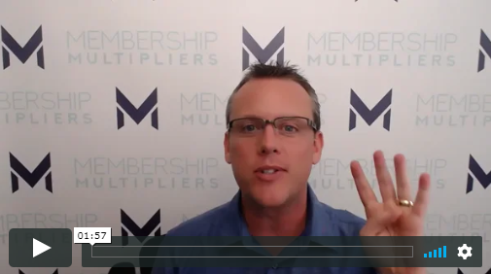

>>Click here and secure your spot!
Look, the process is simple. If you can send and email, you can do it.
I'm going to pull back the curtain and show you how to make it work for you and your membership.
But you have to be on the livecast, this Thursday, August 22nd at 2:00pm Eastern.
I hope to see you there!
Scott
P.S. This is a livecast. There will not be any replays. You owe it to yourself and your membership to be there.
I know that when I help you get more members, I'm actually helping your members. You provide value to your members and I want to help you multiply that impact.
So make plans to attend this Thursday.
>>Click here to register now: [Link]

Scott Whitaker,
Author & Founder of Membership Multipliers

Webinar Promotion

Email #2
Subject: Inc Magazine's fastest growing membership businesses

I just got a message from TWO of my clients.
One made the Inc 500 list (Kim Walsh Phillips pictured left) and the other (Michael and Roslyn Rozbruch pictured right) made the Inc 5,000 list for fastest growing companies!
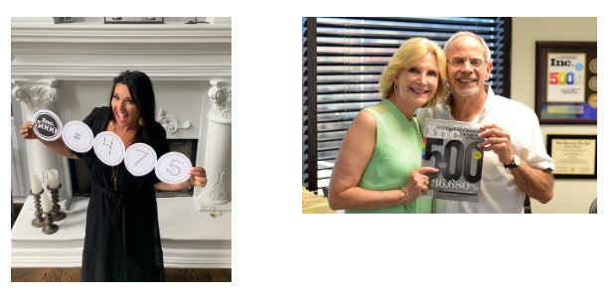

Would you like to learn some of the secrets that I've shared with them to add hundreds of members (and millions of dollars) to their business?
This Thursday, August 22nd at 2:00pm Eastern, I'm doing a FREE Livecast:
How to Get More Members In Four Days Than You Do All Month
(Without Spending Any Money!)
I'll share with you a simple process by which you can get more members in 4-days than you do all month.
It's as simple as sending an email. (You just need to have a list to send it to.)
I've been sharing this process with my private clients, Membership Accelerators Club and Membership Multipliers and every time it's used, they all get members.
But you must register!
Click here to secure your spot now!
I look forward to seeing you on the livecast!
Scott
P.S. This is a livecast with a limited number of spots available. There will not be a replay. You owe it to yourself and to all the people you can help with your membership to be there.
[Link]

Scott Whitaker,
Author & Founder of Membership Multipliers

Webinar Promotion

Email #3
Subject: available tomorrow?

Are you available to join me and numerous other membership and association leaders for a free livecast, tomorrow, Thursday, August 22nd at 2:00pm Eastern?
The topic is:
How to Get More Members in 4 Days Than You Do All Month
(Without Spending Any Money on Marketing)
This is a brand new livecast where I'll be sharing with you the exact process that some of the fastest growing membership businesses are using to get more members in 4 days than they did all month long.
We'll start right at 2:00pm Eastern.
I'll share with you:
- The most practical (and FREE) tool that you can use to double your membership.
- How to turn PROSPECTS into MEMBERS with one simple and repeatable system.
- How to give your members a "quick win" so they stay engaged.
- And much, much more!
Click here to register now!

You can also click above to view a special message I recorded.
I look forward to seeing you on the livecast.
Scott
P.S. Even if you've been on previous webinars and livecasts with me, this one is different. It's brand-new and I'll share with you some of the secrets that I've been sharing with my private clients to help them multiply their membership over and over again.
>>Secure your spot here!

Scott Whitaker,
Author & Founder of Membership Multipliers

Webinar Promotion

Email #4
Subject: "Membership Boy Wonder"

I just put the final touch on my notes for today's free livecast:
How to Get More Members in 4 Days Than You Do All Month
(Without Spending Any Money on Marketing)
Just like Kris Murray, Founder of Childcare Success Company, who sold over $740,000 in membership in just seven months.
Kris has calls me "Membership Boy Wonder" HA!
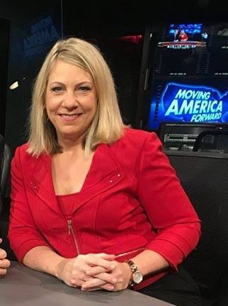

This is a brand new livecast where I'll be sharing with you the exact process that some of the fastest growing membership businesses are using to get more members in 4 days than they did all month long.
You still have time to register. We'll start right at 2:00pm Eastern today, Thursday, Aug 22nd.
[Link]
I'll share with you:
- The most practical (and FREE) tool that you can use to double your membership.
- How to turn PROSPECTS into MEMBERS with one simple and repeatable system.
- How to give your members a "quick win" so they stay engaged.
- And much, much more!
Click here to register now!
I look forward to seeing you on the livecast.
Scott
P.S. Even if you've been on previous webinars and livecasts with me, this one is different. It's brand-new and I'll share with you some of the secrets that I've been sharing with my private clients to help them multiply their membership over and over again.
>>Secure your spot here!

Scott Whitaker,
Author & Founder of Membership Multipliers

Webinar Promotion

Email #5
Subject: Livecast is starting (link enclosed)

John,
We are live in just a few minutes at 2pm Eastern. Click here now to join us:
More Members in 4 Days Than You Do All Month (Without Spending Any Money!)
See you shortly!
Scott Whitaker,
Author & Founder of Membership Multipliers

Webinar Sales

Email #1
Subject: update to today's webinar

Hey John,
Great to see you on today's livecast.
I want to personally invite you to pick up the "The Four Day Membership Generator."
Plus, get all the BONUSES before they disappear.
Click the link below to sign up now:
[Link]
Here’s the opportunity in summary…
Make an investment in your membership business today and get:
- 4-Day Membership Generator - $297 value
- Triple Your Membership Toolkit - $997 value
- Complete access to Membership Multipliers - $2,097 value
Plus, you get these two bonuses:
>> Membership Marketers Private Facebook Group - $500
>> One Free Month of Membership Multipliers - $297 value
Join an elite group of membership business leaders, just like you, who want to get multiply their membership and money.
Plus, you'll get unlimited email access to me and my team!
Click here to sign up now!
I know I don’t have to remind you that this opportunity will end at midnight on Monday!
Let’s get you more members now!
Scott
P.S. Your 100% Satisfaction Guarantee: If you don't get members after running the 4-Day Membership Generator, I'll refund your investment.
I stand firmly behind this training. The same goes for your investment.
In other words, I want to remove any fear you might have in getting this training.
Get your copy now => [Link]

Scott Whitaker,
Founder of Membership Multipliers

Webinar Sales

Email #2
Subject: want me to promote your membership?

Hey John,
Would you like for me to promote your membership?
Yesterday, you were invited to pick up the "The Four Day Membership Generator."
When you do, you're going to get me personally helping you promote your membership to your prospects.
You see, every person who has run the Four Day Membership Generator has picked up members.
There are a couple of reasons for this:
- The generator works! Regardless of the number of prospects you have, you will get members.
- You get me guiding you along the way. I'm not about to let you fail.
Click the link below to sign up now:
[Link]
I want to add you to the "Wall of Fame" just like:
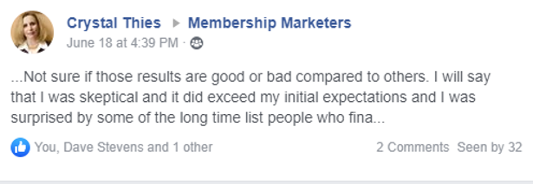

Odell Bizzell who doubled his membership (he's brand new to the membership world!)
Crystal Thies who picked up 17 members in just four days!
Here’s the opportunity in summary…
Make an investment in your membership business today and get:
- 4-Day Membership Generator - $297 value
- Triple Your Membership Toolkit - $997 value
- Complete access to Membership Multipliers - $2,097 value
Plus, you get these two bonuses:
>> Membership Marketers Private Facebook Group - $500
>> One Free Month of Membership Multipliers - $297 value
Join an elite group of membership business leaders, just like you, who want to get multiply their membership and money.
Plus, you'll get unlimited email access to me and my team!
Click here to sign up now!
I know I don’t have to remind you that this opportunity will end at midnight on Monday!
Let’s get you more members now!
Scott
P.S. Your 100% Satisfaction Guarantee: If you don't get members after running the 4-Day Membership Generator, I'll refund your investment.
I stand firmly behind this training. The same goes for your investment.
In other words, I want to remove any fear you might have in getting this training.
Get your copy now => [Link]

Scott Whitaker,
Founder of Membership Multipliers

Webinar Sales

Email #3
Subject: Big Announcement - Build Your Audience

Hey John,
I've got a BIG ANNOUNCEMENT! (Actually 2!)
Announcement #1:
We just added Kim Walsh Phillips as a guest speaker to the "Triple Your Membership Incubator" coming up on October 8-9 in Atlanta, GA.
Kim is an expert at building audiences, getting prospects and turning those prospects into raving buyers.
During the event, she's going to share with you some of her best kept secrets on building your list, including:
- Uncover audiences by identifying the 7 places your PERFECT prospects already gather.
- Rally your tribe with the 12-month media plan to attract thousands of raving fans and expertly position yourself as THE authority in your field.
- Unleash your power monetizing your message doing things that you love choosing the BEST way for you.
Click here to secure your spot!
By the way, her company was just recently named by Inc Magazine as one of the fastest growing membership businesses (ranked #475!)
She's also a private client of mine. She sent me this picture below to celebrate in her success!
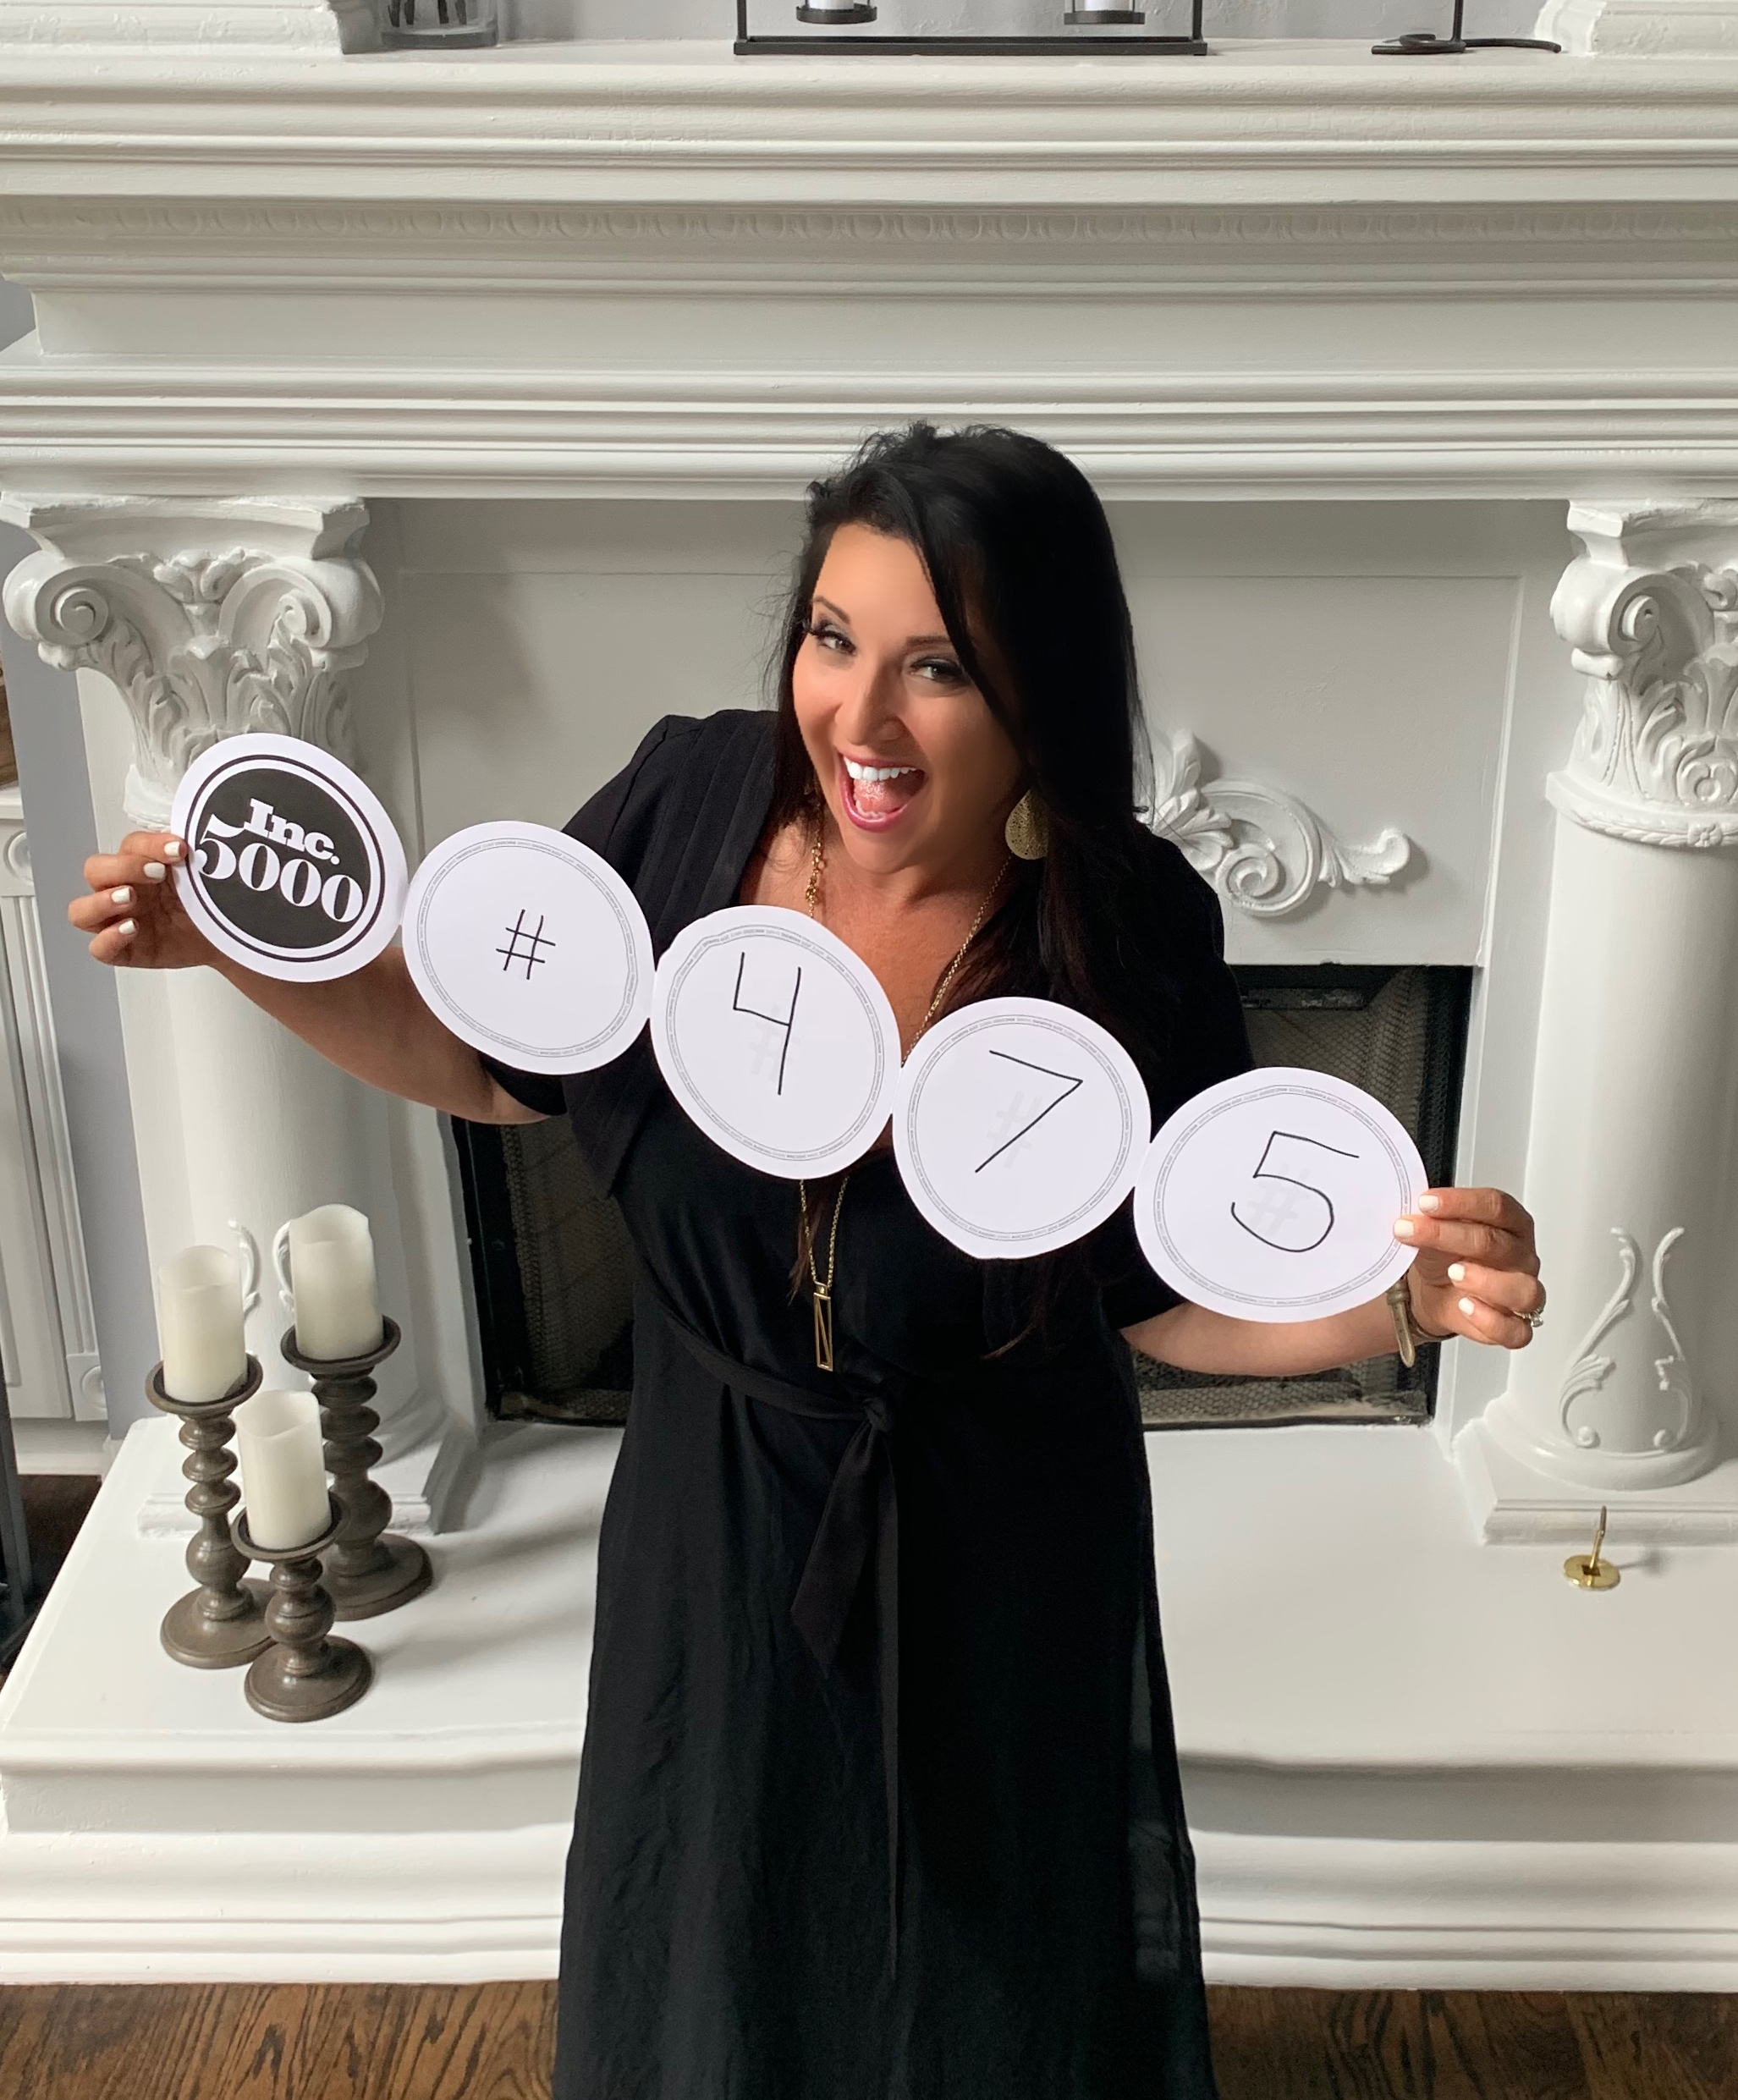

When you attend the "Triple Your Membership Incubator" you're not only going to get more members, you're going to be able to get more prospects and grow your audience.
Click here to register now!
Announcement #2:
We're just one week away from the Super Early Bird Deadline!
Register before Friday, August 30th and save $300.00!
Time is running out.
When you register right now, you also get to bring a guest for FREE!
Here's a powerful question for you to consider:
What would your membership look like if you were to invest two days with the goal of tripling your membership?
Your entire membership would be transformed.
Not to mention what that would do for you personally. You would be able to better fulfill your purpose, help more people and stop living under the stress of constantly chasing after new members.
Once we triple your membership…
- You'll find it easy to get more prospects... because you have the extra cash to do more marketing!
- You'll have a proven process to get your prospects to engage... leading them to sign up for your membership at twice the speed!
- You'll no longer be stressed about finding new prospects... because you'll have a constant flow of new prospects coming in!
- You'll be dominating your market... because new members stay far longer with you than your competitors!
- You'll be growing your membership at twice the speed... because you can invest 200% more to get new members!
- And most importantly… you'll be banking a heck of a lot more money from every all the recurring revenue!
Not too mention, your business, your sales, and your income will no longer be vulnerable to the ever increasing costs of building a membership business...
...because you’ll be banking more than enough money from every new membership to pay for it.
Click here to secure your spot now and save $300.00 with the Super Early Bird Rate!
I look forward to seeing you in Atlanta!
Scott
P.S. One more thing, even if things are a little tight right now, you can use the convenient 3-pay option where you can breakdown your registration into smaller investments, use the bonuses now and get an immediate ROI on your registration.
This will lock you in at the Super Early Bird rate with $1997.00 in bonuses!
Click here to learn more!

Webinar Sales

Email #4
Subject: Big Announcement - Build Your Audience

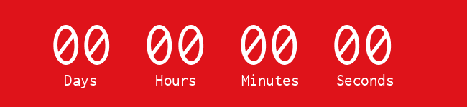

Time is running out..... your opportunity to get more members in four days than you do all month is running out.
Stop struggling to get new prospects or losing your shirt just to get a few leads.
Stop struggling to generate traffic that will turn into members.
Stop being overwhelmed by trying to market your membership.
It's time to put it all to rest....
The "The 4 Day Membership Generator" is a simple way to get people more people to sign up for your membership. Plus, you'll get the "Triple Your Membership in 21 Days Toolkit" to help you get even more members month after month.
Get your membership generator here >> [Link]
Here's what others are saying,
“In just 60 days, my membership group by 43%. Plus, I raised my prices by 46%!” – Jeannette K.
“I was able to get more members just by adding more levels of membership.” – Stacy R.
“We were able to be more profitable just by adding additional services that our members pay for outside of their membership.” – Mike A.
“Scott Whitaker is a membership master! He gave me two tips in under five minutes that helped double our membership revenue. Double! No bull, it is twice what it was and climbing. – Todd T.
Click the link below to sign up now:
[Link]
Make an investment in your membership business today and get:
4-Day Membership Generator - $297 value
Triple Your Membership Toolkit - $997 value
Complete access to Membership Multipliers - $2,097 value
Plus, you get these two bonuses:
>> Membership Marketers Private Facebook Group - $500
>> One Free Month of Membership Multipliers - $297 value
Join an elite group of membership business leaders, just like you, who want to get multiply their membership and money.
Plus, you'll get unlimited email access to me and my team!
Click here to sign up now!
I know I don’t have to remind you that this opportunity will end at midnight on Monday!
Let’s get you more members now!
Scott
P.S. Your 100% Satisfaction Guarantee: If you don't get members after running the 4-Day Membership Generator, I'll refund your investment.
I stand firmly behind this training. The same goes for your investment.
In other words, I want to remove any fear you might have in getting this training.
Get your copy now => [Link]

Scott Whitaker,
Author & Founder of Membership Multipliers

Webinar Sales

Email #5
Subject: at midnight…

At midnight tonight your opportunity to get the The "The 4-Day Membership Generator" and receive over $3,891 in bonuses is going to disappear.
You can literally put the generator to work for you and if it doesn't get you members, then I'll be glad to fully refund your investment.
And as I mentioned on the livecast, I have yet to have someone use the 4-Day Membership Generator and not get members. Everyone has picked up members.
There's nothing to lose.
Get your membership generator here >> [Link]
Let’s get you more members now!
Scott
P.S. Just to recap, when you make an investment in your membership, you'll get:
- 4-Day Membership Generator - $297 value
- Triple Your Membership Toolkit - $997 value
- Complete access to Membership Multipliers - $2,097 value
Plus, you get these two bonuses:
>> Membership Marketers Private Facebook Group - $500
>> One Free Month of Membership Multipliers - $297 value
But only if you pick it up before midnight tonight.
Get your copy now => [Link]

Scott Whitaker,
Author & Founder of Membership Multipliers

