Hello SNAP-Ed Friends,
I hope you all are enjoying the beautiful fall weather! As we head into the December holidays, I want to let you all know that I will be out of town for a couple of weeks, Dec. 14 – Jan. 2, back on Jan. 3. Lee Anne will be around for any questions, but we won’t plan on sending Friday Updates during this time. We’ll be back on schedule the first week of January. Until then, Happy Holidays!

*NEW* FFY2019 Quarterly Report Templates
An updated quarterly report template has been created for FFY2019, and customized for each program. If we’ve done it right, you should be able to use the same template for each of your 3 quarterly reports this year! Each program lead will receive an email with their template today, be on the lookout!

*NEW* Monthly Farmers Market Food Access Forum web meeting

THURS, DECEMBER 13, 2018
12:00PM TO 1:00PM
Weblink: https://zoom.us/j/352615590

For audio by phone instead of computer, please call:
(669) 900 6833; Meeting ID: 352 615 590

“Targeting Food Access Programs to Maximize Farm Sales and Farmers Market Viability”
Samantha Schaffstall, USDA AMS Local and Regional Foods Research Analyst, and Colleen Donovan of Washington State Farmers Market Association, will share research on the concept of “high performing food access” farmers markets, including Farm Vendor interviews to look at SNAP and FMNP from the perspective of farmers markets and farm vendors.

*NEW* Healthy Food Financing Initiative – How to Apply for Funds

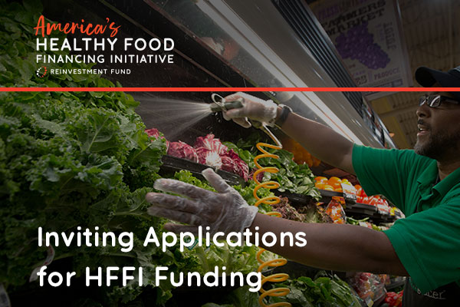

Reinvestment Fund is inviting applications for financial and technical assistance through the Healthy Food Financing Initiative (HFFI) inaugural grants program. Funding for the HFFI grants program is supported by the United States Department of Agriculture (USDA), authorized by the 2014 Farm Bill. As the National Fund Manager, Reinvestment Fund is offering financial resources and expertise to eligible healthy food retail projects to expand access to healthy foods in underserved areas, to create and preserve quality jobs, and to revitalize low-income communities.
HFFI is making available $1.8 million in assistance to support eligible fresh food retail projects to overcome the higher costs and initial barriers to entry in underserved areas. To be eligible for assistance, healthy food retail projects must: 1) plan to expand or preserve the availability of staple and perishable foods in underserved areas with low and moderate-income populations; and 2) accepts or plans to accept benefits under the supplemental nutrition assistance program (SNAP). The application and additional information is available through www.investinginfood.com. The deadline for applications is February 14, 2019.
Reinvestment Fund will hold webinars on December 13, 2018 at 2 p.m. ET and January 8, 2019 at 12 p.m. ET to confirm details about the application process and answer questions. Registration for the webinars is required.

*NEW* Webinar: Guide for Developing and Enhancing Skills in Public Health and Community Nutrition
SNAP-Ed brings together people representing diverse disciplines, different educational backgrounds, and a wide range of experience.
Hot off the press, The Guide for Developing and Enhancing Skills in Public Health and Community Nutrition, 3rd Edition, will help SNAP-Ed leaders develop even higher-performing teams.
The Guide was developed with ASNNA input and uses the Social Ecological Model as a foundation, so the competencies, learning activities and resources can support SNAP-Ed practitioners from entry to management positions.
The content of this comprehensive curriculum covers six domains:
- Food and nutrition
- Communication, marketing and cultural competence
- Advocacy and education
- Policy, systems and environmental change
- Research and evaluation
- Management and leadership.
- Register now for the live webinar to introduce the Guide for Developing and Enhancing Skills in Public Health and Community Nutrition, 3rd Edition!
Webinar Title: Training Our Workforce: A New Guide for Training Public Health and Community Nutrition Professionals
Date: December 20, 2018
Time: 10:00 am – 11:30 am EST
CPEU: 1.5
Cost: FREE
Registration: Register Here
*The audio for this webinar will be presented using VOIP (your computer speakers).

*Reminder* Important Dates – Mark Your Calendars!
- December 31: Please complete all required annual training by this date (Civil Rights, Evaluation, Curriculum)
- January 7: PEARS data DUE for Quarter 1
- January 11: Winter teaching Calendars DUE – to Curriculum Team
- January 14: 1st Quarter Report DUE – to IA
- January 18th: 1st round Amendment requests DUE – to IA
- January 31: Teen Cuisine Webinar – see curriculum webpage for link to join

Happy Friday!
Acacia & Lee Anne

